# ITRACK4PS: A WEB-BASED MONITORING SYSTEM OF 4PS IN MABINI, BATANGAS, IN FIELD OF EDUCATION

A Capstone Project

Presented to the Faculty of

College of Informatics and Computing Sciences

BATANGAS STATE UNIVERSITY

The National Engineering University

Batangas City

In Partial Fulfillment of the Requirements for the Degree

Bachelor of Science in Information Technology

Major in Business Analytics

Banaag, Danica Rose D.

Celis, Monalenne Joy M.

Montealto, Mark Lowel R.

JOSHUA C. ABELLA

Adviser

December 2023

# APPROVAL SHEET

This capstone project entitled ITRACK4PS: A WEB-BASED MONITORING SYSTEM OF 4PS IN MABINI, BATANGAS, IN FIELD OF EDUCATION, prepared and submitted by DANICA ROSE D. BANAAG, MONALENNE JOY M. CELIS, and MARK LOWEL R. MONTEALTOin partial fulfillment of the requirements for the degree Bachelor of Science in Information Technology major in Business Analytics, has been examined and is recommended for acceptance and approval for oral examination.

Mr. Joshua C. Abella

Adviser

Approved by the Committee on Oral Examination with a grade of ______.

PANEL OF EXAMINERS

Jefferson I. Cañada, MSIT

Chairperson

|  |  |
| --- | --- |
| Ms. Jeleen M. Mangubat  Member | Mr. Arjonel M. Mendoza  Member |

Accepted and approved in partial fulfillment of the requirements for the degree Bachelor of Science in Information Technology with a major in Business Analytics

|  |  |
| --- | --- |
| Date _______________ | ____________________________________  Princess Marie B. Melo, DIT  Dean, CICS |

# ABSTRACT

The iTrack4PS program in Mabini, Batangas, seeks to transform the monitoring of education for beneficiaries of the Pantawid Pamilyang Pilipino Program (4Ps). The effort suggests utilizing web-based technology, such as cloud or serverless monitoring solutions, to address the difficulties caused by manual procedures and ghosting lists. The main objective is to provide a dependable, efficient, and adaptable platform that enables effortless collection of data for 4Ps pupils.

The main focus of this project is to provide a user-friendly interface specifically designed for 4Ps staff. This interface will provide essential data on beneficiary figures, graphical depictions of advancement, and enrollment metrics for schools and barangays. The effort focuses on a complete strategy to managing records, which includes integrating, retrieving, modifying, and preserving data related to 4Ps recipients and their dependent children.

In line with Sustainable Development Goal 4 (SDG4), the program emphasizes a dedication to promoting inclusive and fair high-quality education. The iTrack4PS program in Mabini, Batangas aims to make a substantial contribution to the global goal of promoting accessible and equitable educational opportunities, thereby facilitating a brighter and more sustainable future.

# ACKNOWLEDGEMENT

The researchers would like to sincerely thank numerous individuals whose invaluable efforts and unflinching support have made this research project possible. Foremost among these individuals is their capstone instructor, Mr. Joshua C. Abella, together with Mrs. Ria L. Castillo and Mr. Jefferson I. Cañada, whose leadership and wise counsel played a crucial part in molding the practicality and accomplishment of this study. The researchers' academic endeavor was spurred towards completion by the focused guidance and encouragement they received.

The researchers express deep gratitude to their parents, whose unwavering love and unwavering support, together with their consistent reminders about the importance of education, acted as a motivating factor throughout their academic path. The researchers express their gratitude to friends and classmates for their crucial contribution in motivating them to pursue excellence and providing important support in overcoming the hurdles faced during the study process.

Mr. Seiji Villafranca, Mr. Matt Mendez, and Mr. Matthew Uy, who are highly respected leaders of the AngularPH Community in the Philippines, are given special recognition. Their suggestions and thoughts played a crucial role in the project's growth, demonstrating the cooperative nature prevalent in the tech world. The researchers express their gratitude to Mr. Cedric Peterson Miraflor for his valuable advice in negotiating the complexities of project development.

Above all, the researchers express deep appreciation to the Divine Being, whose direction, blessings, and bestowal of knowledge and strength have been essential in enabling this study endeavor. The combination of guidance from mentors, support from family and friends, and inspiration from the holy has not only enhanced the researchers' academic journey but has also emphasized the need of collaboration and appreciation in the quest of knowledge and intellectual pursuits.

# DEDICATION

This research is dedicated to our respective parents, capstone teachers, advisers, defense panelists, and cherished professors, who have been a constant source of inspiration and knowledge in completing this project. They have given us the motivation and discipline to approach a task with zeal and purpose. This endeavor would not have been possible without their love and support.

We also dedicated this research to our friends and to all those who have been a part of this project. We are thankful to have all of you on our side to give your full support, to cheer us up when we feel down at times, and to accompany us on this long journey.

Above all, to our Almighty God, for guidance, blessings, and the knowledge and strength that made this research possible. We offer this dedication as a symbol of our unwavering faith and commitment to the pursuit of knowledge and academic excellence.

**DRDB**

**MJMC**

**MLRM**

# TABLE OF CONTENTS

Title Page i

APPROVAL SHEET ii

ABSTRACT iii

ACKNOWLEDGEMENT iv

DEDICATION v

TABLE OF CONTENTS vi

List of Tables ix

List of Figures x

CHAPTER I 12

INTRODUCTION 12

Background of the Study 12

Objectives of the Study 14

Significance of the Study 15

Scope and Limitations of the Study 16

Definition of Terms 17

CHAPTER II 21

REVIEW OF RELATED SYSTEM 21

Technical Background 21

Local Related Study 24

Local Related System 31

Foreign-Related Studies 40

Related Foreign Systems 46

Conceptual Framework 53

Synthesis 55

Chapter III 57

DESIGN AND METHODOLOGY 57

Software Development Model 57

Requirements Analysis 59

Analysis of the existing system 59

Fish Bone Analysis 60

System Boundary 62

Hardware Requirements 63

Software Requirements 66

Functional Requirements 68

Non-Functional Requirements 69

Constraints 71

Trade-off 73

System Design/Architecture 74

Context Diagram 76

Data Flow Diagram 77

Link Architecture 79

Use case 81

Sequence Diagram 83

Database Design 84

Development Software 85

Web Platform 86

Database 87

Subscription 87

Testing 88

Testing Procedure 89

Data Gathering 90

Deploy 90

Risk Management Plan 90

Risk Analysis 94

Risk Treatment 95

Risk Ownership 97

Risk Management Process 98

CHAPTER IV 100

RESULTS AND DISCUSSIONS 100

Usability Test Results 102

Functionality 103

CHAPTER V 105

SUMMARY OF FINDINGS, CONCLUSIONS, AND 105

RECOMMENDATIONS 105

Summary of Findings 105

APPENDIX A 110

SYSTEM TESTING 110

APPENDIX B 116

GANTT CHART 116

APPENDIX C 117

PROJECT ROLES AND RESPONSIBILITIES 117

APPENDIX D 119

USER MANUAL 119

APPENDIX E 130

BIO NOTE 130

Appendix F 133

Survey Questionaires 133

4ps Staff 133

Admin 137

Bibliography 140

# List of Tables

Table 1. Hardware requirements and specifications 64

Table 2. Hardware Minimum Requirements for End Users 65

Table 3. Software Requirements and Specifications 66

Table 4. Software Minimum Requirements for End Users 67

Table 5. Server-Side Scripting Language 71

Table 6. Databases 72

Table 7. Text Editors 73

Table 8. Technology Stack 74

Table 9. Subscription Fees 88

Table 10. Risk Analysis 94

Table 11. Risk Treatment 96

Table 12. Risk Ownership 97

Table 13. Usability of SAMPLED among four types of Respondents 110

Table 14. 4P’s Staff Functionality Testing 111

Table 15. Administrator Functionality Testing 112

Table 16. 4P’s Staff Reliability Test Result 113

Table 17. Administrator Reliability Test Result 114

Table 18. Roles and Responsibilities 117

# List of Figures

Figure 1. Comparison of traditional Server and Serverless 23

Figure 2. Conceptual Framework 53

Figure 3. Agile Model 57

Figure 4. Fishbone Diagram 61

Figure 5. System Boundary 62

Figure 6. System Architecture on AWS Lightsail 75

Figure 7. Context Diagram 77

Figure 8. Data Flow Diagram 78

Figure 9. Link Architecture 79

Figure 10. Use Case Diagram 82

Figure 11. Sequence Diagram 83

Figure 12. Database Design 84

Figure 13. ISO/IEC 25010 89

Figure 14. Risk Matrix 93

Figure 15. Risk Management Process 99

Figure 16. Gant Chartt 116

Figure 17. Login Page 119

Figure 18. Admin Dashboard 119

Figure 19. Graphs of Graduates Currently Working & Beneficiary Student Continue Studying College 120

Figure 20. Numbers of Status of Every Beneficiaries 120

Figure 21. 4ps Holder Page 121

Figure 22. View Information of 4ps Holder 121

Figure 23. Child Beneficiaries Page 122

Figure 24. Search Button 122

Figure 25. User Management Page 123

Figure 26. Add User Modal 123

Figure 27. Logout Modal 124

Figure 28. Login Page 124

Figure 29. 4ps Holder Page of 4ps Staff 125

Figure 30. View Information of 4ps Staff 125

Figure 31. Update Information of 4ps Holder 126

Figure 32. Archiving 4ps Holder 126

Figure 33. Child Beneficiaries Page 127

Figure 34. Create Child Beneficiary Details 128

Figure 35. Add 4ps Holder Information 128

Figure 36. Search Button 4ps Staff in Holder Page 129

Figure 37. Logout Modal of 4ps Staff 129

# CHAPTER I

## INTRODUCTION

## Background of the Study

The Pantawid Pamilyang Pilipino Program implementation in Mabini, Batangas, managed by the Local Government Unit (LGU) through the Municipal Social Welfare and Development Office (MSWDO), is a praiseworthy attempt to extend the benefits of the 4Ps to disadvantaged families. Mabini has 34 barangays, 11,725 households, and a total population of 50,858, with 867 counts of 4Ps beneficiaries, 1369 counts of senior high school graduates, and 65 counts of beneficiaries currently enrolled in college (Highlights of the Municipality of Mabini Population, 2020 Census of Population and Housing (CPH) | Philippine Statistics Authority, CALABARZON, 2021). The number of 4P recipients is visible in many different public schools. They have increased in number and are regarded as the leading group in terms of education assistance from the government. Their attendance, health, and academic performance are all carefully evaluated.

Despite the program's remarkable results in Mabini, the manual processing and sorting of recipient information posed considerable hurdles. In order to update beneficiary information, program workers had to deliver paper forms to schools every month. This manual approach caused significant delays since staff had to wait for the return of these documents before they could update the beneficiary data. Furthermore, the sorting procedure for beneficiary files frequently resulted in erroneous and out-of-date information, which caused confusion and hampered effective decision-making. Furthermore, there were cases where beneficiary names appeared to vanish owing to delays in changing their status, which were known as "ghosting lists." Overall, these challenges in manual processing and sorting of beneficiary files have posed difficulties for the 4Ps program in Mabini.

The implementation of iTrack4Ps into the Pantawid Pamilyang Pilipino Program (4Ps) in Mabini, Batangas, closely correlates with the Sustainable Development Goals 4 (SDG 4), with a specific emphasis on educational development. iTrack enhances the integrity and efficiency of beneficiary data management by solving manual processing problems, thereby contributing to the SDG goal of inclusive and excellent education. This synergy is highlighted by iTrack's role in lowering educational access inequities and promoting a climate in which all students, regardless of economic background, may benefit from increased learning opportunities. Furthermore, iTrack's collaborative and technological approach aligns with the overarching SDG value of building partnerships to strengthen institutional capacity, confirming the 4Ps program's commitment to long-term educational improvement in Mabini. In addition to its contributions to educational development, the integration of iTrack4Ps into the Pantawid Pamilyang Pilipino Program (4Ps) in Mabini, Batangas, also underscores the program's commitment to addressing broader societal challenges.

## Objectives of the Study

The main objective of the study is to design and develop a web-based tool that is reliable, efficient, and scalable to support increasing user number. The researchers used a cloud or serverless monitoring system for the 4Ps in Mabini, Batangas, in the field of education.

Specifically, this study aims to:

1. To provide a platform for collecting the data of the 4Ps students' beneficiaries.
2. To develop a dashboard tailored for 4Ps staff, facilitating the monitoring of beneficiaries categorized on:

2.1 Count of 4Ps Holders and Beneficiary Children

2.2 Graphical Representation of Statuses

2.3 School with the Most Enrolled Students

2.4 Beneficiary Counts in Different Barangays

3. To provide a comprehensive record collection for:

3.1 Adding 4ps holder /Beneficiary Child

3.2 Searching/Editing/Archiving Holder data

3.3 Updating the Beneficiary Status and 4Ps Holder

## Significance of the Study

The ITrack4Ps serves as essential to the Pantawid Pamilyang Pilipino Program (4Ps) in Mabini, Batangas. Despite commendable efforts by the Local Government Unit (LGU) to extend 4Ps benefits to vulnerable households, challenges with manual processing and sorting of beneficiary files persist, resulting in delays, inaccuracies, and instances of 'ghosting lists.' The integration of iTrack4Ps into the program is not only a response to these challenges but also aligns seamlessly with Sustainable Development Goals (SDGs), specifically emphasizing educational advancements. By solving manual processing inefficiencies, iTrack provides accurate and effective beneficiary data management, thereby contributing to the SDGs' goal of inclusive and excellent education. Furthermore, the system's role in decreasing educational inequities aligns with the SDGs' larger objective of building partnerships to strengthen institutional capacities, supporting Mabini's 4Ps program's commitment to long-term educational growth.

The objectives of the study are intended to have a direct influence on resolving existing obstacles. The creation of a web-based platform speeds data gathering for 4Ps students' beneficiaries, addressing the problems faced by the manual method. The development of a dashboard module empowers 4Ps personnel by giving crucial indicators such as the number of 4Ps holders, graphical representations of statuses, and beneficiary counts in different barangays in real time.

A thorough record gathering system also handles contemporary sorting issues, assuring accuracy and historical reference.

Furthermore, iTrack4Ps has data validation procedures, which eliminates the problem of obsolete and inaccurate beneficiary information. The system's rapid updating of beneficiary status seeks to eliminate delays and decrease instances of 'ghosting lists,' ensuring fast and accurate reporting on the effect of the 4Ps program for program workers, local government units, and 4Ps beneficiaries alike. In conclusion, the iTrack4Ps research is set to make a significant contribution by addressing fundamental issues in the manual processing of 4Ps beneficiary data, aligning with the SDGs, and improving education access and quality in Mabini, Batangas. The outcomes have the potential to considerably benefit program stakeholders while also contributing to the larger goals of long-term educational development.

## Scope and Limitations of the Study

This study established a monitoring system for education for the 4Ps program in Mabini, Batangas, which would increase the efficiency of 4Ps workers. The system is capable of establishing a monitoring dashboard, responsive forms for data collecting, and gathering records of 4Ps beneficiaries who have successfully graduated from senior high school and proceeded on to college.

The scope of this study is limited to the development of a web-based system for the 4Ps program in Mabini, Batangas Municipal. The study only covers the monitoring of 4Ps beneficiaries who have successfully graduated, graduated from senior high school, and continued to college. Other social welfare programs implemented by the local government unit is not be included in the study. The research is limited to the available data gathered by 4Ps personnel and other reliable sources. The development of the system software also be constrained by available hardware resources, programming languages, tools, databases, and security considerations.

Overall, this study aims to develop a functional and effective web-based system that aid the 4Ps program in Mabini, Batangas. The study's limitations provide a clear understanding of the study's scope and boundaries, allowing readers to grasp the study's intended outcomes.

## Definition of Terms

To understand and clarify the terms used in the study, the following are hereby defined:

**Department of Social Welfare and Development (DSWD)** is conducting this study to ensure the efficient and speedy delivery of aid to communities affected by various forms of disaster. The Department of Social Welfare and Development (DSWD) has streamlined the process of providing relief assistance and basic services to these calamity-stricken areas. In this study, DSWD is the user of the developed system.

**Family Development Sessions (FDS)** Seminars for parent-beneficiaries of the Pantawid Pamilyang Pilipino Program (4Ps) aim to promote positive family values and strengthen marital relationships, parental roles, and responsibilities. The study aimed to analyze the changes in the familial relationships of 4P beneficiaries that could be attributed to their attendance in FDS seminars

**Monitoring** is the routine tracking and reporting of priority information about a program / project, its inputs and intended outputs, outcomes and impacts. In our study, iTrack4Ps is seamlessly integrated into the Pantawid Pamilyang Pilipino Program (4Ps) in Mabini, Batangas, specifically to enhance the monitoring process. Leveraging technology, iTrack4Ps streamlines beneficiary data management, ensuring a more efficient and accurate monitoring mechanism within the 4Ps program.

**Social welfare** is a system that offers assistance to individuals and families in need through such programs as health care assistance, food stamps, and unemployment compensation. Less well-known parts of the social welfare system include disaster relief and educational assistance. (Investopedia, 2020). In this study, social welfare is one of the possible programs that can be offered by DSWD. The health and well-being of disadvantaged populations in need of essential support and services can be greatly impacted by the DSWD's role in providing social welfare programs.

**Sustainable Development Goals (SDG)** also known as the Global Goals, were adopted by the United Nations in 2015 as a universal call to action to end poverty, protect the planet, and ensure that by 2030 all people enjoy peace and prosperity. iTrack4Ps is integrated into the Pantawid Pamilyang Pilipino Program (4Ps) in Mabini, Batangas, to promote the accomplishment of Sustainable Development Goal 4 (SDG 4) which focuses on educational development. ITrack aids in the efficient administration of beneficiary data, so supporting the objective of SDG 4 to provide inclusive and high-quality education, while also eliminating gaps in access.

**4ps (Pantawid Pamilyang Pilipino Program)** is a human development measure of the national government that provides conditional cash grants to the poorest of the poor, to improve the health, nutrition, and the education of children aged 0-18. In our study, the operational integration of iTrack4Ps in Mabini, Batangas, enhances the efficiency of the 4Ps program. iTrack4Ps streamlines beneficiary data management, addressing manual processing challenges.

**Beneficiary** - simply the recipient of money or other benefits. In iTrack4Ps, beneficiaries, as 4Ps holders and beneficiary child, are a focal point. They receive government aid but are actively involved in ensuring their children attend school, taking small kids for health check-ups, and participating in family development sessions. iTrack4Ps prioritizes and monitors this dual role, recognizing the transformative potential of the 4Ps when coupled with the responsible engagement of beneficiaries.

**MSWD** provides financial support to individuals and families with limited resources. In the iTrack4PS system, particularly as utilized by the Department of Social Welfare and Development (DSWD) with a focus on municipal linkages, the Municipal Social Welfare and Development (MSWD) office serves a crucial role. This office, embedded in the DSWD and integral to the iTrack4PS system, operates as a vital component for the DSWD's outreach efforts. Specifically, the MSWD provides financial support to individuals and families facing economic constraints.

**Administrator** a person who is in charge of the operation of a network of computers, a website, a group of computer users, etc., and is able to make changes. In our study, the administrator functions as a crucial end user actively engaged in overseeing and monitoring the entire operational scope, including networks, websites, and users. Their role is integral to the study's success, as they make informed decisions and implement changes within the system to maintain optimal performance. By promptly addressing operational challenges, the administrator contributes to the study's efficiency and effectiveness, ensuring that the monitored elements align with the study's objectives and requirements.

**4PS Leader** serve as the main link of the DSWD to the program beneficiaries. They assist in conducting meetings, updating of beneficiaries’ profiles, conduct of monthly family development sessions, and other voluntary efforts helpful in program implementation. In our study, the 4Ps Leader's operational role involves being present with the 4Ps staff during surveys and serving as a primary communicator by transmitting messages, ensuring streamlined and efficient survey processes.

# CHAPTER II

## REVIEW OF RELATED SYSTEM

This chapter primarily presents the different research methods of local and foreign researchers, which have a significant bearing on the variables included in the research. It focuses on several aspects that helped in the development of this study. The study generally focused on the creation of web-based tools for monitoring for the DSWD office in Mabini, Batangas.

## Technical Background

This section explains the technical concepts and provides a foundational understanding of the underlying technologies. and principles that enable the development and implementation of the developed solution. The researcher used HTML, CSS, and the AngularJS framework for the development of the system on the front-end development part.

**AngularJs Framework**

AngularJS is one of the most widely used frameworks for modern single-page web application development and is designed to support dynamic views in applications, according to Jain, N., Bhansali, A., and Mehta, D. More than 1,118,198 websites are active and employing AngularJS, according to BuiltWith. Because of its adaptability, AngularJS is used by numerous multinational companies, or MNCs, for their websites. Because of its many advantages, AngularJS is a top choice for many MNCs, including Netflix, PayPal, Amazon, Snapchat, Udemy, and others. It is a Google-developed open-source JavaScript framework. By integrating pre-built features and components, it increases the range of web apps that may be developed. One of the most well-known web frameworks of the present day is probably AngularJS. Because it maintains strong code quality and testability, many businesses prefer it to other existing frameworks.

**ExpressJS**

The researcher used ExpressJS to develop the system on the backend side. According to Mardan, Azat Express.js (2019) is a web framework based on the core Node.js http module and Connect components. Those components are called middleware. They are the cornerstone of the framework’s philosophy, which is configuration over convention. Some developers familiar with Ruby compare Express.js to Sinatra, which has a very different approach from the Ruby on Rails framework that favors convention over configuration. In other words, researchers are free to pick whatever libraries they need for a particular project. This approach provides them with flexibility and the capability to highly customize their projects.

**PostgreSQL**

PostgreSQL is an open-source object-relational database system that has been around for more than 30 years. It is typically used for applications or systems that require atomicity, consistency, isolation, and durability in their data structures and can accommodate more complex data structures than typical relational databases

**Serverless Computing**

Providing a visual snapshot into the world of serverless computing, where developers can seamlessly execute code without managing servers, Figure 1 illustrates the essence of this streamlined and resource-efficient computing paradigm.

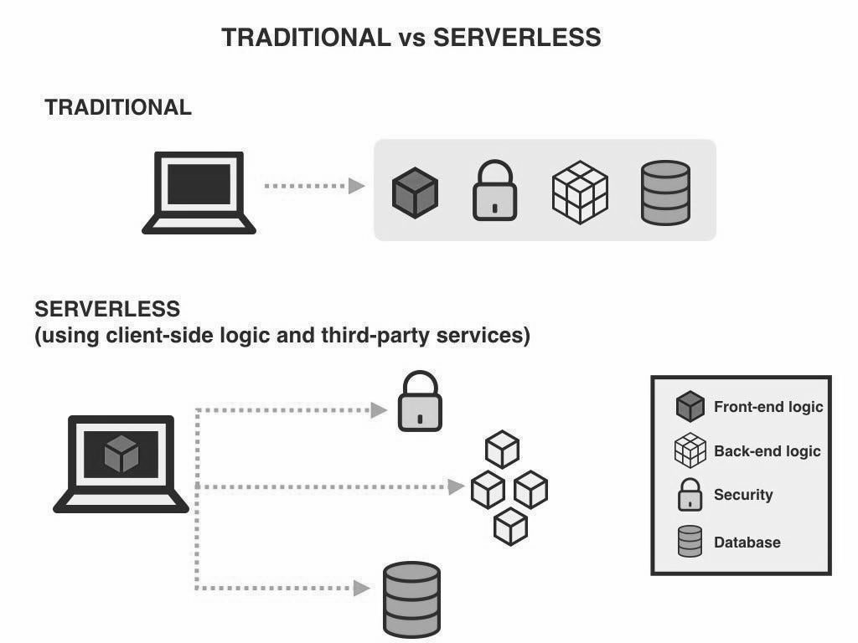

Figure 1. Comparison of traditional Server and Serverless

Traditional server designs entail configuring, maintaining, and managing real or physical servers on which applications work. This involves dealing with issues like as planning for capacity, scalability, patching, and security. It takes a great amount of time, resources, and experience, but it also delivers a high level of environmental control. On the other hand, Serverless architecture is a cloud computing model where the cloud provider manages the servers, allowing developers to focus on writing code. The provider handles scaling automatically and charges only for the compute time used. Although servers are still involved, developers no longer need to manage them. The choice between traditional server and serverless architecture depends on a project's specific needs, with serverless often offering cost savings and efficiency, but traditional servers providing more control.

## Local Related Study

**Effectiveness of the 4Ps**

The effectiveness of the Pantawid Pamilyang Pilipino Program in Tabuk City, Kalinga, was assessed in Busaing's (2020) study by looking at the degree of program objectives achieved, grantee compliance with program requirements, the severity of implementation issues, and performance indicators for health, nutrition, and education. Analysis of the data was done using frequency counts, percentages, weighted averages, and analysis of variance (ANOVA). Data were gathered using a combination of descriptive survey methods, documentary analysis, interviews, and focus group discussions (FGD). The findings demonstrated that the program's goals were mostly met, its requirements were largely followed, and its implementation issues were not as serious. The results of an ANOVA analysis showed that there were no appreciable differences between the perceptions of program objectives, compliance with program conditions, and implementation issues among beneficiaries, implementers, and the community. Furthermore, a documentary analysis of health and nutrition indicators revealed that Pantawid Pamilya children got immunizations, consultation services, and routine weight monitoring, while all pregnant family members cooperated with prenatal appointments and received postpartum follow-up treatment. Higher enrollment rates and regular attendance rates of over 85% each year were the results of strong educational compliance, which was also demonstrated by grantees meeting attendance criteria. Overall, the research finds that despite a few minor implementation issues, the Pantawid Pamilyang Pilipino Program in Tabuk City, Kalinga, has had a favorable impact and that its goals were successfully met because of the high degree of grantee compliance with the program's requirements.

The Pantawid Pamilyang Pilipino Program (4Ps) was shown to have a favorable effect on the household economic position of its recipients in the Philippines. According to the report, the program has improved beneficiary households' income and savings while also assisting in the reduction of poverty. The report also emphasized the need for more effective and efficient delivery systems as well as certain difficulties with the program's targeting of the poorest and most vulnerable households. According to the report, the program might be further enhanced by expanding its coverage to more disadvantaged populations and tightening connections with other social safety programs.

Ramos (2021) conducted a study to evaluate the effectiveness of the Pantawid Pamilyang Pilipino Program (4Ps) on the education and welfare of selected pupil recipients in Rosario, Batangas. The study utilized the descriptive research method and involved grade V and VI pupils and parent-respondents from three large public elementary schools in Rosario East District and three in Rosario West District during the 2020–2021 school year. The study measured the effectiveness of the program based on health, nutritional, and educational welfare indicators and identified constraints faced by the recipients. Statistical analysis of the data was performed using the weighted mean, T-test, and Pearson Product Moment of Correlation Coefficient. The study found a significant difference in the assessment of pupils and parent-respondents regarding the effectiveness of the 4Ps program. Additionally, a significant difference was observed between the assessments of student respondents and parent respondents on the constraints to the effectiveness of the program, and there was a significant negative correlation between health, nutritional, and educational welfare and the constraints on the effectiveness of the program. The study recommended that the Department of Social Welfare and Development (DSWD) enhance the 4P’s PR4Psm in terms of benefits for pupil recipients, increase cash grants for educational welfare, and collaborate with teachers to control family educational expenditures.

In a study conducted by Parreno (2022), the aim was to compare the satisfaction levels of 4Ps beneficiaries in Barangay VI, Victorias City, Negros Occidental, Philippines, between 2015 and 2020. A descriptive comparative research method was used, and the participants were 216 and 250 in 2015 and 2020, respectively, and were official 4Ps beneficiaries in the area during those years. The results were analyzed through frequency, percentage, mean, and T-test. The majority of the participants were female (91.20%), married (77.04%), and above 30 years old (74.89%). The study found an increasing trend in 4Ps parent-beneficiaries in 2020, particularly among those who were widows, single parents or had no work. Moreover, there was a significant difference in the satisfaction level of 4Ps parent-beneficiaries with the CCT program, with higher satisfaction levels in 2020 than in 2015, particularly for health and education grants. Finally, the study recommended the implementation of sustainable programs to improve living conditions and nutrition grants for locals. (Parreno, 2022)

According to Tiu et al. (2022), the 4Ps program is a poverty reduction strategy that provides grants to extremely poor households to improve their health, nutrition, and education, with a focus on children aged 0-14. The program is led by the Department of Social Welfare and Development (DSWD) in collaboration with the Department of Education (DepEd) and the Department of Health (DOH). The study aimed to assess the adequacy of the cash allocation received by the beneficiaries for health, nutrition, and education, as well as the issues they faced during the implementation of the program. The survey technique was used to gather data from 854 beneficiaries in San Francisco, Surigao del Norte. The results showed that the cash grants for health, nutrition, and education were insufficient to cover the actual expenses of the beneficiaries' children in these areas. Delayed cash releases and strict rules and regulations were among the major challenges identified by the beneficiaries. The authors recommended that the DSWD, in collaboration with other lead agencies, should provide entrepreneurial and livelihood training and workshops for beneficiaries to increase their income and sustain their daily needs.

This research aimed to ascertain the perceived elements influencing the academic performance of Apayao State College's Pantawid Pamilyang Pilipino Program (4Ps) beneficiaries. Significantly, perceived factors other than peer factors, such as personal, family, school, teacher, community, and multimedia, can occasionally affect the academic achievement of the 4Ps respondents. This study's findings also show that, except for age, there is a substantial correlation between the respondents' academic achievement and their profile characteristics. However, the student's level of academic performance is only considered satisfactory, so it needs to be raised for him or her to receive higher grades in all of the school's subject areas. The fact that academic success is a multi-factorial variable is further acknowledged; therefore, other issues that impact their academic performance should be addressed before looking into other factors influencing academic performance. (B. Omaweng, 2022).

There is no denying that the Philippines' population lives in a state of poverty. One of the fully operational assistance programs now being administered by the Department of Social Welfare and Development (DSWD) and backed by other government agencies is the Pantawid Pamilyang Pilipino Program (4Ps). To acquire relevant information about the parents of 91 Pantawid Pamilyang Pilipino Program recipients who are currently enrolled at Talumpok Integrated School, a descriptive survey method was used. The primary data collection tool was a questionnaire, which was augmented by an interview with the aid of an interview guide. To determine the degree of frequency of the items in the demographic profile of the respondents, the statistical tools of frequency, percent, and rank were used to analyze the data collected. The analysis revealed that beneficiaries were eligible since they satisfied the program's conditions. Regarding the assistance that 4Ps provides to its beneficiaries in the areas of parenting and home management, health and nutrition, and education, it is judged to be very well given and seen as parallel to and in line with 4Ps' objectives. Parenting and household management, health and nutrition, and education are widely implemented. This demonstrates the effectiveness of the 4Ps in promoting social welfare and beneficiary development. The amount of 4P implementation and support is highly correlated with social welfare and development. However, some of the issues raised by 4P beneficiaries only address the differences in cash grants and cause delays in transactions. The underlying issues that keep beneficiaries' dependents on the program are still unaddressed. The improvement of 4Ps project, which calls for the highest level of participation from school staff, parents, and 4Ps community leaders, was provided as a roadmap for beneficiaries and 4Ps to strengthen its execution (Aguado, 2021).

This study evaluates the Pantawid Pamilyang Pilipino Program's (4Ps) implementation, concentrating on the evaluation of participants' health and educational statuses and identifying programmatic issues. The study examined two unpublished and eleven published beneficiary assessments from 2015 to 2020. The results indicate that the program was successful in achieving its goals in terms of health and education, but there were difficulties in obtaining help, financial literacy, and beneficiaries' lack of eligibility or comprehension of the 4Ps. Overall, the study emphasizes how critical it is to evaluate the efficacy and effects of programs like the 4Ps on the lives of participants.

Since community service is one of the requirements of universities, they are well known for offering extension programs to the communities they have adopted. Planning, needs assessment, implementation, and evaluation are all part of these programs. The majority of training evaluations, however, have merely examined the facilitators, setting, and manner of a certain session. In this essay, the university library's extension program for division office librarians and library assistants from a chosen partner community is evaluated. To assess the success of the outreach effort, the study used a descriptive survey research design. To respond to the instrument created by the researchers, the participants were specifically chosen. Data were gathered on the participants' level of learning and how they applied it to their libraries. The findings indicate that while the participants had learned the fundamentals of library and information science, their use of these abilities in their libraries was weak. The study aims to add to the body of knowledge on the local context's implementation and impact evaluation of library-initiated programs. The results are expected to inform potential directions for future extension programs and act as a launchpad for the university library's future outreach initiatives. It is advised that more research be done to improve the viability of library outreach initiatives (B. Antonio & Advincula, 2020).

The goal of this phenomenological study was to examine the lived experiences of former Pantawid Pamilyang Pilipino Program (4Ps) student-beneficiaries, using Human Capital Theory (1990), Social Capital Theory (1988), and The Concept of Experience by John Dewey (1934) as the foundational theories. The study adhered to the phenomenological research model principles and procedures put forward by Giorgi (2019), which allowed participants to share their views and personal viewpoints on their experiences. The study discovered three themes based on the unique experiences of 4Ps recipients: financial distress, psychological distress, and financial security. In addition, the study found three themes based on participants' personal histories and core values as past 4Ps recipients, namely reduced poverty, spiritual growth, and social growth, and two themes based on co-researchers’ reflections on their lives after participating in the 4Ps, namely improved confidence and academic achievement. The findings may contribute to enhancing the 4Ps program and improving the experiences of its recipients (Pineda & Fabella, 2019).

## Local Related System

**Web-Based Monitoring System**

The study was carried out by Jun Brian P. Tubongbanua, Kwency Maye V. Dahilan, Kayepril Georgette A. Sagun, and Jherex L. Ruiz (2019) and is titled "The Web-Based Information and Monitoring System of the Cagayan de Oro City Academy for International Education's Web-Based Information and Monitoring System." It is intended to give the Cagayan de Oro Academy for International Education access to a web-based information and monitoring system that can handle school-related transactions. A complicated, adaptable system for online information and monitoring is built to satisfy specific needs. The researchers used the prototyping life cycle model to create the suggested system. These programs enhanced the established transaction processing frameworks. According to Jonas Olandria, Evangeline Olandria, Alma Mae Bernales, Epifelward Nino Amora, and Rennan Camoguis (2020), the web-based attendance tracking system was developed to keep track of students' attendance during the school day. Days in school are indicated in this project through the student ID card. Once the terminal has been tapped, the gateway shows the student profile. The portal now has a section for them in addition to sending announcements through SMS. Additionally, it has a dashboard on the admin panel with reports presented in a graphical format for simple system monitoring, along with full wireless computing capabilities.

Web-based barangay information system. The researchers developed a web-based barangay information system that automated the management of barangay households, commodities, and population as well as establish geo-tagging of items and goods for barangays. Locating the goods offered by the barangay is done by using the Google Map API. The system's goal was to create a web-based information system for the barangays of Malita, Davao Oriental. One of the system's goals is to populate barangay data so that it can be accessed on the municipal webpage to track changes in the number of houses, goods, and people for quick response. (Iteit Spamast-Malita, 2020).

Barangay management system that is EB-based. The barangay management information system, according to MuhADINI (2020), is a program that has functions for managing and recording information as well as sending papers from the barangay hall to the city hall. It is a web-based tool for barangays that offers content that instructs and demonstrates how they handle their issues with manual data manipulation; it is made to encourage us to utilize automated systems.

The Person with Disability (PWD) Information System, based on inettutor.com (2020), is a monitoring and records-management system developed primarily to maintain the profile of PWD in each barangay throughout the city. The current method of profiling is carried out by the barangay and sent to the city office for record consolidation; however, respondents claimed that this procedure takes a long time and that record organization is challenging. The researchers developed a project that most likely resolve the concerns brought up by the respondents based on those issues.

The Rapid Earthquake Damage Assessment System (REDAS) software was used to estimate the earthquake impacts (physical damage, economic loss, and fatalities) on selected barangays in Davao City from a 1924-scenario magnitude 8.3 earthquake. This paper discusses the methodology used and the results that were obtained. The impact assessment tool in REDAS' most recent module is related to a project financed by DOST, PCIEERD, and CHED to train state universities and colleges (SUCs) in conducting impact risk assessments. REDAS was created by DOST-PHIVOLCS. Regions II, III, and XI received assistance. Universities participating in Region XI include USEP, which is the principal agency; UP-MINDANAO; DOSCST; SPAMAST; and DNSC. It was intended that these SUCs would eventually serve as local mentors in the area. Additionally, this research project addressed the necessity of planning for disaster preparedness and emergency response, enforcing the building code, and retrofitting crucial structures to support policymakers. Its main goal was to use the REDAS software, which was developed expressly to create an earthquake exposure database and assess earthquake risks, impacts, and losses, to predict earthquake risk. The distribution of buildings at the barangay level, the availability of fragility and susceptibility curves, and the magnitude of ground shaking from a certain earthquake scenario were all important factors in the impact assessment. In terms of building attributes, geographic coordinates, and population, all calculations were based on an actual survey of a few piloted barangays in Davao City. (De Vera et al., 2019)

This study created and approved a general chemistry web-based self-assessment tool (WebSAT). The WebSAT is a cutting-edge self-evaluation tool for college students that offers customized questions and study programs, automatic grading and fast feedback, and direct engagement with the subject on computers and mobile devices. The WebSAT now includes a feature that lets students review their work for accuracy and submit their responses again. The system made use of MySQL as the database, PHP as the programming language, and Adobe Dreamweaver as the Integrated Environment Development (IDE). The WebSAT was assessed by IT professionals, chemistry instructors, and students using quantitative and qualitative methodologies, and it was determined to be useful as a formative assessment tool. They found that it was simpler to use than the typical self-assessment instrument because of its versatility and rapid feedback. It applies to various courses and is appreciated by IT professionals and educators. Students who took the WebSAT said they were more motivated to succeed in the course. The outcome demonstrated that using WebSAT resulted in a substantial difference between the pre-test and post-test. The post-test results showed that the information was highly efficient. (L. De Castro et al., 2017)

Magsasaka Siyentista (MS)-Led Community-Based Banana Farming was an initiative in Davao Oriental that aimed to address issues in the banana industry after Typhoon Pablo. The study aimed to determine the project's effectiveness on economic, physical, and behavioral factors using questionnaires, interviews, and focus group discussions. The research involved 26 farmers from Tarragona, Cateel, and Boston. The project had a positive impact on the farmers' physical, economic, and behavioral aspects. The study found that the project resulted in changes in land preparation, farm management, and adherence to good agricultural practices. Economic effects could be seen in farmers' monthly net profit. Additionally, the study demonstrated that active monitoring and inspection could alter farmers' behaviors, causing physical and economic changes in farming communities. During the project's implementation, issues like pest infestations, weather conditions, and the sale of harvested bananas were encountered. The study recommends replicating this type of project in other areas due to its positive effects (F. Teoxon & Sumile, 2020).

The study aimed to evaluate the management information system in a provincial hospital as it stands right now. It centered on identifying the condition of the hospital's information systems, their level of quality, and the issues that the seven medical care divisions were facing. Additionally, it identified the stark disparity in information service quality between the seven medical service sections. This study included both qualitative and quantitative data and was essentially a descriptive assessment of an institutional study. The 40 medical professionals were included using a universal sample method. According to the findings, all seven sectors were only moderately efficient when it came to the eight hospital information processes. The outpatient sector was rated very well in terms of correctness, completeness, and sufficiency, while the other six sections were rated well in terms of implementing the eight hospital information processes. The records section's quality and timeliness were inadequate, but the other sections were praised for their excellence. The hospital's current information system was plagued by a wide range of issues, which could be divided into hospital information procedures and other issues like facilities, finances, systems, training, and people (both patients and staff). The quality of information services in the various medical care dimensions varied significantly. The results showed the benefits of using an integrated hospital information system (FICS, M.D. Harris D. Macapagal, 2019).

The Philippines' placement within the Pacific Ring of Fire puts its infrastructure in danger of destruction from significant earthquakes. Public schools are among the most vulnerable institutions and are crucial because they provide emergency services and education, among other crucial societal tasks. The emphasis of this study is Sta. Pasig's Lucia High School, which is close to the West Valley Fault, is situated there. The major goals of this study are to generate the seismic fragility curve of the building using the capacity-spectrum approach and to apply the Safer Communities through Safer Schools (SCOSSO) program for quick visual inspections. Since the building's assessed seismic susceptibility was 66%, the researchers completed a quick but thorough evaluation of the BCE II building following the requirements of the SCOSSO program. The capacity spectrum method was used to construct the structural plan of the building in SAP 2000 and subject it to 20 ground motions to generate fragility curves. According to the analysis, the building would become completely damaged at a PGA of 0.352 g or higher, with a chance of more than 10%, and this would happen along the building's weaker axis along the north-south direction of the earthquake along the x-axis. The fragility curves show that the probability of a building falling increases with peak ground acceleration (Baylon et al., 2021).

Educators use students' standardized test scores to assess the effectiveness of instructional initiatives aimed at promoting student accomplishment. Thus, data-driven decision-making is critical in policy formulation and the development of interventions to address educational gaps. The purpose of this research is to assure the accuracy and validity of consolidated assessment data and to give suitable responses through the use of checking and analytic software programs. A descriptive quantitative design was adopted in the investigation. A questionnaire was distributed to participants regarding their perceptions and reflections on the usage of software applications in assessment for the 2018–2019 school year. The study was limited to the software application's effectiveness in terms of inspecting, scoring, recording, organizing, analyzing, and reporting assessment data. The results reveal that assessment software applications outperform traditional assessment techniques in terms of a) providing accurate and reliable data, b) cost-effectiveness, c) flexibility in organizing and analyzing data, and d) speed of providing feedback. The study emphasized the significance of teachers adapting to evolving technology, notably software that may aid them not just in evaluation but also in instruction. As a recommendation, municipal policies on digital evaluation should be developed (Palanas et al., 2019).

In the study "Plea Bargaining in Drug Cases: Its Impact on the Criminal Justice System," researchers attempted to assess the consequences of plea bargaining in drug cases on the criminal justice system. Purposive sampling was used in the study to pick respondents from the six groups that comprise the criminal justice system. The judges of Lipa City's Regional Trial Courts were also polled using convenience sampling. To collect data from barangay officials and inmates or former detainees, the researchers employed a self-created questionnaire and structured interviews. According to the statistics, there is a substantial disparity in how the pillars of the criminal justice system view plea bargaining. The study discovered a substantial association between the respondents' age, pillar, and length of service profile and their evaluation of the influence of plea bargaining on the protection of innocent, guilty, and social values. Gender, on the other hand, had no significant link with their rating. Plea bargaining, according to former and current detainees, impairs the protection of innocent, guilty, and societal principles. They also argued that the negotiating mechanism fails to identify whether defendants are guilty of the crime charged, and that the outcome of the negotiation is contingent on personal characteristics or financial resources. The community was also harmed by plea bargaining, as aiding early release and reintegrating them into society with no prior rehabilitation was viewed as the most detrimental outcome. The prosecution pillar agreed that plea bargaining weakens the protection of the guilty and societal standards, but the court pillar strongly disagreed. However, the court agreed that plea bargaining increases the possibility of convicts committing new offenses. The report emphasizes that any weakness in the pillars of the criminal justice system might lead to the collapse of the entire system (Surban et al., 2018).

One of the best agricultural industries in the Philippines, the banana business has grown to support local Filipino farmers and provide foreign exchange for the nation. The National Economic Development Authority (NEDA) listed the applicability of particular fertilizers on land and soil classes for types of bananas as one of its priorities in its Regional Research Agenda 2011–2016. Researchers discovered that the Bureau of Soils and Water Management's agriculturalists manually calculate the recommended fertilizer rate for a particular crop. By automating the computing process for fertilizer suggestions, the project seeks to produce a web-based decision support application to help agriculturalists determine the precise amount of fertilizer to use. The algorithm for computation is the generic formula provided by the Bureau of Soils and Water Management (BSWM). The number of hands and fingers to be gathered as well as the number of banana herbs to sow are predicted using a decision support system. The study used a descriptive development method using an iterative process model. Utilizing PHP Laravel 5.3, the semaphore API for the SMS feature, and a black box for testing procedures, the application was created (Barrios, 2018).

## Foreign-Related Studies

**Monitoring**

Mangrove mapping and monitoring using GIS and remote sensing: Making successful management decisions and protection measures requires an understanding of mangrove distribution and change. Geographic information systems (GIS) have been extensively employed in studies on mangrove change in Malaysia to define and track mangrove development over a variety of geographical and temporal dimensions. The mangroves have been mapped, and the lost mangroves have been tracked. (Hamdan Omar, Samsudin Musa, and Muhamad Afizzul Misman, 2019)**.**

According to Mardeni (2020), the data on pregnant women is being gathered as part of the Birth Planning and Complication Prevention (P4K) Program at the Riau Provincial Health Office. This information system for monitoring pregnant mothers is part of the Riau Province Health Office. The data collection for pregnant women in the 12 regencies and cities of Riau Province includes information on the population, tabulin, transportation, blood donors, support for pregnant women, and birth assistance programs. Pregnant women's reports and data are still manually entered into Excel. A web-based health monitoring system for expectant mothers was designed to make it simpler for Riau officials.

The study conducted in 2020, titled "Impact Assessment of Outcome-Based Approach in Engineering Education in India," investigates the impact of the adoption of outcome-based education in Indian engineering education in recent years. Outcome-based education shifts the focus from a teacher-centered to a student-centered approach to teaching and learning, and it has been practiced globally since the 1990s. India adopted this approach after ratifying the Washington Accord, and it is now a requirement for certification by the National Board of Certification (NBA), which oversees engineering education quality in the country. While the implementation of outcome-based education in engineering programs in India resulted in positive outcomes, it remains unclear if the faculty members are prepared to incorporate this method. The study, which was conducted through a survey, concludes that the idea of outcome-based education is gaining popularity in engineering education in India, but there is a need for further training in some areas (Jadhav et al., 2020).

According to Kross et al. (2022), the agriculture industry is essential for global food security and the economy, but its practices, such as forest and wetland clearing, water management, and the use of fertilizers and pesticides, are among the significant contributors to environmental degradation and global warming. To address this, the authors propose a geospatial framework that utilizes agri-environmental impact indicators and the environmental impact assessment (EIA) method to systematically assess and monitor the environmental impacts of agricultural practices. The framework employs geospatial approaches for each of the four key phases of the EIA method: screening, scoping, impact prediction and assessment, and impact management. monitoring, and follow-up. The authors show how remote sensing and geospatial methods, such as mapping, spectral indices, multi-criteria decision analysis, and GIS watershed analysis, can be utilized in the different EIA phases. The framework can assess impacts at flexible spatial and temporal scales and integrate existing programs in Canada, such as environmental farm plans and agri-environmental indicators. The framework can be used by various stakeholders, including farmers, farmer organizations, environmental agencies, and consultancies, as well as provincial, territorial, and federal agencies.

In Bradley et al.'s (2022) study, the authors aimed to assess the value and purpose of entrustable professional activities (EPA) in student learning by implementing a framework and matrix in a Sport and Exercise Sciences module for undergraduates. Data were collected through questionnaires and focus group interviews and analyzed using content and thematic analysis, as well as statistical analyses and cluster analysis, to identify commonalities in perceptions. The results indicated that students had a positive perception of the matrix and found it easy to understand, with clearly distinguished statements that were appropriately aligned with the profession. The authors concluded that EPAs provide a well-structured and user-friendly tool to aid in student professional development with minimal barriers to their application in practice.

The monitoring of the general education system's quality evaluation models in the Russian Federation's parts is the main subject of this study. Using content analysis and professional review, the writers assessed 85 normative documents (Chudinsky et al., 2022). Only 23.5% of the entities, they discovered, had high-quality assessment models. To enhance data collection and analysis, an information system was created. To raise the standard of general education in the Russian Federation and establish a unified educational environment, the authors concluded that significant revisions to the governing documents were required.

According to Osiesi (2023), continuous assessment, monitoring, and evaluation of teaching and learning processes in primary schools in Nigeria are crucial to keeping teachers and learners informed of their teaching and learning outcomes. The paper evaluates the importance of assessment, monitoring, and evaluation of teaching and learning processes in Nigeria's primary schools and the numerous challenges that prevent their successful implementation at this level. The author identifies the implications of these challenges, particularly for teachers. The study concludes that to enhance, improve, and ensure sustainable teaching-learning interventions, effective and efficient assessment, monitoring, and evaluation practices should be implemented and sustained regularly in all primary schools. The paper recommends that the challenges impeding the assessment, monitoring, and evaluation of teaching and learning in Nigeria's primary schools be fully addressed.

According to Ribeiro et al. (2021), a software tool called Trial Monitor was developed to assist human-computer interaction researchers in creating personalized web dashboards to monitor participants in technology-enabled field trials. This tool aims to support researchers in monitoring participants' usage patterns remotely using self-report scales, sensors, or application usage logs. The software requires minimal configuration files from researchers or developers, and it generates individualized web dashboards, saving time for researchers who would have otherwise implemented different dashboards for each system evaluated in a field trial study.

According to Chen et al. (2022), learning-oriented education has been a global educational reform concern for a long time, but there is still a lack of suitable assessment tools. The purpose of this study is twofold: firstly, to develop indicators for monitoring learning-oriented school education, and secondly, to use these indicators to assess how learning-oriented education has been implemented in Taiwan. To construct the indicators, the researchers developed a preliminary model based on relevant literature and consulted experts to finalize the model. The researchers then collected 454 valid samples from 48 schools to evaluate how the importance-performance analysis data can identify the strengths and weaknesses of a school's learning-oriented education and provide recommendations for effective leadership in school improvement. The findings suggest that an indicator system for learning-oriented school education should comprise seven dimensions and 34 indicators, with "student learning" and "curriculum planning and implementation" being the most important but underperforming dimensions that need immediate attention.

The epidemic of Covid 19 has had a tremendous impact on engineering education. especially the important stakeholders, namely faculty and students. E-learning has a variety of advantages and disadvantages. This research examines online education during the pandemic and its impact on faculty. An online survey of 150 engineering faculties from diverse branches at Shivaji University was performed to address various e-learning concerns. The faculty responses were evaluated, and substantial results were achieved. The principal component analysis (PCA) approach is used in the analysis. The insights and lessons learned from this effort helped engineering faculties improve the e-learning platform and solve numerous problems. The article examines the pedagogical, personal, and social effects of online education on faculty and makes significant recommendations for long-term adoption. Modes of operation include offline and online (Kalkhambkar & Gaikwad, 2023).

## Related Foreign Systems

**Monitoring**

According to Havrda and Klocek (2023), there has been a recent evaluation of the impact of artificial intelligence (AI) on well-being through the use of a well-being impact assessment approach. This approach incorporates pre-existing frameworks and tools to assess both the positive and unintended negative consequences of AI on well-being while considering the multidimensional nature of well-being. Nonetheless, establishing causal relationships between the operation of AI systems and their observed effects is challenging due to the immense complexity of the socio-technical context. To address this issue, the authors propose a framework for determining the attribution of AI's observed impact on well-being and introduce a new Open Platform for Well-Being Impact Assessment of AI Systems (OPIA). The OPIA platform, which is based on a distributed community, can create reproducible evidence by effectively identifying, refining, iteratively testing, and cross-validating expected causal structures. This article presents a comprehensive approach to impact assessment that has the potential to facilitate causal inferences. The suggested platform could aid in establishing causal relationships between the operation of AI systems and their impact on well-being.

According to Sriwichian, Boonjing, Nillaor, and Muangprathub (2019), the increase in the aging population has transformed many countries into elderly societies. leading to extensive effects on society and the elderly. To address the challenges faced by the elderly, it is necessary to first understand their mental health and quality of life. The study aims to develop a web-based GIS system to monitor the quality of life of the elderly and store their data. The system utilizes GIS technology to collect data on all elderly individuals residing in the four villages of Moo 5, 6, 7, and 8. The system was implemented for 240 individuals in these villages. (Sriwichian et al., 2019).

A study by O. Amora et al. (2020) developed a wireless attendance monitoring system to track students' attendance in school. This technology consists of a terminal that scans student ID cards and a website that displays student profiles. The system also includes a portal section for delivering SMS announcements and a dashboard that presents reports in a graphical format to facilitate system monitoring. An admin panel with complete wireless computing capabilities is also provided. The project utilized various technologies such as the Raspberry Pi, database server, RFID reader, Arduino NMCU, Python, PHP, MySQL, Bootstrap, and CSS.

According to John Wiley & Sons Australia (2023), a comprehensive study of the published literature between the years 2016 and 2021 across six databases was conducted to examine the adoption of AI- and ML-based decision support systems in mental health care settings. The main motif found was confidence and trust. There hasn't been much study done yet on AI-based decision assistance systems for mental health. According to our analysis, there are major obstacles to its adoption into practice, most of which are brought on by a lack of clarity regarding end users' acceptability, clinicians' trust, and system transparency. Understanding the effect of AI on facilitating treatment and recognizing missing care requires more investigation. Researchers and developers must concentrate on building confidence and trust (Higgins et al., 2023).

According to [Brielle](https://link.springer.com/article/10.1007/s00146-022-01618-5#auth-Brielle-Lillywhite) Lillywhite and [Gregor](https://link.springer.com/article/10.1007/s00146-022-01618-5#auth-Gregor-Wolbring) Wolbring, AI and ML increasingly impact humans' ability to have a good life. Various sets of indicators exist to measure well-being and the ability to have a good life. Students play an important role in AI and ML discussions. The purpose of our study using an online survey was to learn about the perspectives of undergraduate STEM students on the impact of AI and ML on well-being and the ability to have a good life. Our study revealed that many of the ability’s participants perceived as needed for having a good life were part of the well-being and ability to have a good life indicator lists, we gave to participants. Participants perceived AI and ML to have and continue to have the most positive impact on the ability to have a good life for disabled people, elderly people, and individuals with a high income, and the least positive impact for people of low income and countries from the global south. Regarding indicators of well-being and the ability to have a good life given to participants, we found a significant techno-positive sentiment. 30% of respondents selected the purely positive box for 28 of the indicators, and none did so for the purely negative box. For 52 indicators, the purely negative was below 10% (not counting the 0%), and for 10 indicators, none were selected as purely negative. Our findings suggest that our questions might be valuable tools to develop an inventory of STEM and other students’ perspectives on the implications of AI and ML on the ability to have a good life (Lillywhite & Wolbring, 2023).

In this study, user satisfaction with an integrated financial information system used to analyze the success of the adaptive model. The 612 parties responsible for running the local financial information system made up the study's population. Saturated samples are used in the sampling method. For the SEM methods, the Smart Partial Least Squares (PLS) application was utilized for data processing. The findings indicated that: Partially, the reliability of information systems, organizational support, benefits, user behavior, and use of the intention to use the local government in North Sumatra; Partially, the reliability of information systems; Partially, the reliability of information systems; Partially, the reliability of information systems; Partially, the reliability of information systems (Nasution et al., 2022).

This study aims to experimentally investigate how user satisfaction with accounting information systems is influenced by the quality of information systems, information, and services. The research developed by Gable, Sedera, and T (2008) and the model updated by DeLone & McLean (2003) were utilized to evaluate the succession of accounting information systems. The information was gathered via questionnaires that were distributed to 84 respondents who used the accounting information system software (SIMDA/SIPKD) and worked as analysts in local governments in the West Java Province. The SPSS application was used to perform a multiple regression analysis of the data. The findings indicate that user satisfaction with accounting information systems is significantly and partially positively influenced by the variables' quality (Ritchi et al., 2021).

In the age of big data and the Internet of Things, computer information systems are essential for all types of companies, including higher education institutions (HEIs). The Lecturer Information System (LIS) is one such system. Based on system quality, information quality, and user happiness, this article evaluates the success of the LIS at UC TATI, a HEI in Malaysia. Academic faculty members were given access to an online survey that was being conducted. The Statistics Package for Social Sciences was used to load the results for analysis. The validity and dependability of the employed metrics were evaluated. The data was analyzed using descriptive statistics and reliability analysis. Results have shown that the method for assessing IS success is workable. Additionally, positive results from empirical analysis have been found in terms of system success, information quality, user satisfaction, and system quality (Wan Othman et al., 2022).

Several studies have focused on technology adoption in Western countries while disregarding the Arab world. The studies that have been conducted in the Arab world have concentrated on the Technology Adoption Model (TAM) and its revisions, ignoring crucial elements like information quality, user participation, accessibility of training, and top management support for the success of information systems (IS). However, this research developed a more comprehensive model of IS success that examined the efficiency of the organization in an Arabic context and identified four essential success elements for IS. Information system success is influenced by three organizational variables (management support, training, and user involvement) and one information system factor (information quality). The study revealed that information quality played a first-ever role in mediating the impact of the three organizations (Rouibah et al., 2020).

The enterprise resource planning (ERP) system is the most critical tool for integrating businesses and implementing the "once only" principle in data entry. This system can improve resource efficiency, many organizational processes, and capabilities, ultimately enhancing business performance. This study focuses on the quality of the ERP system as a dynamic capability of the company, contributing to business performance. The research incorporates theoretical methods to represent the characteristics of the ERP system using primary data obtained through a survey method in a developing nation. The study found a positive relationship between the quality of the ERP system and both forms of organizational business performance, indicating that information service quality is crucial (Commodore et al., 2022).

Positive psychological treatments (PPIs) have been proven in numerous studies to be effective in promoting psychological well-being (PWB). Only a few studies have examined the efficacy of these interventions in older adults, and they have infrequently taken into account an active control group, even though clinical settings have seen encouraging results. Furthermore, the PWB training's effects on quality of life (QoL) and untrained cognitive abilities have never been taken into account. According to the results of this pilot study, PWB training can be beneficial for older people and have a good generalization effect on cognition (WM). The need for creating PPIs that are specific to the needs and resources of older individuals is the main topic of debate (Cantarella et al., 2017).

Strategic environmental assessment (SEA) is becoming a crucial tool for transitions toward sustainability. However, there hasn't been much research done on transition-based SEA. If SEA's main objective is an evaluation methodology that can help with strategic change and direct decision-making toward sustainability that takes into account the various relationships and elements that affect transition processes, this seems very pertinent. The transitions-based SEA design is a method for SEA that is advanced in this study. centered on the institutional setting and governmental framework for the creation of strategic initiatives, including opportunities, enabling laws, and institutional commitments. Within this context, we discuss energy transitions, linking theories of strategic planning, judgment, and transition management.

Building on existing SEA frameworks, the paper describes the essential SEA frameworks that support strategic thinking. A transition-based SEA design should adhere to a few rules and raise a few strategic questions. The building was developed after reviewing the literature on SEA and sustainable transitions and consulting with experts. Transition-based SEA design should adhere to a few rules and raise a few strategic questions. The building was developed after reviewing the literature on SEA and sustainable transitions and consulting with experts. The institutional environment, the overarching transitional vision, and the SEA design are at the center of governance frameworks, the advantages and disadvantages of specified sustainable development paths, and indications of progress to manage the external landscape's effects and constant shift. The framework lays out how to stretch the boundaries of what SEA can and should do overall with new features. A strategic evaluation tool challenges traditional thinking and practice beyond its applicability. programs, techniques, and policies (Nwanekezie et al., 2021).

## Conceptual Framework

Figure 2. Illustrate the conceptual framework of Itrack4Ps: Monitoring system in Mabini Batangas.

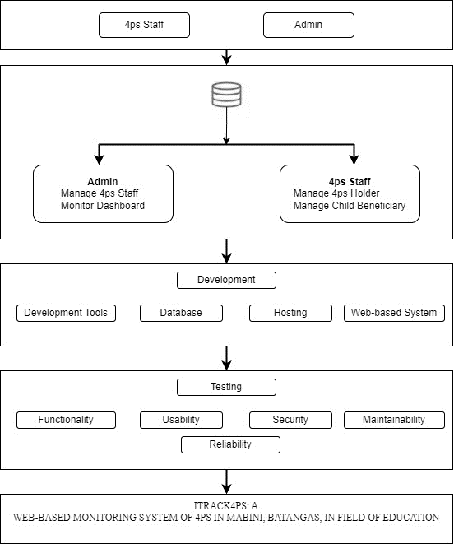

Figure 2. Conceptual Framework

The ITrack4Ps: Monitoring System in Mabini Batangas comprises a complete approach to monitoring and administering the government's 4Ps initiative in the region. Various crucial variables, such as the number of 4P holders and beneficiary children are tracked under the framework. The system also keeps track of beneficiary courses, allowing for a complete picture of the program's influence on the community. The graphical representation aspect aids visual interpretation, giving stakeholders clear insights on beneficiary distribution and progress. This improves not only decision-making but also transparency and accountability in the administration of social welfare programs.

The development phase defines the tools and infrastructure required for the monitoring system's effective implementation. This involves identifying the development tools used, the database architecture for storing beneficiary information, the web-based system's hosting platform, and the technology supporting seamless development. The testing process is similarly important, as it includes examinations of functionality, usability, security, maintainability, and reliability. Usability testing focuses on user experience, whereas functionality testing assures that the system works as intended. Security measures are put in place to protect sensitive beneficiary data, and maintainability and reliability testing are critical for long-term system sustainability, ensuring that the monitoring system is effective and reliable throughout its existence. This thorough conceptual framework ensures a solid and dependable foundation for the successful implementation of the ITrack4Ps system in your organization.

## Synthesis

According to the study conducted by Tiu et al. (2022), the program is led by the Department of Social Welfare and Development (DSWD) in collaboration with the Department of Education (DepEd) and the Department of Health (DOH), and it is similar to the developed system in that it provides grants to extremely poor households to improve their health, nutrition, and education, with a focus on children.

According to the study conducted by Nasution et al., 2022, user satisfaction with an integrated financial information system used to analyze the success of the adaptive model. The 612 parties responsible for running the local financial information system made up the study's population. Saturated samples are used in the sampling method. For the SEM methods, the Smart Partial Least Squares (PLS) application was utilized for data processing. It is similar to the system that we conducted because it also monitors the users and can handle a lot of data like for beneficiaries who go to school and register in this system. It automatically save and surely be safe.

Based on the study conducted by Jun Brian P. Tubongbanua, Kwency Maye V. Dahilan, Kayepril Georgette A. Sagun, and Jherex L. Ruiz (2018), "The Web-Based Information and Monitoring System of the Cagayan de Oro City Academy for International Education's Web-Based Information and Monitoring System”. It is similar to the developed system because it is intended to give the Cagayan de Oro Academy for International Education access to a web-based information and monitoring system that can handle school-related transactions. A complicated, adaptable system for online information and monitoring is built to satisfy specific needs. Identifying whether a student is a beneficiary or not is simple. This is due to the fact that only those who have been granted permission to use the 4Ps program are allowed to register using the form. It is easier for the school's registration process to identify 4Ps program participants.

According to Jonas Olandria, Evangeline Olandria, Alma Mae Bernales, Epifelward Nino Amora, and Rennan Camoguis (2020), the web-based attendance tracking system was developed to keep track of students' attendance during the school day. It is similar to the system that we conducted because it is both monitoring student attendance and outcomes effectively. Just like the system we implemented, which monitors students who continue to college after senior high and those whose students have work right after graduation,

According to the study conducted by Osiesi (2023), continuous assessment, monitoring, and evaluation of teaching and learning processes in primary schools in Nigeria are crucial to keeping teachers and learners informed of their teaching and learning outcomes. This study is similar to the developed system because this paper evaluates the importance of assessment, monitoring, and evaluation of teaching and learning processes in Nigeria's primary schools and the numerous challenges that prevent their successful implementation at this level. The author identifies the implications of these challenges, particularly for teachers.

# Chapter III

## DESIGN AND METHODOLOGY

This chapter describes the conceptual design and system architecture of the system. The data set that the researchers gathered was evaluated and analyzed to provide the expected output as stated in the objectives of the study. The methodology that was used in developing the system is discussed in this chapter.

## Software Development Model

The study was developed using the Agile Model, as depicted in Figure 3. Agile is a project management methodology that prioritizes collaboration, flexibility, continuous improvement, and high-quality results. The Agile Model consists of five phases: requirements analysis, design, development, testing, and implementation.

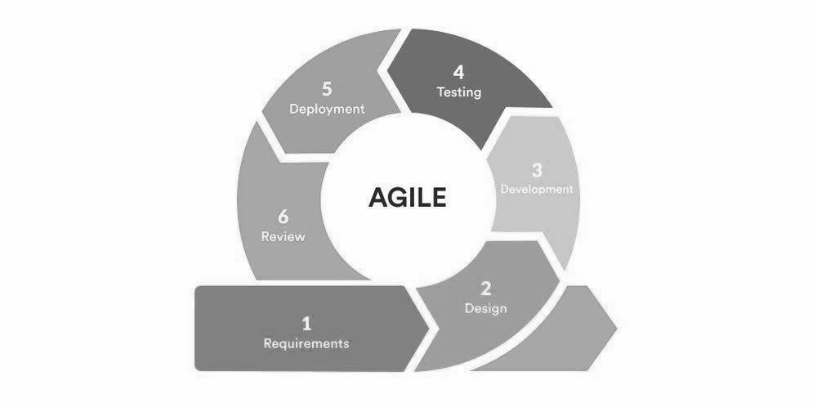

Figure 3. Agile Model

In operating the iTrack4PS system, Agile methodologies, particularly the Scrum framework, are instrumental. The process commences with the breakdown of detailed functional requirements into user stories, encapsulating specific functionalities from the perspectives of administrators and 4Ps staff. These user stories collectively form the product backlog, serving as a dynamic guide throughout the system's operational phase.

The operational phase is structured into time-boxed iterations, or sprints, each lasting 2-4 weeks. Sprint planning meetings inaugurate each sprint, during which the development team selects user stories from the product backlog to address. Daily stand-up meetings facilitate regular communication, enabling the team to discuss operational progress, challenges, and plans. Continuous integration and testing practices remain integrated to maintain the reliability and quality of the operational product. At the conclusion of each operational sprint, a review unfolds, presenting the accomplished operational work to stakeholders, including the Municipal Link, who represents the client. This iterative feedback loop ensures the operational product closely aligns with the needs and expectations of end-users. Operational retrospectives provide the development team with opportunities for self-reflection, nurturing a culture of continuous improvement.

Collaboration between the operating team and the Municipal Link is a key component. Regular client involvement ensures that their feedback guides any incremental refinements or adjustments to the operational system. The Agile approach, known for its adaptability, allows the team to respond to emerging operational needs and prioritize features based on their significance, ensuring the ongoing delivery of valuable functionalities. Documentation is meticulously maintained to provide clarity and serve as a reference for the operational team and future users. Through the ongoing application of Agile methodologies, the iTrack4PS system is designed to embody flexibility, responsiveness, and a continuous enhancement cycle, ensuring it adeptly fulfills the evolving needs of the education monitoring system in Mabini, Batangas.

## Requirements Analysis

This is where the problem was assessed in order to determine the requirements for developing the system’s features. The researchers collected data for the process of allocating an impact assessment that the 4Ps in Mabini currently have and found out that they are still using manual service, resulting in a slow-paced process that makes it hard for the beneficiary to fill out forms. That being the case, this system was able to automate the said process for the Municipality of Mabini, resulting in a faster pace of operation.

## Analysis of the existing system

The existing method to monitoring 4Ps beneficiaries in the field of education in Mabini, Batangas, utilizes manual processes employing Excel spreadsheets. The municipal link, who is in charge of coordinating this effort, physically visits each school, distributing and collecting monitoring forms. Despite the use of Excel as a tool, the process is devoid of a specific impact assessment system, relying instead on human data entry and spreadsheet maintenance.

While Excel provides a digital platform for data organizing, the whole process remains time-consuming and prone to inefficiencies. The lack of a more streamlined and automated approach complicates rapid data display and analysis. The use of manual techniques and Excel creates complications and increases the time and effort necessary to adequately synthesize and understand the collected data. Given these constraints, there is a chance to investigate more advanced and integrated monitoring methods that can improve the efficiency and accuracy of tracking 4Ps beneficiaries in Mabini, Batangas. A system like this might provide a consolidated platform for data collecting, analysis, and reporting, allowing for a more streamlined and effective monitoring process for the municipality's education-related programs.

## Fish Bone Analysis

The manual monitoring system for the 4Ps in Mabini, Batangas, presents difficulties in terms of precision, effectiveness, and flexibility. Timely decision-making and progress tracking are impeded by data input errors and labor-intensive processes. The absence of a digital platform hampers the ability to adjust to policy changes and exposes vulnerabilities during environmental shocks. Possible enhancements encompass the implementation of digitalization to automate data management, the development of staff capacity, and the implementation of strong data security measures. By implementing these modifications, the efficiency, accuracy, and adaptability of the 4Ps monitoring system may be greatly improved, which will be advantageous for both administrators and beneficiaries, and also enable future program expansion.

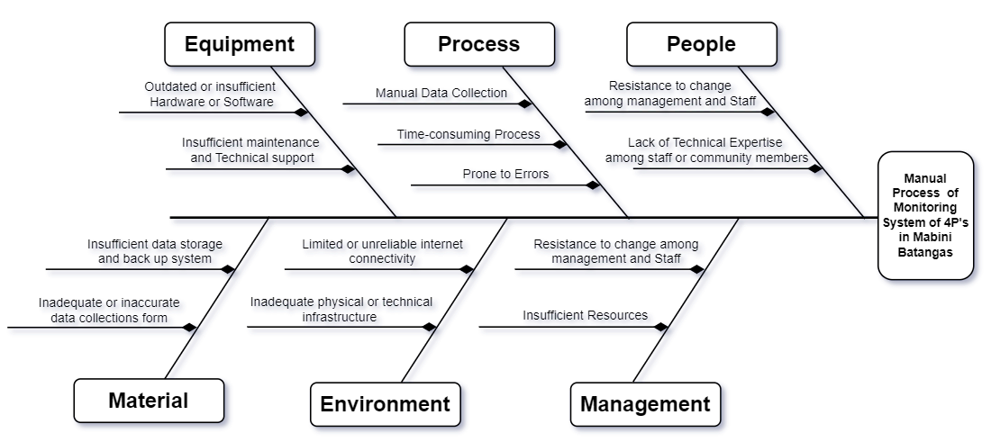

Figure 4. Fishbone Diagram

In terms of management, worker resistance to change and a lack of resources impede system adoption. The people element faces both management and staff opposition to change, as well as a lack of technical understanding among staff or community members, inhibiting effective system utilization. The system's reliability is jeopardized by environmental issues such as poor or unreliable internet connectivity and inadequate physical or technical infrastructure. Manual data gathering is time-consuming and error-prone, reducing data handling efficiency. Inadequate data storage and backup technologies, as well as erroneous data gathering forms, pose material risks to the integrity of stored information.

Furthermore, equipment-related concerns, such as old or insufficient hardware and software, combined with insufficient maintenance and technical assistance, have an impact on overall system performance. Addressing these issues is critical for increasing syste­­­m efficiency, assuring correct data handling, and supporting a smooth transition to a more advanced and dependable monitoring system.

## System Boundary

The system boundary is defined as a conceptual model that illustrates the

process of the system and shows interactions between users and the environment. The researchers used the system boundary to visualize the overall environment that connects within the system. The researchers believe that locating and establishing the elements within one essential element of a system is the relationship between the system and the environment. As a result, this calls for the creation of the system boundary, as shown in Figure 5.

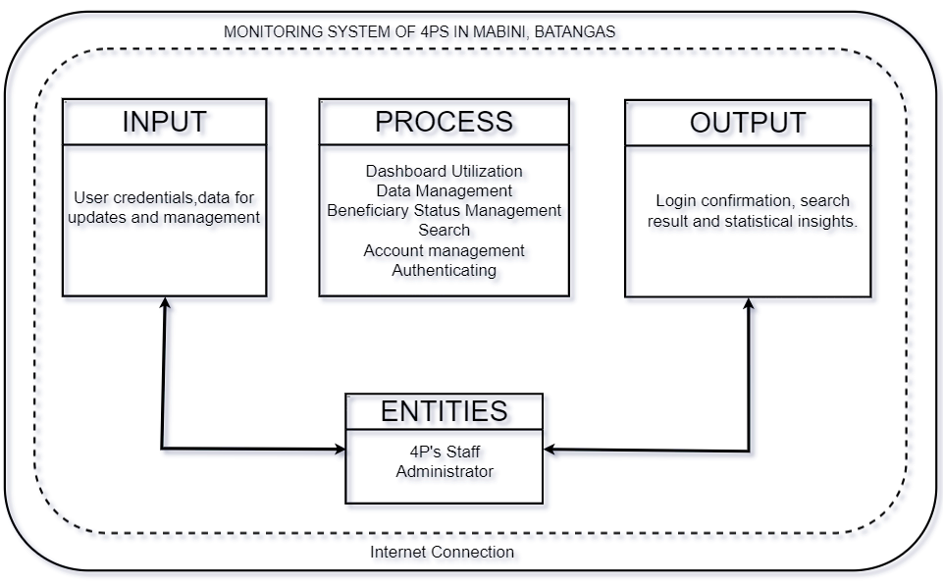

Figure 5. System Boundary

Figure 5 illustrates the project’s system boundary. Users, whether administrators or 4Ps staff, actively engage with the iTrack4PS system by providing essential input, including login credentials and data for account management. The system, in turn, delivers meaningful outputs such as confirmation of successful logins, search results for 4Ps holder names, and statistical insights presented on the user-friendly dashboard. To manage these interactions, iTrack4PS executes various processes, encompassing authentication, account management, search functionalities, and beneficiary status updates. Additionally, data management processes cover tasks like adding, editing, viewing, and archiving staff, 4Ps holders, and beneficiary child data. The dashboard utilization process plays a pivotal role in presenting statistical analyses, including the number of 4Ps holders, beneficiary children, and other key insights. In conclusion, iTrack4PS operates within a comprehensive system boundary, facilitating user tasks, providing accurate information, and enabling informed decision-making through a seamless integration of input, output, and processes.

## Hardware Requirements

The system requires computer specifications that comply with the requirements of the Windows operating system installed in the unit. The processor speed and size of the RAM on the hard disk should meet the minimum system specifications. It is just as important to check the requirements for hardware. Tables 1 and 2 show the list of computer specifications and recommended requirements.

**Table 1**.

Hardware requirements and specifications for Development

| **Hardware** | **Minimum Requirements** |
| --- | --- |
| Processor Speed | 2.3 GHz or more |
| Memory | 12 GB of RAM or more |
| Storage | 500 GB of SSD |
| CPU core | 8 cores or more |

|  |
| --- |
|  |

Hardware requirements are the most effective way of meeting the user's needs and reducing the cost of implementation. Minimum requirements for system implementation include the necessary hardware, which contains the following: CPU core, memory, and storage. It is advised to utilize a CPU with a speed of at least 2.3 GHz and 8 cores. How much information can be received at once and how quickly it can be processed on a particular computer depends on the processor speed and CPU core. However, because computer random access memory (RAM) is one of the most crucial factors influencing the system's performance, 12 gigabytes of RAM are needed for system implementation. RAM provides apps with a location to store and access data temporarily. The minimal need for the system also calls for a 500 GB ROM HDD, which contains the instructions needed for system implementation and communication between different hardware parts. As previously said, it is needed for the BIOS's storage and execution, but it is also useful for fundamental data management, storing software for utilities' fundamental functions, reading, and peripheral device types.

**Table 2.**

Hardware Minimum Requirements for End Users

|  |  |  |  |
| --- | --- | --- | --- |
| **Web User** | | **Mobile User** | |
| **Hardware** | **Minimum Requirements** | **Hardware** | **Minimum Requirements** |
| **Processor** | 2.3 GHz | **Processor** | Quad Core 1.8 GHz |
| **Memory** | 2 GB of RAM | **Memory** | At least 2 GB RAM |
| **Storage** | At least 20GB | **Storage** | At least 1GB ROM |
| **CPU core** | 6 core or more |  |  |

User specifications for the final user are crucial and succinct, user criteria must be easier to read, comprehend, and give a clearer understanding of how the system is going to work. For the required hardware for web users, the following needs must be met: processor, memory, storage, and CPU core. Six CPU cores and a minimum processing speed of 2.3 GHz are advised. How much information can be processed depends on the CPU core's and the processor's speed. how quickly particular data may be processed on a certain system after being received all at once. On the other hand, the end user needs 2 GB of RAM capacity to access, considering that random access memory (RAM) is one of the most crucial elements in assessing the effectiveness of the system. RAM gives apps a temporary storage and access place. Additionally, a 20 GB ROM HDD is needed as a bare minimum for the user. ROM gives the guidance needed for hardware connectivity between diverse device components.

In addition, the minimal hardware requirements for mobile end users include a quad-core 1.8 GHz CPU, at least 2 GB of RAM, and at least 1 GB of flash memory. Using this minimum need and the amount of storage available, mobile users can install and run browser programs that are compatible with responsive websites like the developed system. These minimum requirements are required to have favorable performance when accessing the developed system, yet researchers suggested using the above specifications to deliver the best output and services from the system.

## Software Requirements

Table 3 outlines the software requirements for our web-based monitoring system at the 4Ps office in Mabini Municipality, specifying types and specifications.

**Table 3**.

Software Requirements and Specifications

|  |  |
| --- | --- |
| **Software** | **Type /Specification** |
| Operating System | Microsoft Windows  Linux |
| Version | Windows 10  Debian Linux |
| Web Browsers | Google Chrome  Brave Mozilla Firefox |

Software requirements are the system implementation's setup and what the end user must possess for the software to operate effectively. There are two key prerequisites for the system's implementation, an internet browser and an operating system. There are two options for the operating system: Microsoft Linux or the Windows operating system. The researchers advised Windows, for system efficiency, to update to Windows 11. The most recent version, Debian Linux version of Linux, is recommended for its well-known security features, usefulness, and security offered.

Furthermore, there are no specific requirements for web browsers. Almost all web browsers are compatible with the system, although we recommend using the most recent version of the most effective web browser, such as Chrome, Mozilla Firefox, Brave, etc., for both user experience and security.

**Table 4**.

Software Minimum Requirements for End Users

|  |  |
| --- | --- |
| **Software** | **Type /Specification** |
| Operating System | Microsoft OS  Android OS  IOS |
| Version | Windows 7  Android 5.0  IOS 10 |
| Web Browsers | Google Chrome  Brave Mozilla Firefox |

Software is what gives the computer instructions. Users is not required specialized software to use the developed system. A common piece of software, an operating system for a personal computer, is required at the very least for Android 5.0 for users of Android and Windows 7 for users of Windows, and the previously specified minimal requirements are the same for the IOS 10 version. operating system versions that can execute responsive web apps dating back to the time you may visit a web portal using popular web browsers like Google Chrome, Internet Explorer, Mozilla Firefox, etc.

## Functional Requirements

Functional requirements outline the behaviors or actions that the system must perform and describe what the system should do. In order to develop an efficient web-based monitoring system for 4Ps in Mabini, Batangas, in the field of education, it is necessary to specify its requirements and expectations to the researchers of the study through functional specifications.

**1. Administrator**

1.1 Administrators can log in using the email and password

1.2 Administrators can create an account for the staff.

1.3 Administrators can search for the name of the 4Ps holder and beneficiary

1.4 Administrators can archive the staff, 4PS holders, and their beneficiary child accounts.

1.5 Administrators can update, and view the beneficiary status.

1.6 Administrators can add, edit, view, and archive staff and 4PS holders 1.7 Administrators have the capability to observe the dashboard.

**2. 4Ps Staff**

2.1 4Ps Staff can log in using the verified username and password provided by the administrator.

2.2 4Ps Staff can search for the name of the 4Ps holder.

2.3 4Ps Staff can archive the staff, 4PS holders, and their beneficiary child accounts.

2.4 4Ps Staff can edit, update, and view the beneficiary status.

2.5 4Ps Staff can add, edit, view/archive the staff, 4PS holders, and beneficiary child data.

## Non-Functional Requirements

The following non-functional requirements were considered in creating the expected output of the study.

1. **Reliability**

1.1 The system should be reliable and available 24/7 to ensure that 4Ps staff can access it at any time.

1.2 The system should have a backup and recovery plan in case of any failures or outages.

1. **Scalability**

2.1. The system should be scalable to support increasing numbers of users and data over time.

2.2 The system should be able to handle a large volume of data without compromising performance.

1. **Security**

3.1 The system should have proper authentication and authorization mechanisms to ensure that only authorized users can access the data.

3.2 The system should be designed with security best practices to prevent unauthorized access and protect the data from cyberattacks.

3.3 The system should be hosted on a secure cloud or serverless platform that complies with industry and regulatory standards.

1. **Usability**

4.1 The system should be easy to use and intuitive for 4Ps staff, who may not have technical expertise.

4.2 The system should have clear and concise documentation to assist with onboarding and training new users.

1. **Performance**

5.1 The system should have a fast response time to ensure that 4Ps staff can quickly access the data they need.

5.2 The system should be optimized for performance to handle a large volume of data and user requests.

## Constraints

The preceding tables include the different software design constraints. while ratings were created via autonomous and intentional involvement based on the researcher's skill and comprehension of each choice, reviewing, and background information.

In terms of server-side scripting tools, the researchers came up with four options namely CSS, JavaScript, AngularJS, and WordPress, as shown in Table 5. As the researchers have sufficient knowledge to manipulate and control AngularJS, it was chosen as the server-side scripting language. Moreover, the researchers believe that it would be of great help in producing a dynamic and interactive web page since it could interact with PostgreSQL databases, among the other alternatives.

**Table 5**.

Server-Side Scripting Language

|  |  |  |  |  |
| --- | --- | --- | --- | --- |
| **Design Constraints** | **CSS** | **Javascript** | **AngularJS** | **WordPress** |
| Performance | 8 | 8 | 9 | 7 |
| Dependability | 8 | 8 | 8 | 8 |
| End User Criteria | 8 | 7 | 8 | 7 |
| Reliability | 8 | 7 | 9 | 7 |
| Usability | 9 | 6 | 10 | 7 |
| Availability | 7 | 7 | 9 | 6 |
| Security | 9 | 8 | 8 | 8 |

Three database alternatives were presented by the researchers: PostgreSQL, Oracle, and MS Access are both included in Table 6. The databases mentioned above received ratings based on the AngularJS resources available. Therefore, PostgreSQL was selected by the supporters since it has a reliable database server for information queries. It works with any operating system and supports a variety of development interfaces, particularly in AngularJS.

Unlike MS Access, MySQL and Oracle each have a username and password, strengthening these. Many platforms support MySQL and Oracle, MS Access, however, is limited to Windows. Despite the fact that Oracle has a lot of MySQL has a number of benefits over Oracle, and it has higher performance overall. It is the most well-known database because of its functional performance.

**Table 6**.

Databases

|  |  |  |  |
| --- | --- | --- | --- |
| **Design Constraints** | **PostgreSQL** | **Oracle** | **Ms Access** |
| Performance | 9 | 7 | 8 |
| Dependability | 9 | 7 | 8 |
| End User Criteria | 9 | 7 | 7 |
| Reliability | 9 | 8 | 7 |
| Usability | 9 | 8 | 7 |
| Availability | 8 | 8 | 6 |
| Security | 9 | 7 | 9 |

The different text editors like Sublime Text, are shown in Table 7. and Visual Studio Code. Despite the fact that Codium analyzes the codes, On the basis of their knowledge of text editors, supporters get to the conclusion that it is too slow. Visual On the other side, Studio Code features a quick source code editor that is suitable for usage immediately. VS Code also regularly adds new languages with its support for hundreds of them provided syntax highlighting, bracket matching, auto-indentation, box selection, snippets, and other features that allowed the researchers to become productive right away.

**Table 7**.

Text Editors

|  |  |  |
| --- | --- | --- |
| **Design Constraints** | **VsCode** | **Codium** |
| Performance | 9 | 7 |
| Dependability | 9 | 7 |
| End User Criteria | 9 | 7 |
| Reliability | 9 | 8 |
| Usability | 9 | 8 |
| Availability | 8 | 8 |
| Security | 9 | 7 |

## Trade-off

One of the main problems that the paper addresses is the consideration of trade-offs that researchers have emphasized in order to meet competitive goals and invest even more time in resources for performance improvement. Many halo effects would also be involved because these relate to the cognitive biases that a researcher directly or indirectly Decision-making was influenced by the researcher’s overall impression. Consequently, the sets of designs presented in Table 8 together with the associated technological stack.

**Table 8.**

Technology Stack

|  |  |
| --- | --- |
| **Design** | **Technology Stack** |
| Design A | AngularJS, CSS, ExpressJS, Restful API, PostgreSQL |
| Design B | WordPress |
| Design C | Python |

|  |
| --- |
|  |

According to the table, Design A includes open-source products that can be utilized to create the accrediting framework. On the other hand, WordPress is defined in Design B. Since it is easy to use and has a clear interface, it has become a viable alternative. Additionally, this technology is straightforward, so formatting time would be significantly reduced. Python, another popular programming language, is mentioned in Design C. due to its flexibility and adaptability. Its supporters think it is a true all-rounder among the most widely used programming languages.

## System Design/Architecture

System design, or architecture, defines the structure of how to illustrate the system's processes. It is a conceptual model to represent an easy and simple way to demonstrate the other components that are related to the system and become more detailed depending on the interaction of the system. In Figure 6, it shows the architecture of how the system be deployed on the cloud.

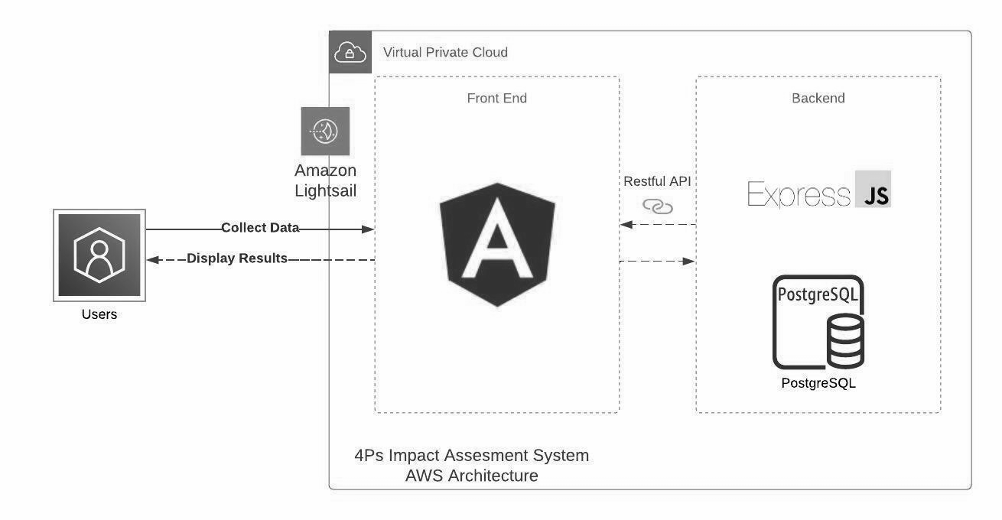

Figure 6. System Architecture on AWS Lightsail

Figure 6 illustrates a system architecture for a web application that includes several components such as a user, front-end, API, back-end, virtual private cloud (VPC), and Amazon Lightsail. At the front end of the system is Angular, which is a popular JavaScript framework used for building user interfaces. The user interacts with the application through the Angular front end. When a user interacts with the application, for example by making a request or submitting a form, the application sends the request to an API. The API is a set of protocols and tools used for building software applications, and in this diagram, it is responsible for sending and receiving data between the front-end and back-end components.

The back end of the system is composed of Express.js and PostgreSQL. Express.js is a web framework used for building web applications, while PostgreSQL is a popular open-source relational database management system (RDBMS). The back-end is responsible for handling requests sent by the front-end through an API, processing the data, and storing it in the PostgreSQL database. To ensure the security and privacy of the application, a virtual private cloud (VPC) is used. A VPC is a private network within the cloud infrastructure that allows resources to be isolated from the public internet. This ensures that the application is only accessible to authorized users.

Finally, the application is hosted on Amazon Lightsail. Amazon Lightsail is a cloud-based service provided by Amazon Web Services (AWS) that allows developers to host their applications on a virtual private server (VPS). Lightsail provides various benefits, such as reliable performance, automatic backups, and easy scaling.

## Context Diagram

Figure 7 illustrates the development of a Context diagram that is essential for managing the 4Ps program in Mabini, Batangas. This visual tool depicts the sequential actions performed by system administrators and staff with the goal of improving overall efficiency and user-friendliness. The aim of the study is to enhance program management by implementing an efficient and effective approach to 4Ps administration in Mabini. The primary focus is on increasing the functionality of the system for both program administrators and staff members working in the program.

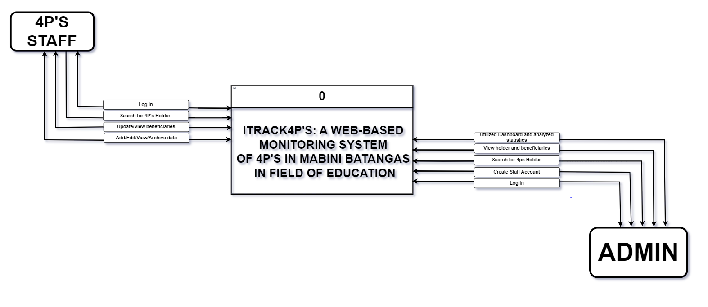

Figure 7. Context Diagram

Administrators serve as key members of the system, executing responsibilities such as login operations, employee account creation, beneficiary management, and statistics analysis via the system dashboard. They are in charge of updating beneficiary information as well as preserving crucial data. Staff, on the other hand, contribute to the system by doing tasks including login in, data management, beneficiary approval, 4PS holder searches, and accessing the dashboard for crucial information. This study goes deeply into these sequences, offering insights into the precise capabilities granted to administrators and personnel in Mabini, Batangas, with the overarching objective of boosting system performance and supporting optimal program management.

## Data Flow Diagram

Figure 8 iTrack4Ps web-based monitoring system's Data Flow Diagram (DFD) provides a visual representation of how data circulates inside the system, providing a full understanding of its architecture. The major goal is to provide seamless interactions and efficient data flow between important components. This graphic illustrates the complex layout of the iTrack4Ps system by capturing the essence of user authentication, data management processes, beneficiary status updates, and the integration of a dynamic dashboard.

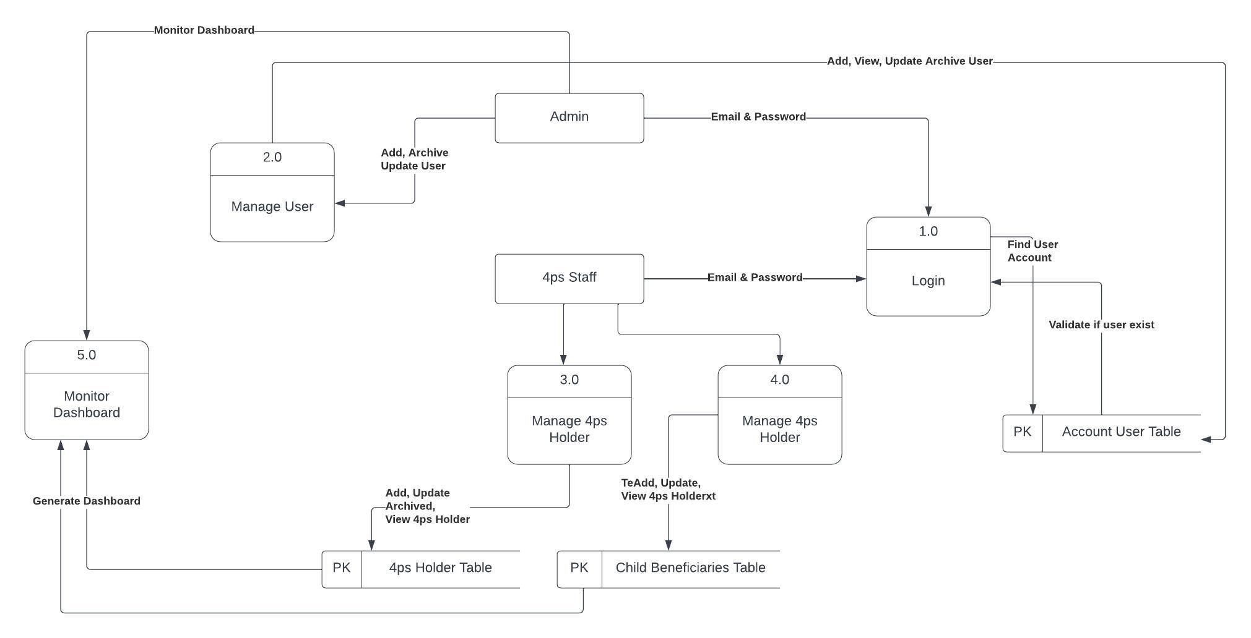

Figure 8. Data Flow Diagram

Figure 8 illustrates the process flow of the web-based iTrack4Ps system, which begins with secure user authentication for administrators and 4Ps Staff. Administrators have the ability to create staff accounts, search for 4Ps holders, and archive material, establishing critical ties to repositories. The beneficiary status module interfaces to a large data store, allowing for quick updates and approvals. Administrators effectively manage staff and beneficiary kid data, establishing essential links. 4Ps Staff communicate fluidly as they move via the search, archiving, and beneficiary status modules. The integrated dashboard improves analytical capability to provide real-time insights. From user authentication to data management, the system enables efficient interactions with clear feedback loops and external outputs, indicating a well-designed system for effective monitoring and decision-making.

## Link Architecture

The network architecture depicted in Figure 9 has a crucial impact on the direction of the 4Ps program in Mabini, Batangas. This visual representation provides a clear and detailed explanation of the complex relationships between 4Ps staff and the administrative team, revealing their specific duties and interactions within the program's structure. The graphic serves as a schematic blueprint, enabling a user-friendly and clearly understandable system flow.

The main goal of this study is to improve the organization, allocation, and implementation of activities within the 4Ps program by carefully charting these connections. The research aims to create a visually consistent representation that will simplify the program's structure, leading to a more efficient and influential management. The design of these links plays a crucial role in maximizing user engagement, which in turn enhances the overall performance of the system. The meticulously planned link architecture acts as a guiding structure, playing a crucial role in the program's effectiveness and promoting a more unified and adaptable approach to implementing the 4Ps project in Mabini, Batangas.

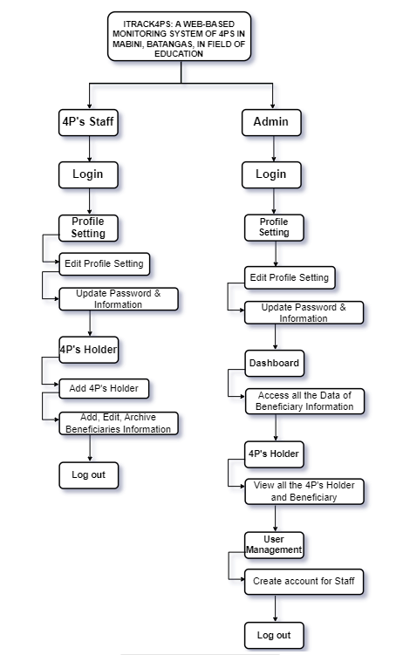

Figure 9. Link Architecture

Figure 9 illustrates the link architecture of the iTrack4Ps web-based monitoring system is intricately designed to facilitate seamless interactions and data flow among its key components. Beginning with user authentication, both administrators and 4Ps Staff access the system securely through dedicated modules. Administrators can create staff accounts, search for 4Ps holders, and archive data, establishing links to various repositories. The beneficiary status module connects to the comprehensive data repository, enabling the update and approval of beneficiary statuses. Administrators can access the `staff and beneficiary child data, forming links to respective data entities. Integration with the dashboard allows administrators to analyze statistics and gain real-time insights. Similarly, 4Ps Staff navigate through search, archiving, and beneficiary status modules linked to underlying data structures. The data management capabilities empower them to interact with staff, 4PS holders, and beneficiary child data. The dashboard integration for 4Ps Staff enhances their ability to analyze statistics and make informed decisions. Overall, the iTrack4Ps link architecture ensures streamlined interactions and effective data flow, supporting the system's efficiency.

## Use case

Figure 10 illustrates a use case diagram that summarizes the link between user and the system, along with its features and cases.

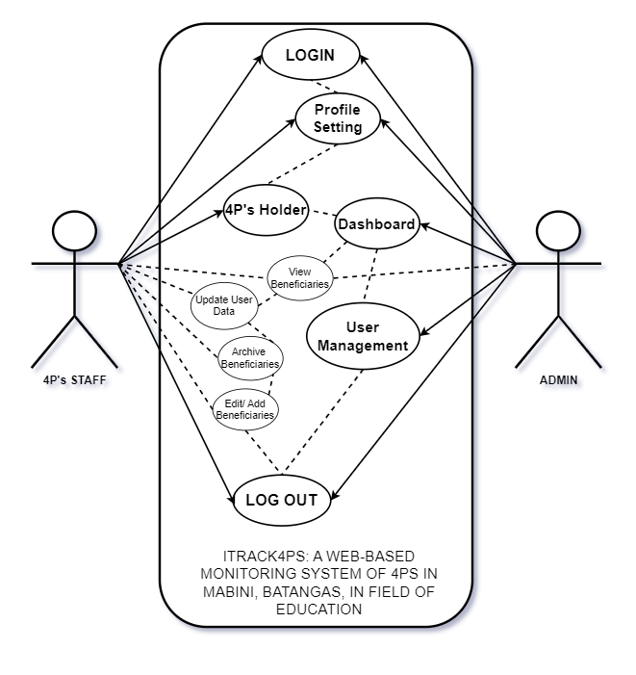

Figure 10. Use Case Diagram

Figure 10 shows the numerous actions and roles performed by various users in the system. The admin and 4P’s Staff are the system's two primary actors. The admin has complete control over the system and can customize it to meet the requirements of the 4Ps program. 4P’s Staff may manage user accounts, update user passwords, add 4P’s Holders and also the Beneficiaries. These two shares one common use case: logging in to the system, and all have the ability to log out of the system, ensuring security and privacy for all interactions within the system.

## Sequence Diagram

**Figure SEQ Figure \* ARABIC 10.** *Use Case Diagram*

The sequence diagram defines how the processes or operations are detailed and carried out based on the functionality of the system. It is used to visualize the flow and scenarios accordingly throughout the process of the system.

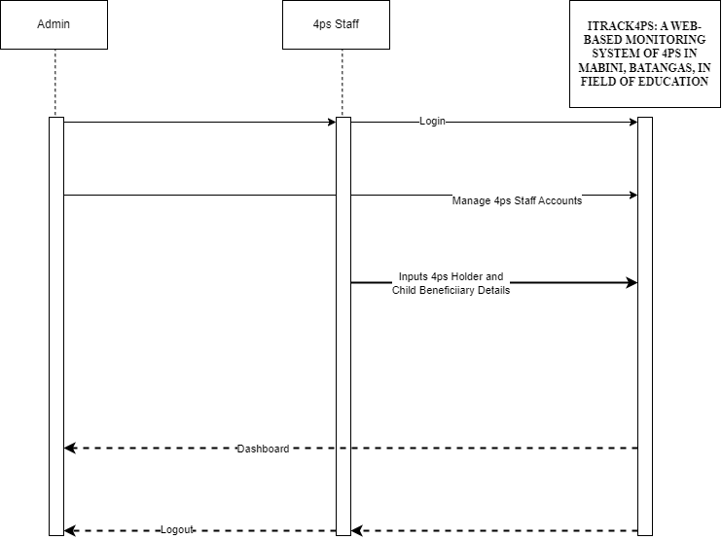

Figure 11. Sequence Diagram

Figure 11. Shows the sequence diagram for 4P’s Monitoring System. This diagram shows the interaction on how the monitoring system would be carried out; the beneficiary's information is approved by staff and automatically added to the dashboard. Based on the illustration, the sequence was organized according to which processes come from first to last as the user navigates within the application throughout time. The admin user is the system owner while the 4P’s Staff is like an assistant that inputs all the beneficiary’s information. Additionally, the Admin and 4P’s staff can both access the Dashboard, Profile Setting, 4P’s Holder, Add Beneficiary. The main difference is the Admin can access the User management but the Staff can’t access. I designed this diagram based on the step-by-step process of the system, illustrating how a user interacts with it.

## Database Design

Figure 12 shows the data that must be processed and how these data items interrelate. Furthermore, this acts as a road map for applying data to specific software applications, while supporters get a deeper grasp of the data to be stored in the database using the ER diagram.

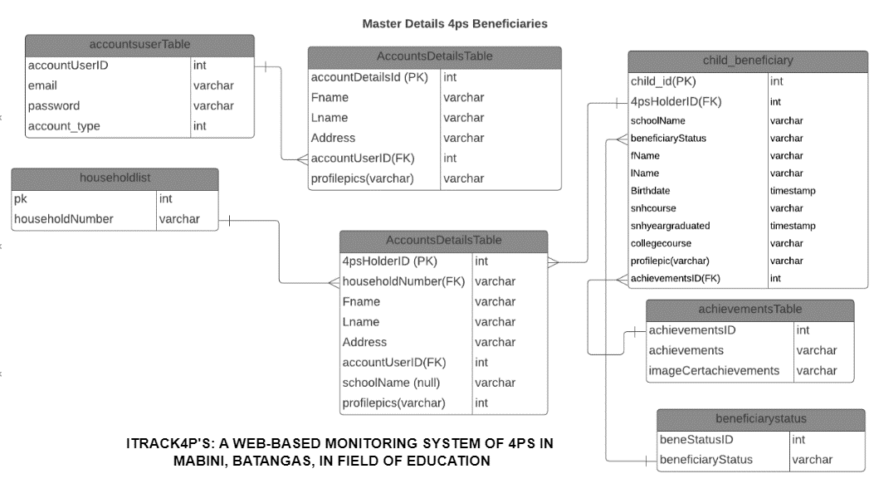

Figure 12. Database Design

Figure 12 provides an illuminating Entity-Relationship Diagram (ERD) that serves as a fundamental visual representation of the underlying structure of our database system. This ERD meticulously organizes entities and their attributes, presenting the intricate web of relationships that exist between them. Entities are arranged in a logical order, while connecting lines intricately depict how they interconnect, showcasing the vital associations that drive data management within our database. This figure is pivotal in offering a clear and comprehensive insight into the architecture of our database, aiding in the efficient storage and retrieval of data.

## Development Software

The researchers have specifically selected the Windows operating system as the primary focus for their study on system software. The reason for this choice is Windows' capacity to effectively handle computer hardware, software resources, and offer crucial services for different computer programs. The specified operating system functions as a vital intermediary between users and computer hardware, exerting authority over the execution of various programs. As a result, the system has been designed to be compatible with devices running on the Windows platform, particularly Windows 7 or any newer versions. In addition, the researchers have implemented Angular as the preferred frontend framework for client-side scripting languages. The integration of Angular enables the system to effortlessly include language into HTML pages, promoting a dynamic and interactive user experience. This framework, well-known for its strong and reliable characteristics, improves the effectiveness and quickness of the user interface.

In addition, ExpressJS has been utilized for the server-side scripting component of the project. With the researchers' extensive knowledge of this programming language, ExpressJS plays a crucial role in developing dynamic and interactive web applications. The value of the software is enhanced by its compatibility with PostgreSQL, allowing for efficient communication and interaction with the database. The integration of Angular and ExpressJS facilitates the creation of a cohesive and all-encompassing system, efficiently fulfilling the project's goals.

## Web Platform

The researchers choose AngularJS documentation as the preferred web development platform for their system since it provides detailed instructions on how to use the system's dependencies. They claim that, out of several options, AngularJS is a highly efficient and cost-effective framework, making it the favored choice for constructing the frontend of the system. The documentation not only enhances comprehension of AngularJS but also simplifies the incorporation of crucial dependencies, in accordance with the researchers' focus on efficiency and cost-effectiveness in their development methodology. Moreover, the researchers value AngularJS for its active community support and continuous updates, ensuring a sustainable and cutting-edge development environment for their system.

## Database

For the back-end technology, the researchers used PostgreSQL because it is a powerful and feature-rich database management system that offers numerous benefits for organizations of all sizes. Its extensive functionality, reliability, scalability, and compliance with standards make it an attractive choice for data-driven applications. The open-source nature of PostgreSQL, coupled with strong community support, contributes to its continuous improvement and ensures a high level of security and performance. By leveraging PostgreSQL, businesses can effectively manage their data, enhance application development, and achieve their objectives efficiently.

## Subscription

Table 9 shows a detailed analysis of the charges for subscribing to the software as a service (SaaS) and infrastructure as a service (IaaS) that are necessary for the functioning of the system. This table further elaborates on the data provided in Table 6. The researchers have allocated an approximate annual cost of ₱2,000 for the GoDaddy Domain, which serves as the distinct Internet address visible in users' browser address bars. In addition, the infrastructure as a service encompasses AWS Lightsail, an Amazon Web Service chosen for its user-friendly and cost-efficient attributes, providing simpler virtual private servers (VPS) and expedited application deployment. The annual subscription fee for AWS Lightsail is approximately ₱5,000. This subscription allows users to utilize the server and deploy the database on the Lightsail instance, ensuring that it can be accessed universally through the internet.

**Table 9**.

Subscription Fees

|  |  |  |
| --- | --- | --- |
| **Software as a Service (SaaS)** | **Description** | **Estimated Cost**  **(Per Year)** |
| GoDaddy Domain | The identification string within the  Internet. | ₱2,000 |
| **Infrastructure as a Service (SaaS)** |  |  |
| **AWS Lightsail** | is a user-friendly and cost-effective cloud computing service that offers simplified virtual private servers (VPS) and easy application deployment. | ₱5,000 |

## Testing

This section focuses on the fourth phase of the Agile Methodology Model.

Testing the system entails discovering faults and problems. Testing is one of the most critical aspects of the development process that must be done correctly to establish precisely that the system is running effectively and executing properly in order to match the desired output. ISO 20510:2011 is used to test the system. It comprises functional stability, efficiency/performance, compatibility, usability, dependability, security, and so on while evaluating the system's maintainability and chance of successfully identifying the testing process.

In general, these qualities show how thoroughly the component is tested:

1. meets the specifications that determined its design and development.
2. responds to all types of inputs efficiently,
3. performs its tasks in an appropriate period of time, and
4. achieves the overall goal of the stakeholder.

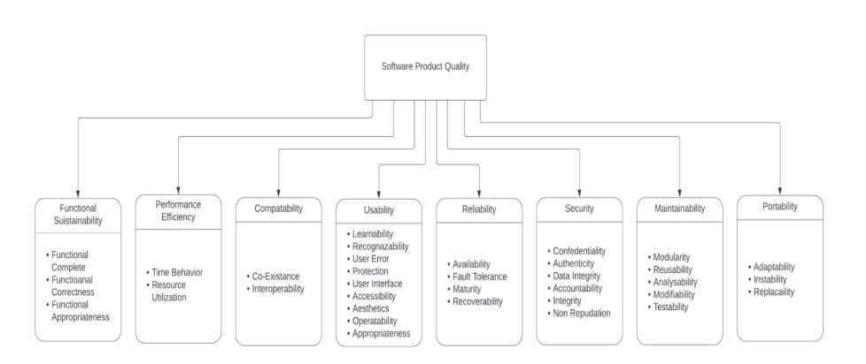

**Figure 13.** ISO/IEC 25010

Figure 16 shows the surveying process. The ISO/IEC 25010:2011 quality-in-use model encompasses five characteristics, some of which have subcategories, that collectively define the outcome of interactions with a product within a specific context. This model is designed to be applicable to a broad spectrum of stakeholders engaged in various aspects of software and software-intensive computer systems, including acquisition, requirements, development, usage, assessment, support, maintenance, and overall quality. It provides a comprehensive framework that addresses diverse viewpoints, including auditing, assurance, and control, ensuring a holistic and multifaceted approach to evaluating and enhancing the quality of software products throughout their lifecycle.

## Testing Procedure

In terms of testing, user testing be carried out on a group of potential users. Users be sought for input to maximize the agile technique for the agile testing framework. The input from the previously described system be utilized to enhance the system and the quality of the findings.

## Data Gathering

In gathering the data for the developed system, the researchers approached the municipal link of 4Ps in Mabini, Batangas, to gather insights about their manual process and use that information, particularly on functionality, reliability, usability, interface, performance, and security of the web system.

## Deploy

During this phase, researchers reviewed the actions that must be completed. 4Ps staff and Admin can connect to the system over the Internet. In this example, the system has been fully created and tested and is ready for deployment.

The web system was deployed to be used by users who could access the internet using a paid cloud server. In that way, the service or system can now be viewed by anyone with a browser. Anyone can now find the system, especially the target users. After its web system has already been implemented on the internet, the account used to administer this system be given to the 4Ps staff or on the Municipal Link of 4Ps in Mabini, Batangas.

## Risk Management Plan

This risk management plan details the methods used to identify, evaluate, and manage risks that are connected to the established system's objectives. It outlines the procedures for conducting, documenting, and keeping track of risk management activities during the course of the capstone project's lifecycle. The planning process resulted in the creation of the risk management plan, which is regularly reviewed and revised.

Risks are potential hazards that, if they become realities in a project management setting, might be regarded as concerns that must be appropriately addressed. As a result, detecting, analyzing, and then responding to any risk that develops during the course of a project's life cycle is critical for the project to stay on track and accomplish its objectives. Risk analysis and management would be adopted as a core project management strategy throughout the study to guarantee that as few surprises as possible occur while the project is underway. While unpredictable events can never be anticipated with precision, a simple and simplified risk management strategy to predict project uncertainties and minimize the occurrence or impact of these uncertainties might have a significant impact on the entire project. Furthermore, this increases the likelihood of project completion and decreases the effects of those risks.

In this regard, the researchers highlighted eight concerns that could have a significant impact on the developed monitoring system:

**RISK 001: Weak Password.** Weak passwords can allow unauthorized users to easily obtain access to sensitive information or systems, resulting in security breaches or data loss. This can jeopardize the project's integrity and result in legal or reputational harm.

**RISK 002: Poor Internet Connection.** Delays, suspensions, or disturbances in project activities might result from a poor internet connection. This can have an impact on the project's timeline, expenses, and deliverable quality. It can also lead to irritation and low morale among team members.

**RISK 003: Operational Risk.** refers to the possibility of suffering a loss as a result of inadequate or failing internal systems, people, and processes. These difficulties include things like system outages, security breaches, and data loss. Operational risks need to be recognized and reduced for the project to succeed.

**RISK 004: Human Error.** can lead to errors or oversights that have ramifications for project results, such as data loss, system downtime, or delays. To limit the danger of human error, it is critical to give proper training and support to team members.

**RISK 005: SLOW RESPONSE.** Users may lose interest in the system as a result of slow response times and a bad user experience. Prioritizing system reaction time Optimization is essential to ensuring that the system is responsive and user-friendly.

**RISK 006: Unavailable Resources.** Project schedules can be affected by the lack of resources, such as hardware or software, which can cause delays. The project must be supported by the availability and proper operation of the essential resources.

**RISK 007: Data Leakage** Data leakage is the unintentional disclosure of private or sensitive information, which can result in reputational harm, legal troubles, or financial losses. To stop data loss and safeguard sensitive information, it's crucial to adopt security measures and controls.

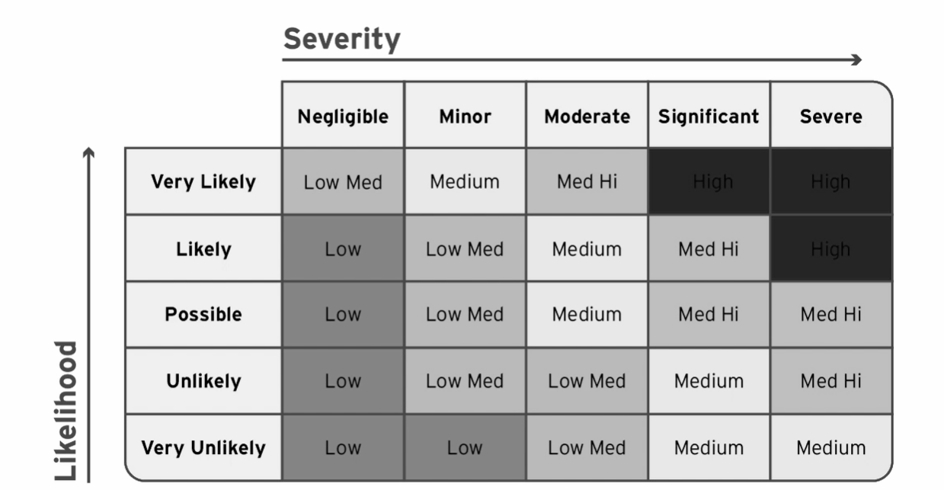

**Figure 14.** Risk Matrix

This plan outlines how we identified, assess, and manage risks to the project's objectives. It must be done to identify and address potential issues in order to keep our project on track and meet our objectives. We hope to reduce surprises and increase project success by proactively addressing uncertainties. In this context, we've identified eight major issues with our monitoring system. To ensure the project's smooth progress risks such as weak passwords and data leakage must be carefully monitored and mitigated. This plan serves as our road map for navigating and minimizing any possible obstacles.

## Risk Analysis

To further classify and elaborate on the aforementioned risks, illustrated in Figure 17, is the Risk Matrix, which would serve as the basis for the risk analysis presented in Table 10.

**Table 10.**

Risk Analysis

|  |  |  |  |  |  |
| --- | --- | --- | --- | --- | --- |
| **ID** | **RISK** | **CATEGORY** | **LIKELIHOOD** | **SEVERITY** | **IMPACT** |
| 001 | Weak Password | Technical | Possible | Moderate | High |
| 002 | Poor internet connection | Technical | Possible | Severe | High |
| 003 | Operational Risk | Project Management | Likely | Significant | Med High |
| 004 | Human Error | Project Management | Possible | Moderate | Med High |
| 005 | Slow Response | Technical | Unlikely | Severe | High |
| 006 | Unavailable Resources | Project Management | Unlikely | Significant | Med High |
| 007 | Data Leakage | Technical | Possible | Significant | High |

To effectively manage risks, it is necessary to identify and assess all possible risks that may arise in a project or organization. Table 10 provides a comprehensive list of such risks, categorized as technical or project management risks. Using an ID number for each risk, it assigns as many likelihood ratings as possible, probable, or unlikely, and a severity rating as moderate, major, or severe. Additionally, each risk is ranked according to its impact as high, medium-high, or low. This information can be utilized to develop risk mitigation strategies, prioritize risk handling, and allocate resources accordingly. With Table 10 as a reference, project managers can take proactive measures to mitigate risks and ensure successful project completion.

## Risk Treatment

Once risks have been identified and assessed, the next phase is to develop risk management strategies for mitigating them. This involves specifying suitable treatment plans for each risk, as not all risks have the same potential impact on the business. Table 11 provides a comprehensive list of risk treatments developed by researchers for each risk identified in Table 10. These treatments include avoidance, mitigation, transfer, or acceptance. Depending on the nature and severity of the risk, project managers may need to employ one or several of these treatment plans. The goal is to reduce the likelihood of a risk occurring, minimize its impact, or transfer the risk to a third party. By implementing effective risk management strategies, organizations can protect their assets, achieve project objectives, and enhance their reputation.

**Table 11**. Risk Treatment

|  |  |
| --- | --- |
| **Risk** | **Risk Treatment** |
| **RISK 001: Weak Password** | Implement a strong password policy that includes requirements such as minimum length, complexity, and expiration. Consider using multi-factor authentication to provide an additional layer of security. |
| **RISK 002: Poor Internet Connection.** | Creating a backup plan, offline capabilities, and different communication routes can assist in limiting the danger of a poor internet connection. |
| **RISK 003: Operational Risk** | Regular risk assessments, the implementation of quality management systems, and comprehensive personnel training can all help reduce the likelihood of operational failures. |
| **RISK 004: Human Error** | Standard operating procedures, regular training and refresher courses, and proper supervision and oversight can all help to reduce the risk of human error. |
| **RISK 005: Slow Response** | Implement techniques such as caching, compression, and content delivery networks (CDNs) to improve server speed. Ascertain that the server infrastructure is scalable and capable of handling anticipated traffic demands. Perform routine performance testing and optimization. |
| **RISK 006: Unavailable Resources** | Conduct a thorough inventory of all resources needed for the project and ensure that they are available and functional before starting. Develop contingency plans to mitigate the risk of unavailable resources. Consider outsourcing or renting resources if necessary. |
| **RISK 007: Data Leakage** | The danger of data leakage may be reduced by using strong data ownership measures such as data encryption, access limits, and data backup. A data breach response strategy must be in place to handle any occurrences that may arise. |

Table 11 presents a methodical strategy for managing risk, including recognized hazards and their respective treatment solutions in order to minimize or prevent negative effects on the firm. Encompassing a wide range of possible weaknesses, including technological and operational difficulties, human mistakes, and data security worries, each approach to managing risks is customized to target specific risks. It provides a series of actions that are intended to either prevent the risk altogether or reduce its potential harmful effects. The recommended strategies cover various aspects of risk management, including the application of policies, technological improvements, planning of resources, and training of staff. These techniques offer a comprehensive and diversified set of tools to effectively reduce risks.

|  |
| --- |
|  |

## Risk Ownership

Table 11 is a key instrument that provides information on various strategies and procedures to manage and mitigate any risks that could affect the success of a project. This comprehensive framework offers an organized way to effectively manage risks, encompassing strategies ranging from risk avoidance to mitigation and transfer. In order to guarantee a successful implementation, it is of utmost importance to assign a team member with the responsibility of monitoring and guiding the execution of these treatments. This will effectively reduce the possible impact of risks on the project. Table 12 provides a comprehensive overview of the primary duties of a risk owner, elucidating their significance in the risk management and analysis procedure.

**Table 12.** Risk Ownership

|  |  |  |
| --- | --- | --- |
| **ID** | **RISK** | **OWNER** |
| **001** | Weak password | Danica Rose Banaag |
| **002** | Poor internet connection | Danica Rose Banaag |
| **003** | Operational Risk | Monalenne Joy Celis |
| **004** | Human Error | Mark Lowel Montealto |
| **005** | Slow Response | Monalenne Joy Celis |
| **006** | Unavailable Resources | Mark Lowel Montealto |
| **007** | Data Leakage | Monalenne Joy Celis |

Table 12 cont’d

Table 12 shows a list of identified risks and the corresponding team member who is responsible for managing and mitigating each risk. Each risk has a unique identifier and description, such as a weak password or poor internet connection. The names of the team member assigned as the risk owner for each risk is also indicated. It is an essential component of effective risk management, ensuring that each potential risk is assigned to an accountable individual who can take the necessary actions to minimize its impact.

## Risk Management Process

The risk management process is a methodical and critical approach to ensuring project success by discovering, analyzing, treating, and managing possible risks. Figure 18 illustrates the many processes involved in this process, which begin with the identification of various hazards, both internal and external. The graphic most typically depicts this phase by displaying several sources or types of dangers. Following risk identification, the assessment step assesses the likelihood and effect of each risk, assisting in risk prioritizing. The picture next depicts treatment techniques such as avoidance, transfer, mitigation, or acceptance. The process is dynamic, and the illustration may illustrate monitoring and control via a continuous loop, emphasizing the continual aspect of risk management.

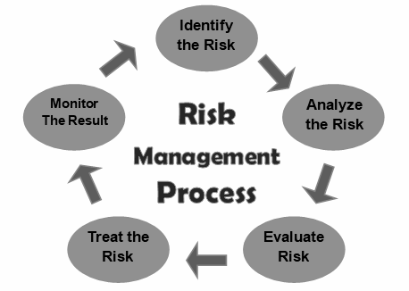

Figure 15. Risk Management Process

This risk management plan details the methods used to identify, evaluate, and manage risks that are connected to the established system's objectives. It outlines the procedures for conducting, documenting, and keeping track of risk management activities during the course of the capstone project's life cycle. The planning process resulted in the creation of the risk management plan, which is regularly reviewed and revised.

# CHAPTER IV

## RESULTS AND DISCUSSIONS

This chapter presents how the objectives of this project have been accomplished. The results of the questionnaire design and testing have been discussed.

The project’s primary goal, to design, develop, and implement a web-based Monitoring system for the 4P’s Staff and Admin Mabini Batangas, involved several steps. Following the achievement of the project’s specific objectives, it was launched and put into operation.

**Data collection platform**

The platform for collecting data on 4Ps students' beneficiaries within iTrack4Ps signifies the establishment of a dedicated and efficient space within the system. This space is designed to systematically gather and manage essential information about participants in the Pantawid Pamilyang Pilipino Program. Administrators and 4Ps staff can utilize this centralized hub to input and access crucial details such as personal information, educational background, and program participation status. The aim is to create a user-friendly and secure environment that streamlines the process of collecting comprehensive data. This organized repository becomes a valuable tool for administrators, enabling informed decision-making, effective program monitoring, and the customization of interventions based on the specific needs of the 4Ps beneficiaries.

**Developed a dashboard tailored for 4Ps staff, facilitating the monitoring of beneficiaries**

The dashboard module in iTrack4Ps has been intricately designed to empower 4Ps staff by providing a comprehensive overview of key program metrics. Through intuitive visualizations, the dashboard presents essential information, including the total count of 4Ps holders and beneficiary children, allowing staff to quickly grasp the program's scope and impact.

The graphical representation of beneficiary statuses through charts or graphs enhances data interpretation, providing a visual tool for staff to identify trends and areas requiring attention promptly. This metric enables staff to assess academic engagement and tailor support accordingly. Information on the school with the most enrolled students and a detailed breakdown of beneficiary counts in different barangays contribute to strategic resource allocation and program planning. In essence, the dashboard module in iTrack4Ps serves as a valuable decision support tool, consolidating diverse program metrics in an accessible format for informed decision-making and efficient program management by 4Ps staff.

**Provided a comprehensive record collection**

The record collection system in iTrack4Ps provides 4Ps staff with a suite of functionalities tailored for efficient data management. Through secure login using verified credentials, staff gain controlled access to the system and the ability to search for specific 4Ps holders, ensuring targeted retrieval of beneficiary information. A key feature of the system is the capacity for staff to archive records, including staff profiles and beneficiary child accounts, fostering organized database management. Additionally, staff actively participate in updating, viewing, and approving beneficiary statuses, ensuring the system reflects the latest and most accurate information about program participants.

Aside from archiving and status management, the system allows staff to add, amend, and view staff profiles, 4PS holders, and beneficiary children data, allowing for more thorough data submission. This versatility guarantees that the database keeps up with the program's increasing demands. The dashboard connection streamlines access to numerous information and analytics, such as beneficiary numbers, graphical representations, and academic indicators, for staff. Essentially, the record collecting system provides 4Ps personnel with safe access, focused search capabilities, archiving choices, and active engagement in updating and managing beneficiary data, promoting effective data management that is critical to the program's success.

## Usability

Based on the survey outcomes, it is evident that users perceived the online system as notably user-friendly and efficient. The survey encompassed diverse aspects of usability, including users' willingness to engage with the system, navigational ease, clarity in the system's flow, absence of confusion in its usage, user confidence while interacting with the system, response time for various actions, effectiveness in error rectification, and safeguarding personal and data information during monitoring. Furthermore, users expressed appreciation for the system's transparent communication regarding security measures and data protection. These findings reflect that a majority of users had a positive experience with the system and were content with its usability.

The system's effectiveness was evaluated by a set of 20 target users in Mabini, Batangas, who included 4Ps staff, and administrators. These individuals were invited to test the web-based tool and respond to a usability questionnaire. The findings indicated the expected usability and stability of iTrack 4Ps. Users strongly concurred, as evidenced by a weighted mean score of 4.7, indicating the system's efficacy in data collection for 4Ps student beneficiaries and the enhancement of decision-making for 4Ps staff through the dashboard module. As a result, the composite means of 4.7 indicates that users agree that iTrack4Ps is an effective tool for monitoring and updating the status of 4Ps recipients in Mabini, Batangas.

## Functional Sustainability

A complete functionality evaluation took place for several user types, such as 4P staff and administrators in Mabini, Batangas, within the framework of the iTrack4Ps system. The purpose of this evaluation was to ascertain the system's dependability and conformity to specified functionalities. The assessment for beneficiaries mostly involved evaluating tasks such as creating an account, signing in, navigating the platform, and managing their profile. The results of the Beneficiaries functionality test, as depicted in the accompanying tables, demonstrated complete adherence with weighted mean scores ranging from 4.4 to 4.6, showing a high level of satisfaction and solid consensus in carrying out these activities. The functioning tests conducted for both 4P workers and administrators regularly resulted in weighted mean ratings ranging from 4.5 to 4.6, indicating a high level of satisfaction and agreement. The composite mean scores, which represent the average satisfaction levels for each user role across all functionalities, consistently exceeded 4.5, indicating strong agreement and contentment. The tests confirm that the system is stable, easy to use, and effectively performs the specified functions for various user groups. This emphasizes its reliability and usefulness for the 4Ps program in Mabini, Batangas.

## Reliability

The reliability testing results for iTrack4Ps provide an impressive proof of the system's strong performance, confirming its reliability for both 4P's personnel and administrators. The examination of 4P's staff scenarios revealed that the system exhibited a smooth login process and easy-to-use sidebar, achieving weighted averages of 4.5 and 4.36, respectively. Operating the dashboard and overseeing beneficiaries significantly enhanced the system's dependability, as indicated by weighted averages of 4.0 and 4.5 (SA), respectively. The average score of 5.17 (SA) across all situations for 4P's staff highlights the consistent and dependable performance of the system in various activities.

ITrack4Ps demonstrated consistent reliability across many settings, which was particularly beneficial for administrators. The dashboard's navigation got a notable weighted mean of 5.0 (SA), highlighting the system's dependable performance in allowing direct interactions. The addition of users, the maintenance of profiles, and other tasks related to user management exhibited a high level of dependability, as shown by weighted means ranging from 4.55 to 4.78 (SA). The composite average of 4.76 (SA) strengthens the credibility of iTrack4Ps as a dependable tool for administrators, guaranteeing the effective and flawless completion of crucial duties. Overall, these findings establish iTrack4Ps as a reliable and resilient system, prepared to facilitate the efficient administration and surveillance of 4Ps beneficiaries in Mabini, Batangas.

## Portability

Regarding portability testing, the results indicate that iTrack4Ps has a very positive outlook. This is due to the high amount of accessibility and control that administrators are given. The survey, similar to its usability equivalent, examined different areas, closely analyzing the system's portability features. The user management features received high appreciation from users, with a weighted mean of 4.9, suggesting strong agreement that only the admin user can see the list of users. This further emphasizes the system's dedication to regulated entry and enhanced security. Similarly, users unanimously agreed, with a weighted average of 4.8, that only the administrator should have the authority to add users. This highlights the importance of a strong control system that adheres to the highest requirements of portability. Furthermore, users demonstrated trust in the administrator's only capability to access the created reports, as indicated by the 4.5 weighted average. This enhances the system's overall portability and ensures secure handling of data. The overall weighted average of 4.83 confirms that users unanimously agree (SA) that iTrack4Ps is a very portable and secure solution. These findings highlight the system's ability to give administrators the required controls, strengthening its position as an effective and secure option for monitoring and updating the status of 4Ps recipients in Mabini, Batangas.

## Security

ITrack4Ps highlights a strong dedication to system security, as indicated by outstanding weighted averages in important aspects. The system employs a weighted mean of 4.9 (SA) to guarantee that only the admin user can access user lists, hence protecting user privacy. The control mechanism remains strict, with a weighted mean of 4.8 (SA), indicating that only the administrator has the authority to add users, hence reducing the possibility of illegal access. Furthermore, the impressive weighted mean of 4.5 (SA) provides confirmation that only the administrator has access to the created reports, hence improving the confidentiality of the data. The remarkable overall weighted average of 4.83 (SA) solidifies these findings, establishing iTrack4Ps as a reliable and dependable system for overseeing and controlling 4Ps beneficiaries in Mabini, Batangas. This fosters trust among users in terms of the privacy and reliability of their data within the system.

## Maintainability

The extensive testing of iTrack4Ps goes beyond assessing its performance and reliability, and also examines the essential aspect of system maintainability. The users' experiences in adjusting to various screen resolutions and display sizes achieved a favorable weighted mean of 4.0 (A), demonstrating the system's ability to adapt and perform well on multiple devices. In addition, the system's well-integrated functions achieved a remarkable weighted mean of 4.6 (SA), demonstrating a smooth and effective collaboration among different components. Users praised the overall simplicity of updating and maintaining pig-related data and administering systems, achieving a weighted average of 4.5 (SA). The adaptability, user-friendliness, and easy maintainability of iTrack4Ps make it well-suited for efficient data administration, meeting user expectations. The overall weighted average of 4.34 (A) for all aspects of maintainability confirms that iTrack4Ps is a strong and user-focused solution that stands out in terms of adaptability, integration, and ease of maintenance. This makes it highly effective for monitoring and managing 4Ps recipients in Mabini, Batangas.

## Compatibility

The system compatibility testing for iTrack4Ps demonstrates outstanding performance, highlighting its smooth integration across several platforms and browsers. The web-based application's compatibility received high praise from users, with a weighted mean of 4.6 (SA) for Question 1. This highlights the effectiveness of the system in accommodating various web browsers such as Chrome, Firefox, Edge, and Safari, guaranteeing a uniform and dependable user experience. In addition, the system's interface demonstrated a high level of consistency between laptops and desktops, as indicated by a weighted mean of 4.7 (SA) for Question 2. This emphasizes the presence of a uniform and user-friendly interface, regardless of the platform being utilized. The impeccable presentation of graphs, attaining a spotless score of 5 (SA) for Question 3, highlights the system's expertise in precisely and fully showcasing graphical data. The exceptional performance of iTrack4Ps is reflected in its overall composite mean score of 4.77 (SA), which establishes it as a highly compatible system. iTrack4Ps guarantees a smooth and visually enlightening user experience on all platforms and devices, thanks to its compatibility with numerous web browsers, constant interface rendering, and immaculate graph presentations. In summary, iTrack4Ps is a powerful and suitable technology that demonstrates its dedication to offering users can easily accessible and dependable monitoring and administration solution for 4Ps beneficiaries in Mabini, Batangas.

# CHAPTER V

## SUMMARY OF FINDINGS, CONCLUSIONS, AND

## RECOMMENDATIONS

This chapter presents a summary of findings, conclusions, and recommendations from the researchers. The overall result of the survey was also conveyed in this section.

## Summary of Findings

The study's findings provide insight into the successful implementation and utilization of the iTrack4Ps system, which was developed to improve the management and monitoring of Pantawid Pamilyang Pilipino Program (4Ps) individuals in Mabini, Batangas. The system significantly improved data collecting and management procedures, providing an accurate foundation for fast access to well-organized beneficiary data. Particularly, its improved program staff decision-making by assuring faster and more accurate decisions based on accessible data.

The effectiveness of the system depends on the data collection platform for 4Ps pupils. This platform functions as a single center that organizes the collection and management of vital beneficiary data. Administrators and 4Ps personnel benefit from a user-friendly and secure platform that expedites the process of gathering complete data, facilitates informed decision-making, and supports program monitoring. The strategic design and development of this customized platform is crucial to enhancing the iTrack4Ps system's overall effectiveness.

The dashboard offers a comprehensive overview of the 4Ps program, encompassing key metrics such as the count of 4Ps holders, beneficiaries, and the overall Mabini population. The graphical elements include a line graph illustrating the beneficiary count per barangay, providing insights into distribution patterns. Additionally, a bar graph visualizes the number of graduates currently employed, offering a clear representation of post-education outcomes. A doughnut graph highlights the distribution of beneficiaries across schools, emphasizing the most enrolled institutions. A pie graph conveys the percentage of beneficiaries continuing their education, shedding light on the program's impact on academic pursuits. Moreover, a bar graph categorizes beneficiaries based on different statuses, providing a nuanced understanding of the diverse circumstances within the program. This refined dashboard facilitates efficient decision-making by presenting data in a visually accessible format, empowering staff to identify trends, allocate resources strategically, and address specific areas of concern promptly.

The record collecting system within iTrack4Ps functions as a flexible and secure platform, allowing 4Ps staff in Mabini, Batangas, to handle beneficiary data efficiently. The system assures the accuracy of participant records with features such as secure login, specialized search capabilities, and real-time updates. Its versatility enables dynamic adaptations to changing program requirements. The seamless integration with the dashboard consolidates diverse program metrics, providing a unified space for effective data management. This system plays a pivotal role in maintaining accurate records, promoting transparency, and supporting informed decision-making by 4Ps staff, ultimately contributing to the success of the 4Ps initiative in the region.

According to the findings of the survey, the iTrack4Ps web-based tool was thoroughly assessed for usability, functionality, and reliability through tests involving various user groups, including 4Ps staff, and Administrators in Mabini, Batangas. The results of the usability evaluation revealed a high level of agreement, equivalent to a consensus of "strongly agree," with a weighted mean score of 4.7, affirming the system's efficiency in monitoring and updating the status of 4Ps beneficiaries. Functionality tests conducted for each user type also yielded complete compliance, aligning with an overall rating equivalent to "agree," with a composite mean score of 4.6 across all user categories. The system's reliability, as per the survey findings, was evaluated through after-scenario questionnaires with 4Ps staff, and administrator accounts. The survey outcomes indicated error-free components and received high satisfaction ratings across all scenarios, reinforcing the perception of "strongly agree." Consequently, the comprehensive survey findings confirmed that the iTrack4Ps system is stable, user-friendly, and reliable for effectively monitoring and updating the status of 4Ps beneficiaries in Mabini, Batangas.

**Conclusion**

Itrack4ps is driven by a defined set of objectives aimed at designing and implementing a web-based tool within the 4Ps program in Mabini, Batangas, specifically focusing on the educational sphere. The primary aim was to develop a dependable, efficient, and scalable system to handle increasing user numbers within this social welfare initiative. This overarching goal guided the research efforts, which were effectively aligned with and addressed through a series of specific objectives.

The platform for collecting data within iTrack4Ps has been a pivotal achievement, establishing an efficient and dedicated space for systematically gathering and managing essential information about 4Ps students' beneficiaries. Administrators and 4Ps staff now benefit from a user-friendly and secure environment, streamlining the process of collecting comprehensive data and enabling informed decision-making and program monitoring.

The iTrack4Ps dashboard module is an effective decision-making tool for 4Ps personnel, providing a rapid and complete overview of important program indicators. iTrack4Ps delivers numerous functionalities for simplified data administration when combined with an effective record gathering method. Its secure login, focused search, and active participation in updating beneficiary data ensure that the system always reflects the most recent and correct information. The flexibility and interaction with the dashboard combine various program measures, supporting good data management, which is critical to the program's success. To summarize, iTrack4Ps improves the efficiency of 4Ps personnel by offering sophisticated tools for data collecting, analysis, and decision-making, considerably adding to the overall performance and effect of the 4Ps program in Mabini, Batangas.

**Recommendations**

Based on the findings and conclusion presented, the following recommendations were suggested:

1. Future research should explore incorporating data analytics tools to process beneficiary information efficiently. These analytics offer valuable insights, allowing for in-depth assessments, identification of trends, correlations, and areas for improvement. Implementing descriptive, predictive, and prescriptive analytics is crucial to understanding past and current situations, forecasting future outcomes, and recommending actionable steps for program enhancement.
2. Scaling up the system to encompass a broader spectrum of beneficiary needs beyond education, such as health and livelihood, is recommended. This expansion would enable a more comprehensive and holistic approach to the 4Ps program. Incorporating features that address various aspects of beneficiaries' well-being would enhance the program's effectiveness in supporting overall livelihood and health-related needs.
3. Creating a user-friendly mobile application for the system is suggested. This addition would significantly increase accessibility for both program beneficiaries and staff. A mobile application would offer greater ease of access, allowing beneficiaries to conveniently engage with the system, access information, and receive support, ultimately fostering higher engagement and utilization of program resources.

# APPENDIX A

## SYSTEM TESTING

**Table 13.**

Usability of SAMPLED among four types of Respondents

|  |  |  |  |  |
| --- | --- | --- | --- | --- |
| **Question** | **Admin** | | **4P’s Staff** | |
|  | **W.M** | **V.I** | **W.M** | **V.I** |
|  |  |  |  |  |
| 1. Registering for an account and starting to use iTrack4PS was a straightforward process. | 4.5 | SA | 4 | A |
| 2. The process of entering data about 4Ps students' beneficiaries is straightforward and intuitive. | 4 | A | 4.3 | A |
| 3. I can quickly find the specific information I need regarding the status of 4Ps beneficiaries, senior high school graduates, college-bound students, and employed graduates. | 4.5 | SA | 4.3 | A |
| 4. The user interface of the web-based tool is visually appealing and enhances the user experience | 4 | A | 5 | SA |
| 5. I was able to perform tasks related to data collection and monitoring on the web-based tool without encountering significant errors or issues. | 4.5 | SA | 4.3 | A |
| 6. The web-based tool's response time and loading speed are satisfactory, allowing me to work efficiently. | 4 | A | 4.6 | SA |
| 7. I feel confident that I can rely on this tool for accurate and up-to-date information on 4Ps beneficiaries and related categories. | 3.5 | A | 3.6 | A |
| 8. The web-based tool provides clear and concise labels for buttons, menus, and navigation elements, making it easy to use. | 4.5 | SA | 4.3 | A |
| 9. Updating my profile settings is an intuitive process, enabling me to personalize my experience. | 4.4 | A | 4 | A |
| 10. Error messages and feedback provided by the tool are informative and assist in issue resolution. | 4.5 | SA | 4.3 | A |
| **Composite mean** | **4.3** | **A** | **4.29** | **A** |

Table 13 cont'd

**Table 14.**

4P’s Staff Functionality Testing

|  |  |  |
| --- | --- | --- |
| **Function** | **Weighted Mean** | **Verbal Interpretation** |
| 1. Overall, I am satisfied with the ease of logging in as a 4P’s Staff and accessing the system | 4.5 | Strongly Agree |
| 2. Overall, I am satisfied with the ease of verifying the sidebar's clickability is intuitive and user-friendly. | 4.5 | StronglyAgree |
| 3. Overall, I am satisfied with the ease of viewing the Dashboard from the system without difficulties. | 4.6 | Strongly Agree |
| 4. Overall, I am satisfied with Viewing the registrar list and the beneficiary list is achieved without errors and difficulties. | 4.7 | Strongly Agree |
| 5. Overall, I am satisfied with adding 4P's Staff which can be accomplished quickly and efficiently using the system's features. | 4.5 | Strongly Agree |
| 6. Overall, I am satisfied with the ease of Managing and editing content (images) to achieve without technical problems | 4.5 | Strongly Agree |
| 7. Overall, I am satisfied with the ease of Managing and editing content (avatars) to achieve without technical problems | 4.4 | Agree |
| 8. Overall, I am satisfied with the ease of Saving changes made within the system that consistently provided a reliable experience | 4.6 | Strongly Agree |
| 9. Overall, I am satisfied with the ease of Adding, Deleting, and editing the 4P's staff information from the system. | 5 | Strongly Agree |
| 10. Overall, I am satisfied with the logging out because the system is hassle-free. | 5 | Strongly Agree |
| **Composite Mean** | **4.63** | **Strongly Agree** |

Table 14 cont'd

**Table 15.**

Administrator Functionality Testing

|  |  |  |
| --- | --- | --- |
| **Function** | **Weighted Mean** | **Verbal Interpretation** |
| 1. Overall, I am satisfied with the ease of logging in as an Administrator and accessing the system | 4.5 | Strongly Agree |
| 2. Overall, I am satisfied with the ease of verifying the sidebar's clickability is intuitive and user-friendly. | 4.5 | StronglyAgree |
| 3. Overall, I am satisfied with the ease of viewing the Dashboard from the system without difficulties. | 4.5 | Strongly Agree |
| 4. Overall, I am satisfied with Viewing the registrar list and Beneficiaries list and 4P’s Staff is achieved without errors and difficulties. | 4.6 | Strongly Agree |
| 5. Overall, I am satisfied with the ease of Managing and editing content (images, avatars) to achieve without technical problems | 4.5 | Strongly Agree |
| 6. Overall, I am satisfied with the ease of Saving changes made within the system that consistently provided a reliable experience | 4.5 | Strongly Agree |
| 7. Overall, I am satisfied with the ease of Adding all users which can be accomplished quickly and efficiently using the system's features. | 4.5 | Agree |
| 8. Overall, I am satisfied with the ease of Access and control of all the users of the system. | 4.5 | Strongly Agree |
| 9. Overall, I am satisfied with the ease of Saving changes made within the system that consistently provided a reliable experience | 5 | Strongly Agree |
| 10. Overall, I am satisfied with the logging out because the system is hassle-free. | 5 | Strongly Agree |
| **Composite Mean** | 4.63 | **Strongly Agree** |

Table 15 cont'd

**Table 16.**

4P’s Staff Reliability Test Result

|  |  |  |  |  |  |  |  |  |
| --- | --- | --- | --- | --- | --- | --- | --- | --- |
| **ASQ Sequence General** | | | | | | | | |
| **SCENARIO** | **A B C** | | | | | | | |
|  | **W.M** | **V.I** | **W.M** | **V.I** | **W.M** | **V.I** | **W.M** | **V.I** |
| **SCENARIO 1: LOGGING IN**  Logging into the system is smooth and without issues.  **SCENARIO 2: VERIFY THE SIDEBAR** | 4.5 | SA | 4.1 | A | 4.5 | SA | 4.36 | A |
| Verifying the sidebar's clickability is intuitive and user-friendly.  **SCENARIO 3: DASHBOARD** | 4.3 | A | 3.8 | A | 3.9 | A | 4 | A |
| Navigating through the dashboard is straightforward and without difficulties  **SCENARIO 4:**  **VIEW BENEFICIARIES LIST** | 4.0 | A | 3.6 | A | 4.0 | A | 3.86 | A |
| Viewing the Beneficiaries list is achieved without errors and difficulties.  **SCENARIO 5:**  **VIEW REGISTRAR LIST** | 4.5 | SA | 4.3 | A | 4.1 | A | 4.3 | A |
| Viewing the registrar list is achieved without errors and difficulties.  **SCENARIO 6:**  **VIEW 4P’S**  **STAFF LIST** | 3.9 | A | 4.5 | SA | 4.4 | A | 4.26 | A |
| Adding 4P’s Staff can be accomplished quickly and efficiently using the system's features.  **SCENARIO 7:**  **FILL-UP PROFILE SETTINGS** | 4.2 | A | 4.4 | A | 4.5 | SA | 4.36 | A |
| Adding a user is easily achievable without encountering errors.  **SCENARIO 8: MANAGING BENEFICIARIES** | 4.5 | SA | 4.6 | SA | 4.4 | A | 4.5 | A |
| User management is carried out seamlessly.  **SCENARIO 9: UPLOADING IMAGE** | 4.0 | A | 4.3 | A | 4.2 | A | 4.16 | A |
| Managing and editing content (images) is achieved without technical problems | 4.6 | SA | 4.5 | SA | 4.5 | SA | 4.53 | SA |
| **SCENARIO 9: UPLOADING AVATAR**  Managing and editing content (avatars) is achieved without technical problems.  **SCENARIO 10: SAVE AND CHANGES** | 4.5 | SA | 4.5 | SA | 4.4 | A | 4.46 | A |
| Saving changes made within the system consistently provided a reliable experience  **SCENARIO 11: LOGGING OUT** | 4.4 | A | 4.3 | A | 4.6 | SA | 4.43 | A |
| Logging out of the system is hassle-free. | 4.6 | SA | 4.5 | SA | 4.4 | A | 4.5 | SA |
| **Composite Mean** | 5.2 | SA | 5.14 | SA | 5.19 | SA | 5.17 | SA |

Table 16 (cont'd)

**Table 17.**

Administrator Reliability Test Result

|  |  |  |  |  |  |  |  |  |
| --- | --- | --- | --- | --- | --- | --- | --- | --- |
| **ASQ Sequence General** | | | | | | | | |
| **SCENARIO** | **A B C** | | | | | | | |
|  | **W.M** | **V.I** | **W.M** | **V.I** | **W.M** | **V.I** | **W.M** | **V.I** |
| **SCENARIO 1: LOGGING IN**  Logging into the system is smooth and without issues.  **SCENARIO 2: DASHBOARD** | 4.7 | SA | 4.6 | SA | 4.7 | A | 5 | SA |
| Navigating through the dashboard is straightforward and without difficulties  **SCENARIO 3: ADDING USERS** | 4.4 | A | 4.5 | A | 4.5 | A | 5 | A |
| Adding beneficiaries can be accomplished quickly and efficiently using the system's features.  **SCENARIO 4: ADDING SCHOOL REGISTRAR** | 4.4 | A | 4.2 | A | 4.6 | A | 4.65 | A |
| Adding a school registrar can be accomplished quickly and efficiently using the system's features.  **SCENARIO 5: ADDING 4P’S STAFF** | 4.5 | SA | 4.1 | A | 4.5 | SA | 4.78 | A |
| Adding 4P’s Staff can be accomplished quickly and efficiently using the system's features.  **SCENARIO 6: ADDING ADMINISTRATOR** | 4.2 | A | 4.5 | A | 4.7 | A | 4.55 | A |
| Adding an Administrator can be accomplished quickly and efficiently using the system's features.  **SCENARIO 7: FILL-UP PROFILE SETTINGS** | 4.2 | A | 4.3 | A | 4.8 | SA | 4.55 | A |
| Adding beneficiaries is easily achievable without encountering errors.  **SCENARIO 8: USER MANAGEMENT** | 4.5 | A | 4.7 | A | 4.6 | A | 4.56 | A |
| User management is carried out seamlessly.  **SCENARIO 9: UPLOADING IMAGE AND AVATAR** | 4.9 | A | 4.6 | SA | 4.9 | SA | 4.53 | A |
| Managing and editing content (images, avatar) is achieved without technical problems.  **SCENARIO**  **10: LOGGING OUT** | 4.8 | SA | 5 | SA | 5 | A | 5 | SA |
| Logging out of the system is hassle-free. | 4.7 | SA | 5 | A | 5 | SA | 5 | SA |
| **Composite Mean** | **4.53** | **SA** | **4.55** | **SA** | **4.73** | **SA** | **4.76** | **SA** |
|  |  |  |  |  |  |  |  |  |

Table 17 (cont'd)

# APPENDIX B

## GANTT CHART

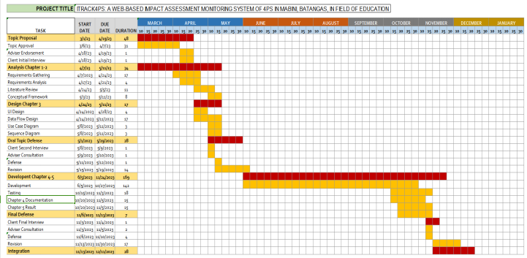The Gantt Chart is a key instrument in project management since it displays the project timeline and tasks graphically. As shown in Figure 14, it helps the team to plan and manage project deadlines, assign resources efficiently, assess progress against the baseline plan, and make real-time modifications to assure project success.

Figure 16. Gant Chartt

The Gantt Chart for this project shows a list of major tasks, including project planning, design, coding, testing, and deployment. Each task is divided into smaller sub-tasks, allocated to one or more team members, and dated based on expected start and end dates. Tasks that occur in parallel or have dependencies are logically connected to demonstrate the general order and logic of the project plan.

# APPENDIX C

## PROJECT ROLES AND RESPONSIBILITIES

Table 18 shows the roles or responsibilities of each researcher throughout the study, whereas the team's organizational structure is designated as Domain Specialist. In relation to this, the researcher worked effectively where each researcher has specific expertise and knowledge in a range of disciplines.

**Table 18.**

Roles and Responsibilities

|  |  |
| --- | --- |
| **Name** | **Responsibilities** |
| Banaag, Danica Rose D. | FrontEnd Developer / Documenter |
| Celis, Monalenne Joy M. | UI/UX Designer / FrontEnd Developer / Documenter |
| Montealto, Mark Lowel R. | Lead Developer / System Tester |

Table 10 presents a comprehensive breakdown of the roles and responsibilities assigned to three key individuals involved in the study. Banaag, Danica Rose D., is designated as a Front-End Developer and Documenter, responsible for the creation of the visible and interactive elements of the project, along with documentation tasks. Celis, Monalenne Joy M., is in charge of the UI/UX Designer, Front-End Developer, and Documenter roles. Their responsibilities encompass designing the User Interface and User Experience, contributing to the visual components, and documenting project progress. Finally, Montealto, Mark Lowel R., takes on the responsibilities of Lead Developer and System Tester. Their role involves guiding the developmental process and conducting system testing procedures to ensure the system's functionality and reliability. This table highlights the specific tasks and roles assigned to each team member, showing their different responsibilities as they contribute to the study's development and evaluation phases.

# APPENDIX D

## USER MANUAL

**ADMIN**

1. Visit [https://itrack4ps.solutions/#/login](https://itrack4ps.solutions/%23/login%20) to direct in “Login Page”. 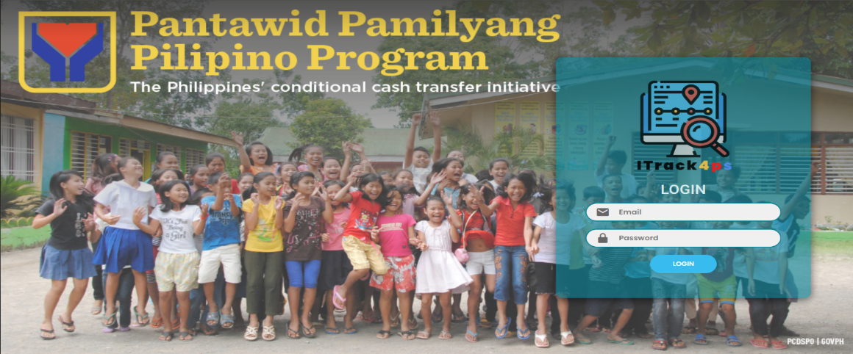

Figure 17. Login Page

1. Once you Login your Account you can now go to the main page which is the “Dashboard”. The “Login Successful” appear after clicking the login button. After logging into your account, you can proceed to the main page, known as the 'Dashboard.' Here, various graphs are displayed, representing different statuses of 4P's beneficiaries. It's easier to understand the information based on these graphical representations.

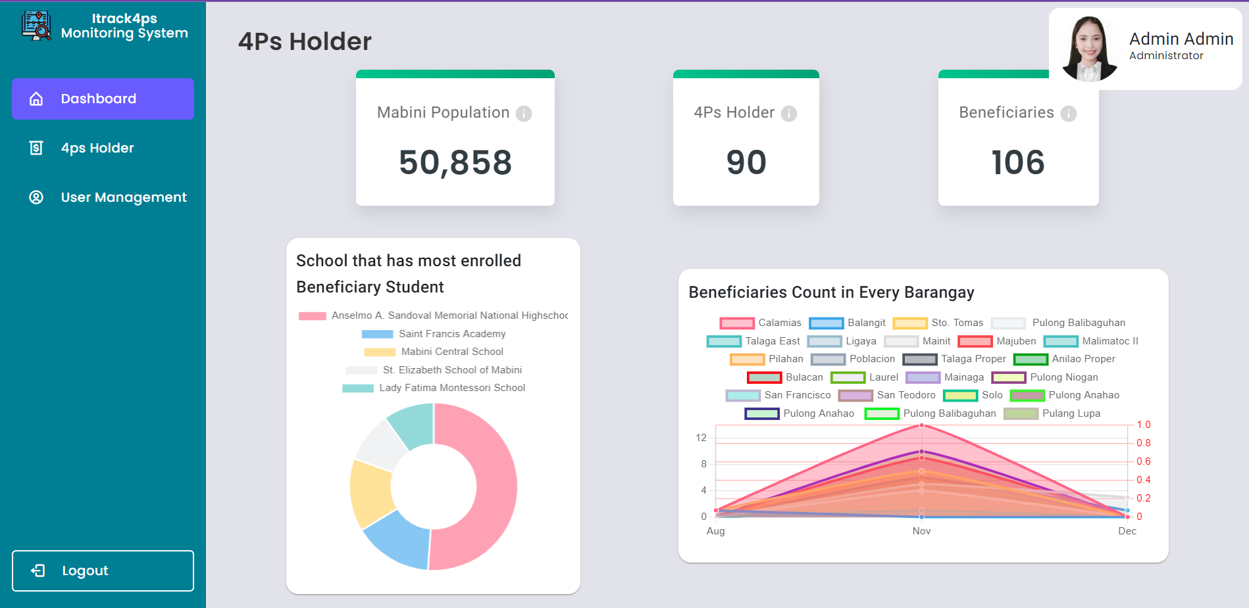

Figure 18. Admin Dashboard

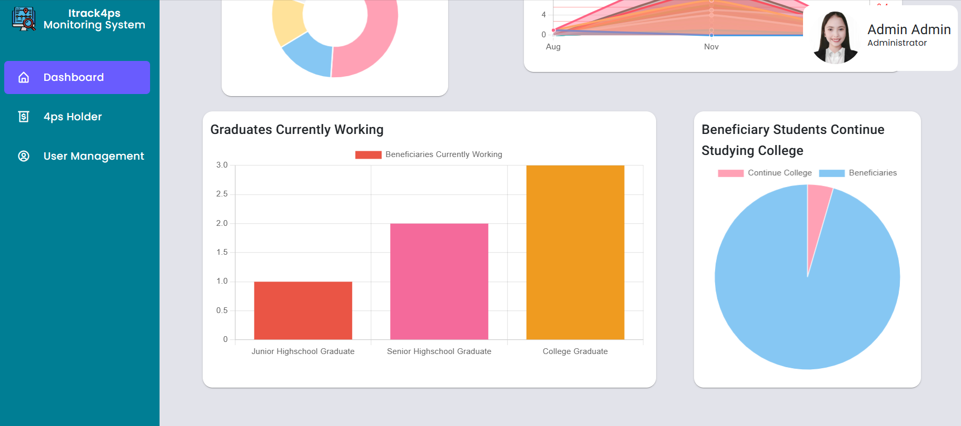

Figure 19. Graphs of Graduates Currently Working & Beneficiary Student Continue Studying College

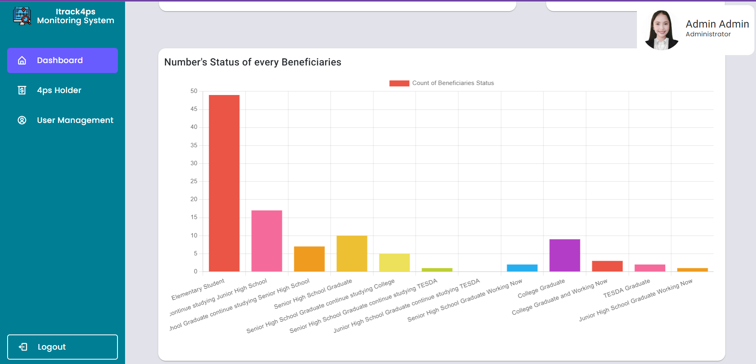

Figure 20. Numbers of Status of Every Beneficiaries

1. On the right side of the screen, the user see the “Dashboard”, “4P’s Holder”, “User Management” And “Logout”.
2. Clicking the “4P’s Holder” button directs you to the list of all beneficiaries that staff have inputted. Here, you can easily find all 4P’s holders in the list. As you can see on the left side, they have 4 button which is the “VIEW INFORMATION”, “EDIT”, “ARCHIVE”, and “VIEW CHILD BENEFICIARY”

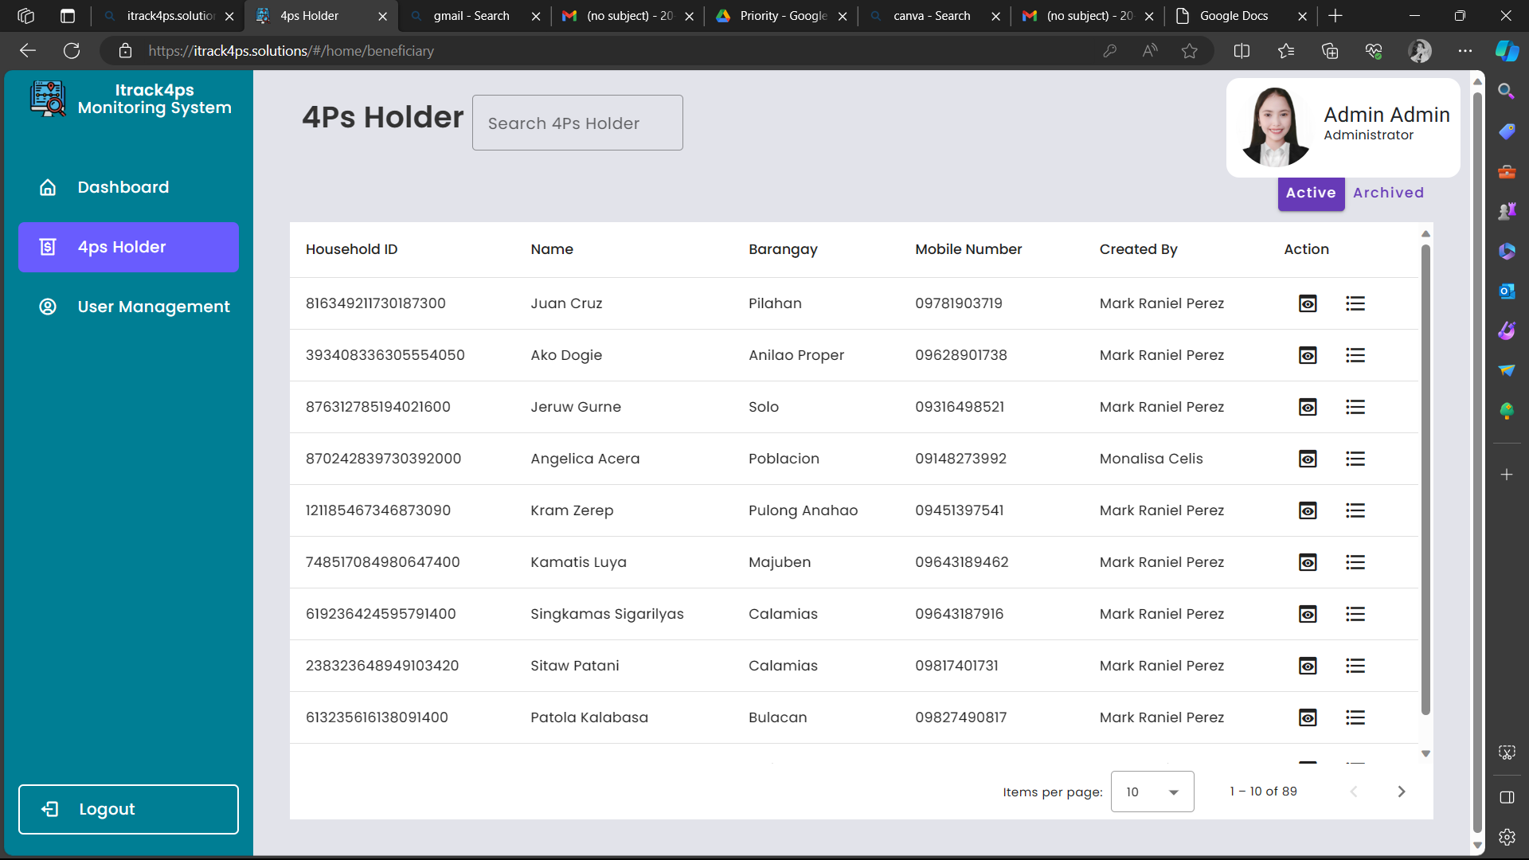

Figure 21. 4ps Holder Page

VIEW INFORMATION:

When you click on “VIEW” the user directed to the 4P’s Holder Information page, where you can view all of their details.

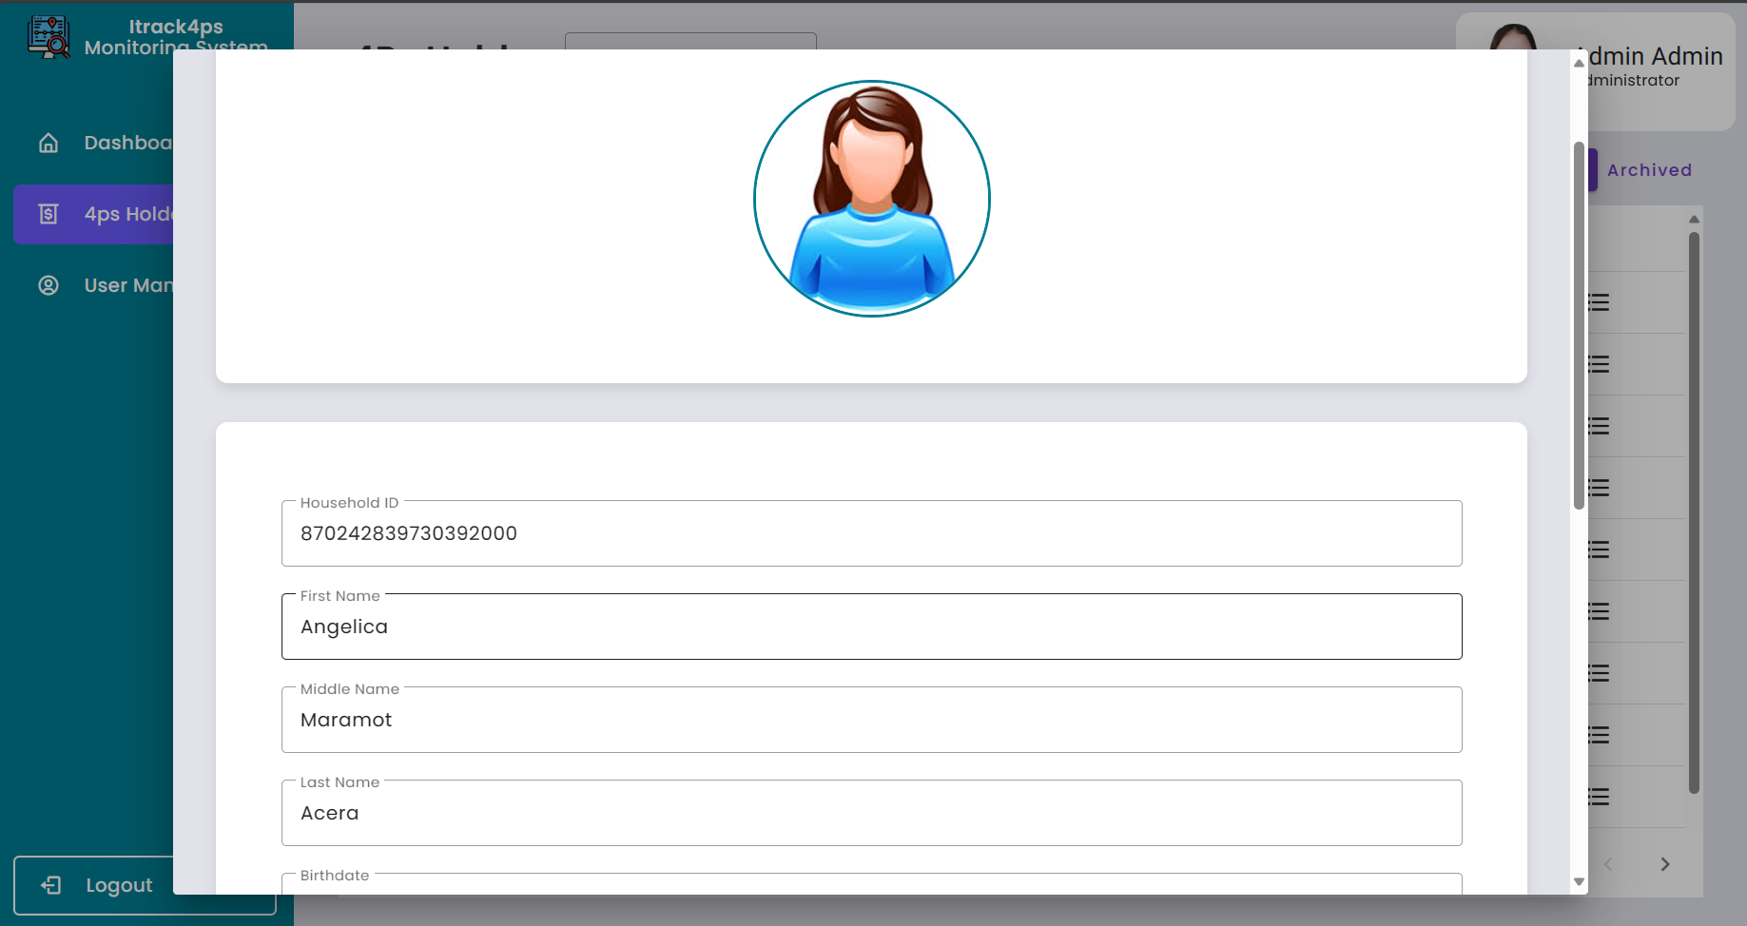

Figure 22. View Information of 4ps Holder

VIEW CHILD BENEFICIARY:

When you Click the “VIEW CHILD BENEFICIARY, the user directed to the Child Beneficiary page, where you can see all the Beneficiaries and also you can add Beneficiary on the list.

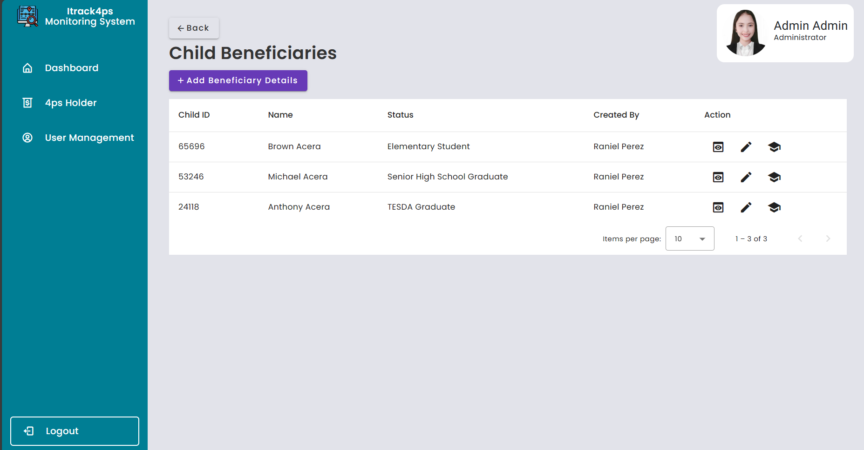

Figure 23. Child Beneficiaries Page

1. Next is the Search button, the purpose of this is for you to find the 4P’s holder or Beneficiaries that need to edit and update their information details.

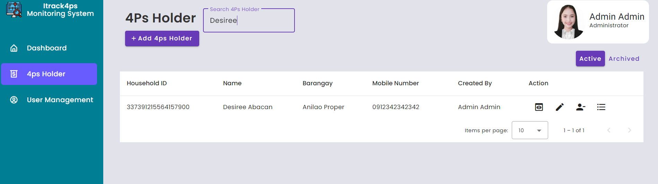

Figure 24. Search Button

1. When you click the “USER MANAGEMENT”, the user directed to the list of Staff names. Only the Admin has the access and authority to add staff accounts. Here, you can see all the accounts that the admin has add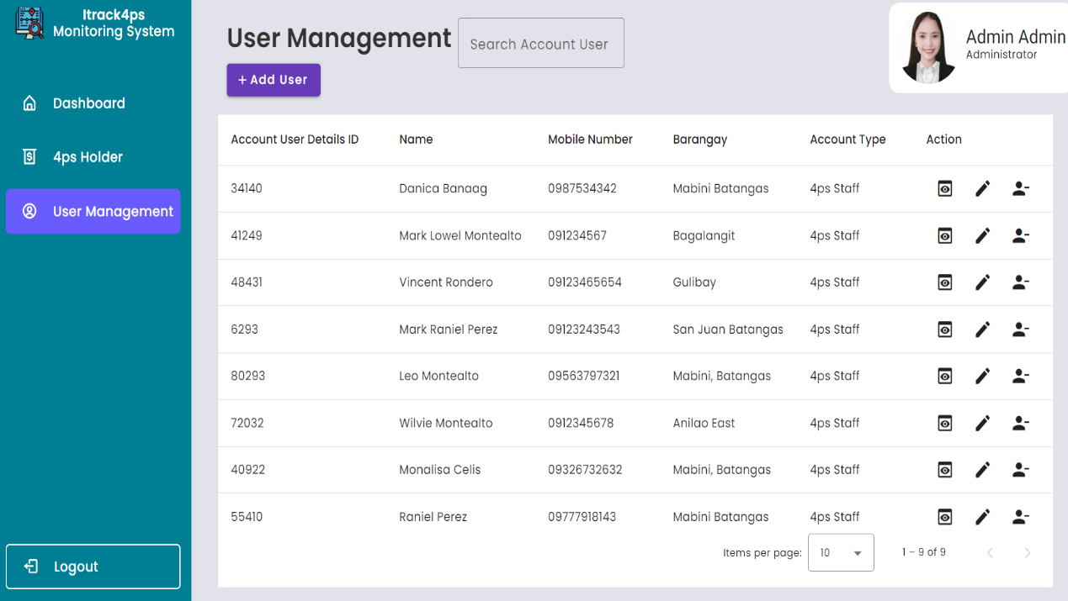

Figure 25. User Management Page

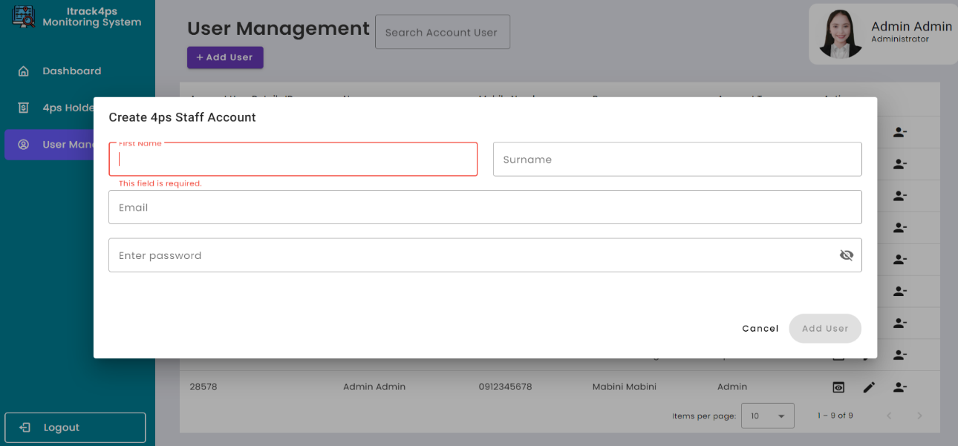 Clicking the “ADD USER” directs you to the Create 4P’s Staff Account, where you can add 4P’s Staff acc.

Figure 26. Add User Modal

1. Lastly is Clicking the “Logout '' button, once you are done fill out the form and add users then click the logout button and the user directed to the Login page again.

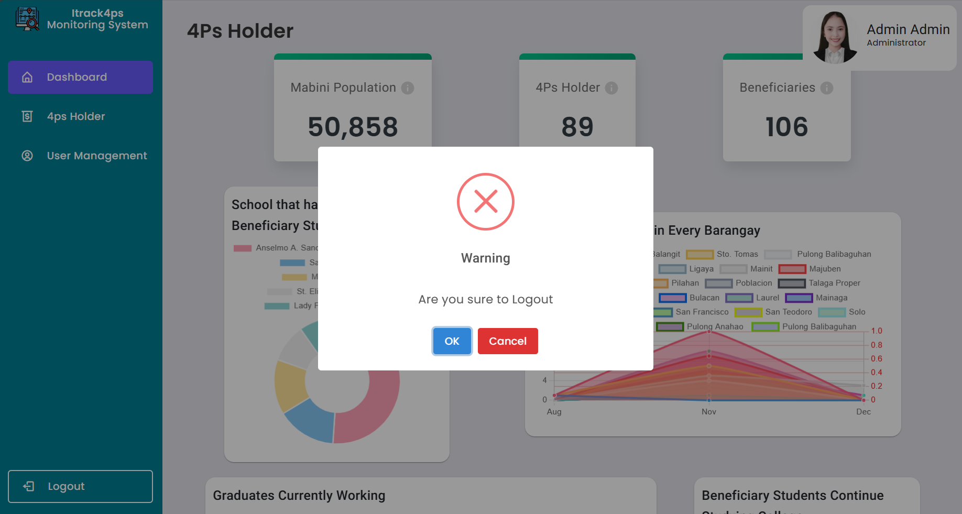

Figure 27. Logout Modal

**4P’S STAFF**

1. Visit [https://itrack4ps.solutions/#/login](https://itrack4ps.solutions/%23/login%20) to direct in “Login Page”.

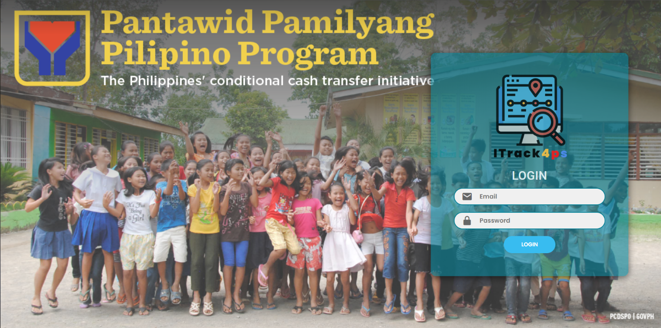

Figure 28. Login Page

1. Clicking the “4P’s Holder” button directs you to the list of all beneficiaries that staff have inputted. Here, you can easily find all 4P’s holders in the list. As you can see on the left side, they have 4 button which is the “VIEW INFORMATION”, “EDIT”, “ARCHIVE”, and “VIEW CHILD BENEFICIARY”

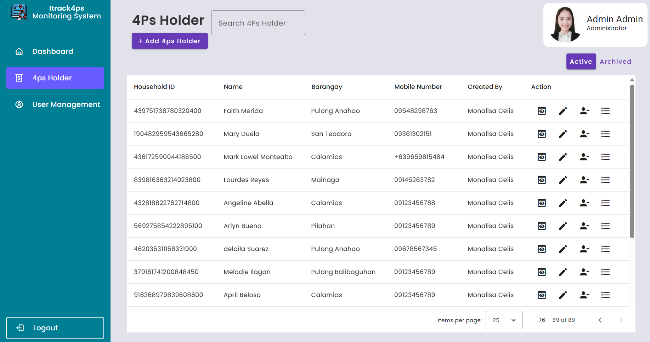

Figure 29. 4ps Holder Page of 4ps Staff

VIEW INFORMATION:

When you click on “VIEW” the user directed to the 4P’s Holder Information page, where you can view all of their details.



Figure 30. View Information of 4ps Staff

EDIT:

When you click on “EDIT”, the user directed to the Edit Information page, where you can edit all of their details.

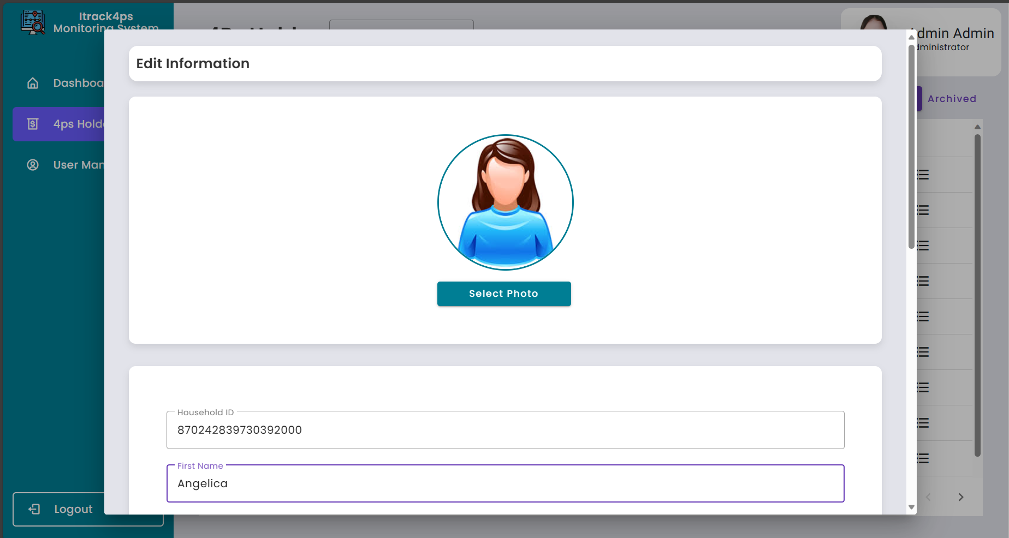

Figure 31. Update Information of 4ps Holder

ARCHIVE:

When you click the “ARCHIVE”, the warning pop up on the screen asking if “Are you sure you want to archived” this 4P’s Holder.

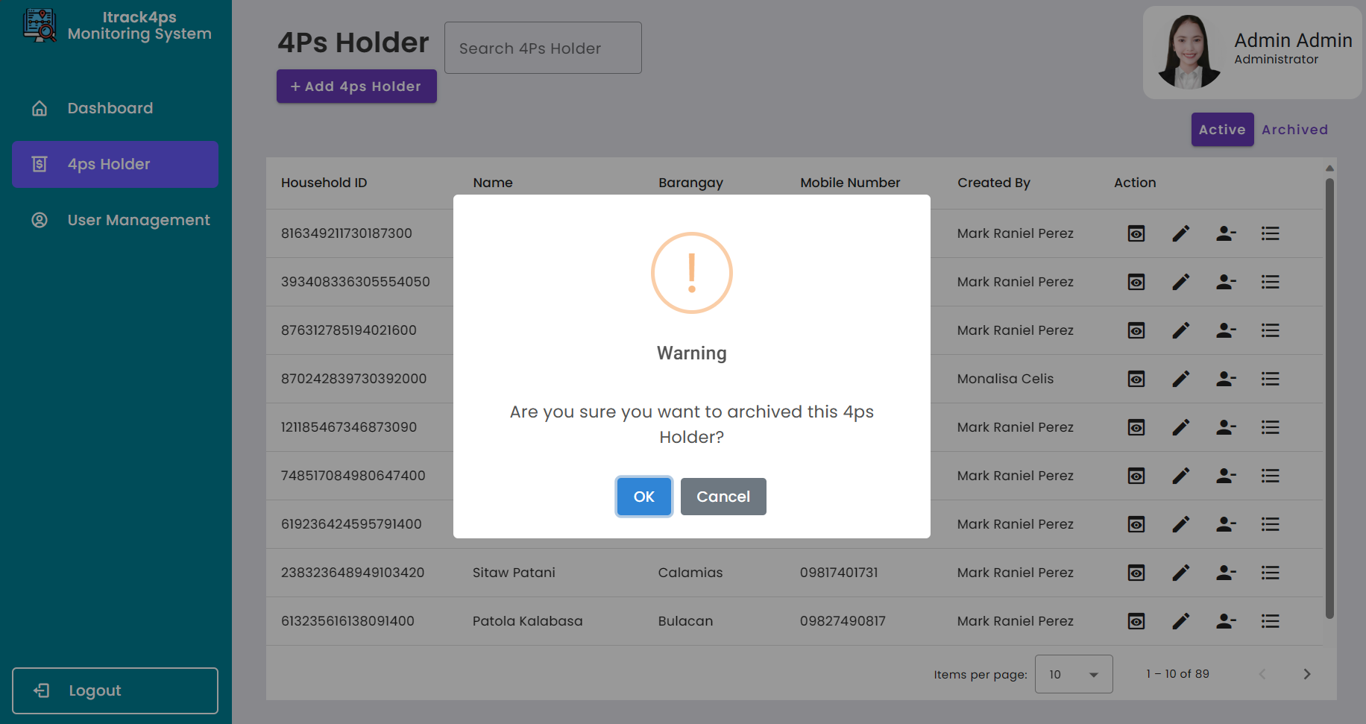

Figure 32. Archiving 4ps Holder

VIEW CHILD BENEFICIARY:

When you Click the “VIEW CHILD BENEFICIARY”, you are directed to the Child Beneficiary page, where you can see all the Beneficiaries and also you can add Beneficiary on the list.

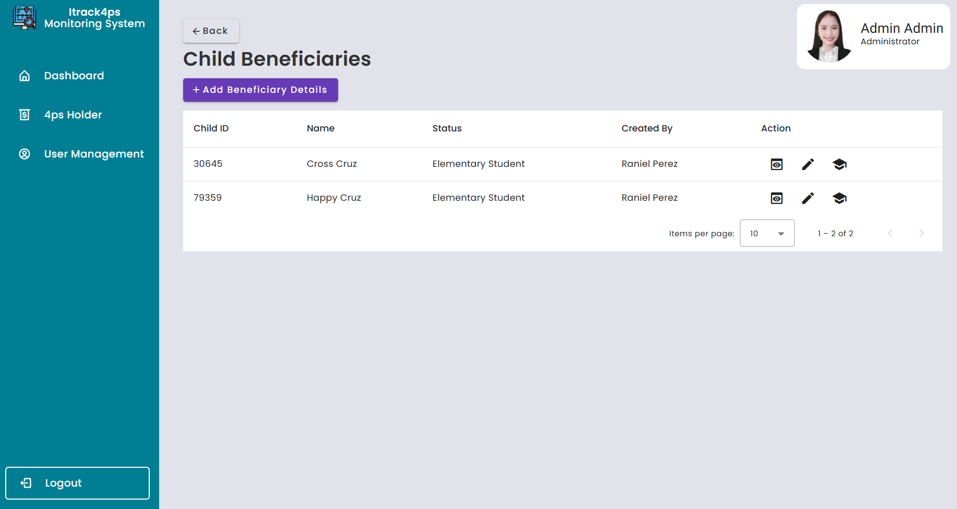

Figure 33. Child Beneficiaries Page

This page is for “ADD BENEFICIARY DETAILS”, If the holder has multiple children, all beneficiaries should be included in the list.

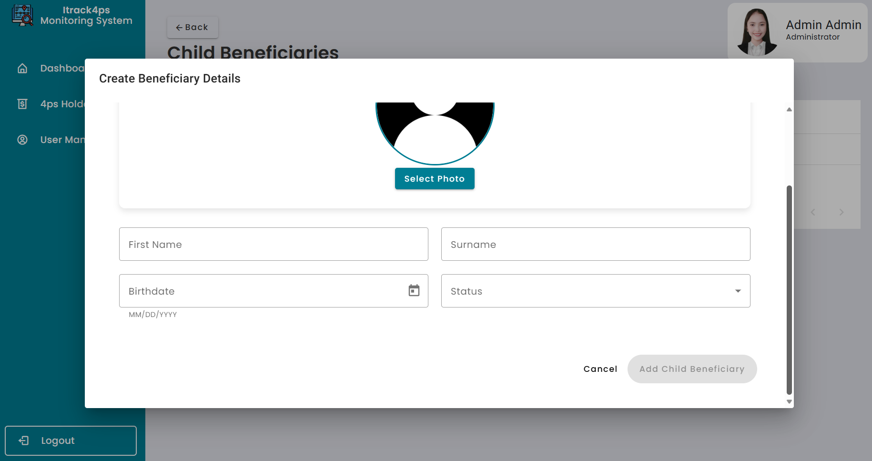

Figure 34. Create Child Beneficiary Details

1. And on the right side you can see the “ADD 4P’s HOLDER” , When you click that button you’ll be directed to the Input 4P’s Holder Information page,

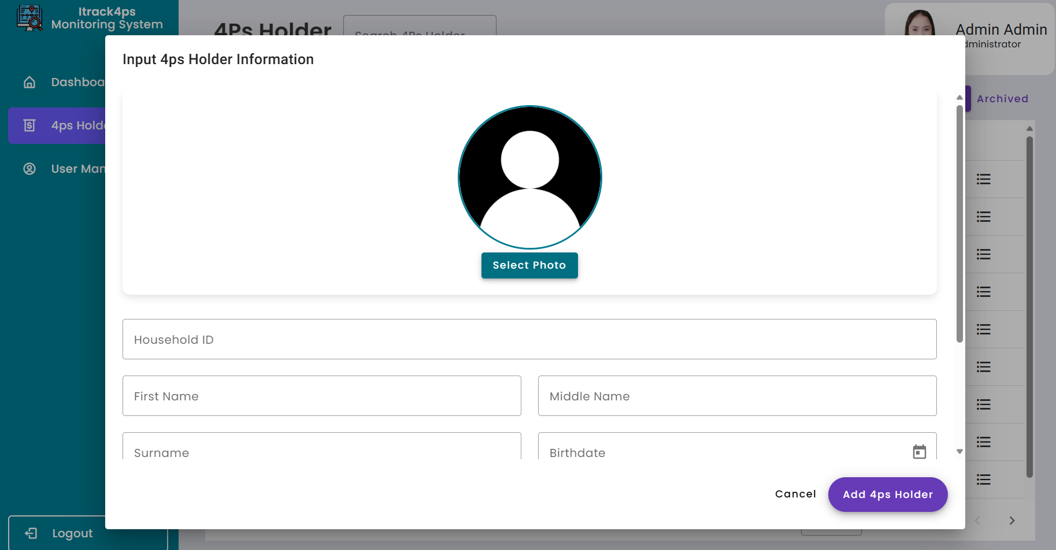

Figure 35. Add 4ps Holder Information

1. Next is the Search button, the purpose of this is for you to find the 4P’s holder or Beneficiaries that need to edit and update their information details.

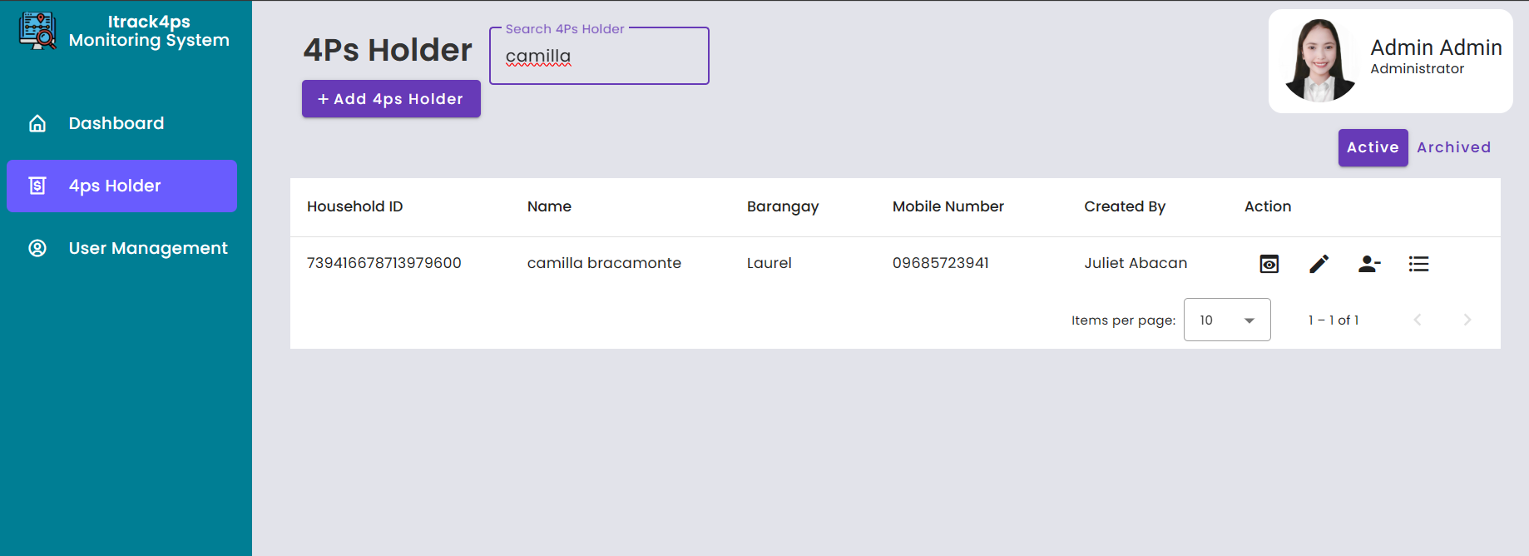

Figure 36. Search Button 4ps Staff in Holder Page

1. Lastly is Clicking the “Logout '' button, once you are done fill out the form and add users then click the logout button and you are directed to the Login page again.

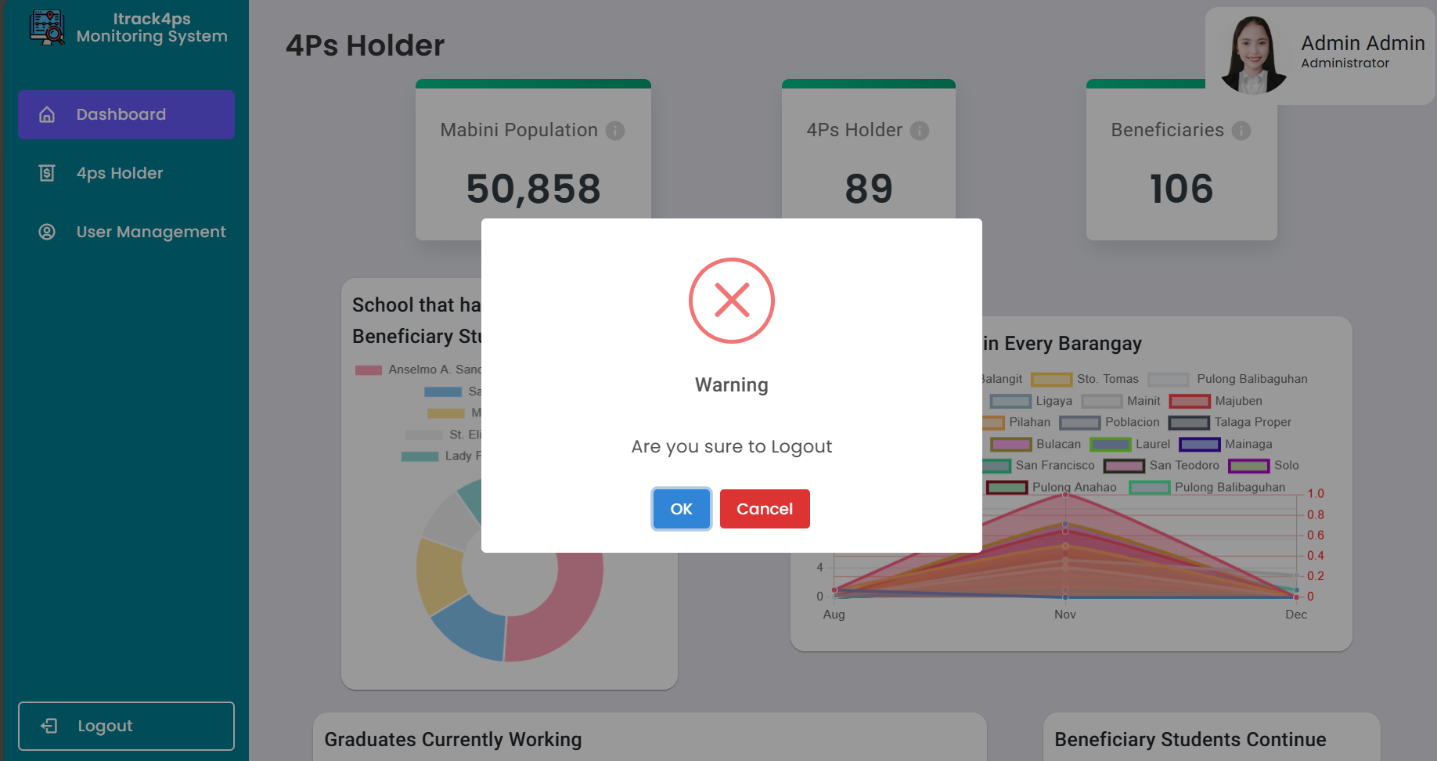

Figure 37. Logout Modal of 4ps Staff

# APPENDIX E

## BIO NOTE



**Monalenne Joy Celis**, a forward-thinking and proactive fourth-year student with a focus on Business Analytics, distinguishes herself as a leader possessing a natural inclination to take the initiative and confront challenges. Renowned for her unwavering work ethic and quick learning prowess, Monalenne is driven by a profound eagerness to expand her knowledge base and foster collaborative endeavors. Her academic achievement has consistently earned her the honor of being a three-time Dean's Lister Awardee at Batangas State University. Her commitment to continuous growth is evident through her active participation in various seminars and training programs, such as the AWS Cloud Practitioner Essentials and the DICT Step Up Acceleration Program. With a diverse field of interest spanning UI/UX Design, Data Analytics, Responsive Design, Data Visualization, and Web Development, Monalenne demonstrates a well-rounded understanding of the dynamic intersection between technology and design.



**Danica Rose De Mesa Banaag**, A Student from Batangas State University - The National Engineering University, taking up Bachelor of Science in Information Technology major in Business Analytics. She is the child of Decena Banaag and Damian Banaag, and she is also the fifth among siblings. Born on March 18, 2002, Batangas City. The student who is eager to learn about everything, pursue challenges, and face obstacles in life and attending seminars about the IT industry can help boost and broaden her knowledge. She joins in the DICT Startup Training Program, knowing that it be beneficial, particularly in honing her skills to confidently engage with diverse groups of people and interact with other professionals.



**Mark Lowel Montealto** is an Information Technology student, Photo Editor, and Video Editor. He has experience as a Cloud Engineer and Full Stack Web Developer, specializing in web development, web design, and graphic design. Mark is skilled in developing dynamic and responsive web applications using the Angular framework, collaborating with UX/UI designers to create visually appealing interfaces. He is proficient in desktop support, troubleshooting hardware and software issues, and implementing security protocols. Mark is also passionate about quality assurance and technical support, conducting thorough testing and identifying defects to ensure product quality. Additionally, he is actively involved in various tech communities, sharing his knowledge through speaking engagements and volunteering in events. Mark stays updated on the latest industry trends and technologies to enhance his skills and deliver high-quality work.

# Appendix F

## Survey Questionaires

## 4ps Staff

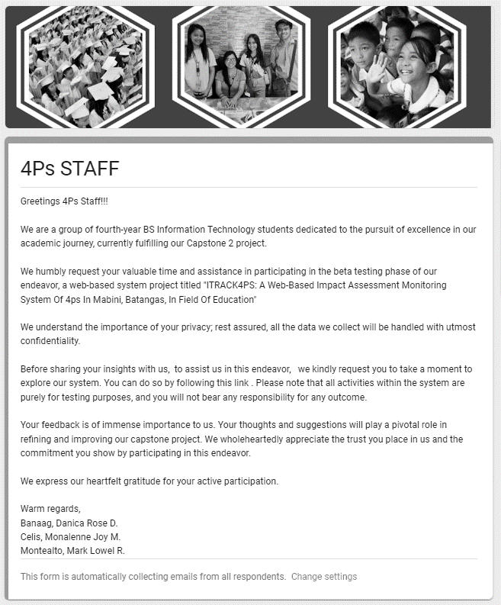

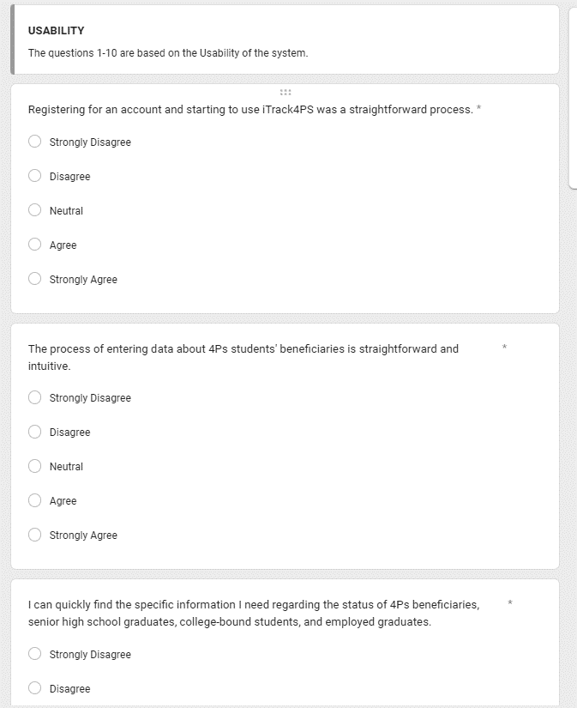

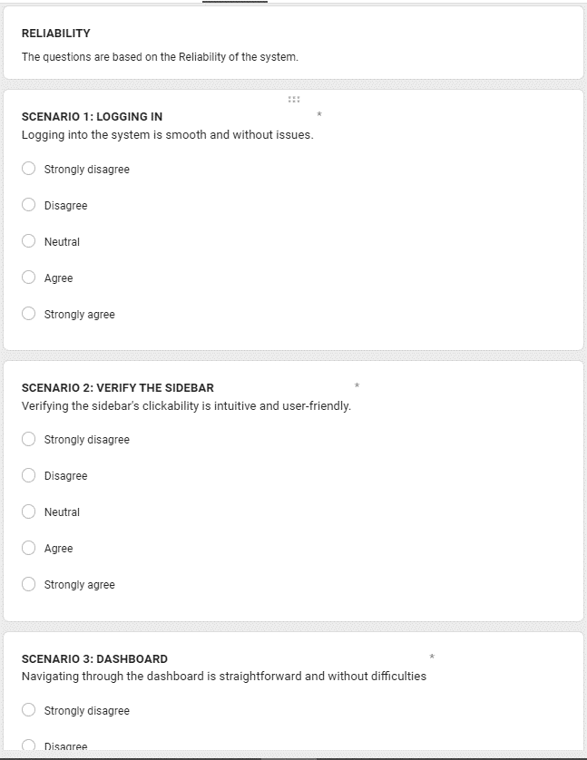

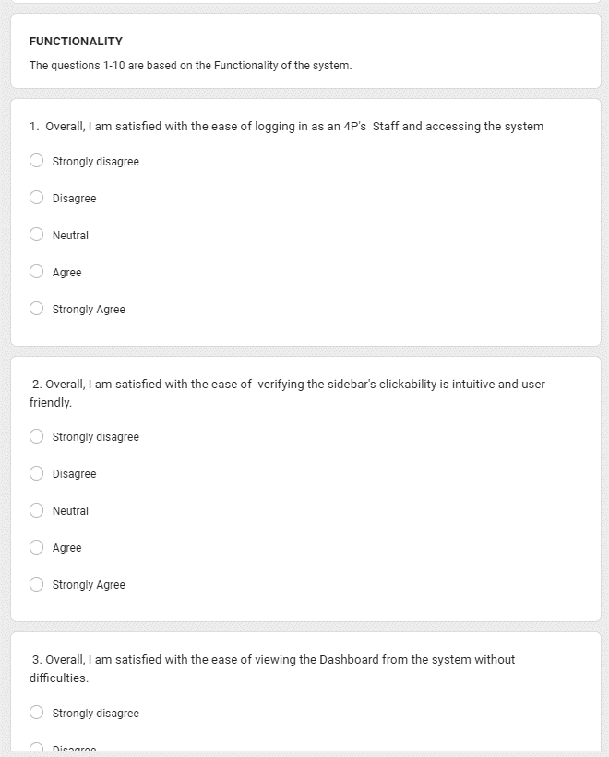

## Admin

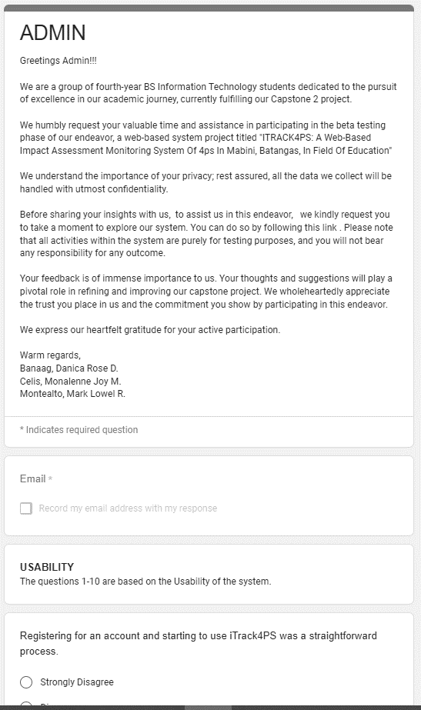

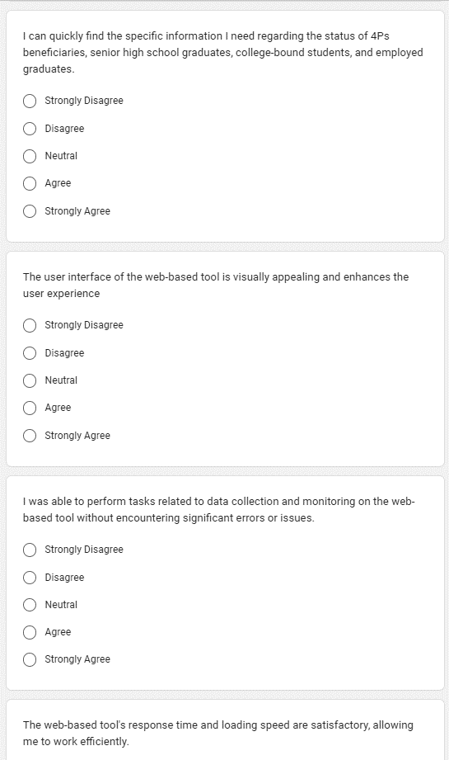

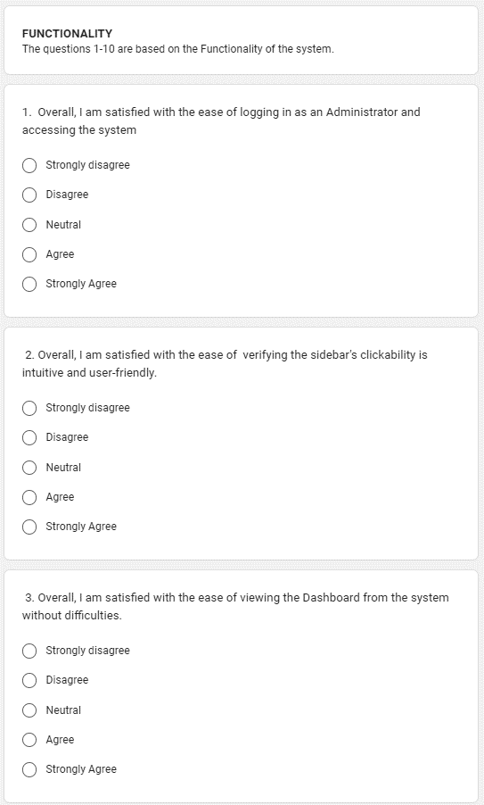

# Bibliography

Orbeta Jr., A. C., M. Melad, K. A., & V. Araos, N. V. (2021, April 2). *Reassessing the Impact of the Pantawid Pamilyang Pilipino Program: Results of the Third Wave Impact Evaluation*. Think Asia. <https://think-asia.org/handle/11540/13173>

Flores, M. J. S., Espinoza, C. A. B., Enrico, H. C., & Casimiro, R. R. (2019, June 11). Pantawid Pamilyang Pilipino Program (4Ps): Its Effect on the Academic Performance of Student-Beneficiaries in Calaba National High School in the Philippines. *Journal of Public Administration and Governance*, *9*(2), 193. <https://doi.org/10.5296/jpag.v9i2.14762>

*Impact assessment of outcome-based approach in engineering education in India*. (2020, June 16). Impact Assessment of Outcome Based Approach in Engineering Education in India - ScienceDirect. <https://doi.org/10.1016/j.procs.2020.05.113>

Bradley, D. E. J., Board, D. L., Archer, D. D., & Morgans, M. (2022, November). Evaluation of entrustable professional activities and competency assessment in sport and exercise sciences in higher education: Student perceptions of the impact on learning. *Journal of Hospitality, Leisure, Sport & Tourism Education*, *31*, 100402. <https://doi.org/10.1016/j.jhlste.2022.100402>

Chudinsky, R. M., Malev, V. V., Maleva, A. A., Dubov, V. M., & Kubryakov, E. A. (2022, July 1). Monitoring quality assessment models in general education in the Russian Federation and developing tools to implement best practices. *Perspectives of Science and Education*, *57*(3), 715–737. <https://doi.org/10.32744/pse.2022.3.41>

De Los Reyes, B. X. E., Azarias, R., Mamaclay, K. E., Carranza, C. A., Rayray, A., Directo Jr, F. A., & G Orpilla, J. R. (2022, August 9). Rang-Ay Babaen ti 4Ps: Its Impact to Selected Ilokano Beneficiaries in Santiago, Ilocos Sur, Philippines. *American of Interdisciplinary Research and Innovation*, *1*(1), 44–49. [https *Journal*://doi.org/10.54536/ajiri.v1i1.451](https://doi.org/10.54536/ajiri.v1i1.451)

JDulliyao, R. (2019, July 31). THE IMPLEMENTATION OF PANTAWID PAMILYANG PILIPINO PROGRAM(4PS) AND ITS SOCIOECONOMIC IMPACT TO THE LIVING STANDARDS OF THE BENEFICIARIES IN TABUK CITY. *International Journal of Advanced Research*, *7*(7), 291–303. <https://doi.org/10.21474/ijar01/9360>

Kowalski, D., & Suchorab, P. (2023, January 25). The Impact Assessment of Water Supply DMA Formation on the Monitoring System Sensitivity. *Applied Sciences*, *13*(3), 1554. <https://doi.org/10.3390/app13031554>

Zsakai, A., Annar, D., Koronczai, B., Molnar, K., Varro, P., Toth, E., Szarvas, S., Tauber, T., Karkus, Z., Varnai, D., & Muzsnai, A. (2023, March 13). A new monitoring system for nutritional status assessment in children at home. *Scientific Reports*, *13*(1). <https://doi.org/10.1038/s41598-023-30998-x>

Havrda, M., & Klocek, A. (2023, April). Well-Being Impact Assessment of Artificial Intelligence - a Search for Causality and Proposal for an Open Platform for Well-Being Impact Assessment of AI Systems. *Evaluation and Program Planning*, 102294. <https://doi.org/10.1016/j.evalprogplan.2023.102294>

Osiesi, M. P. (2023, March 25). Assessment, Evaluation and Monitoring of Teaching and Learning in Nigeria Primary Schools: Challenges and Implications for Teachers. *Utamax : Journal of Ultimate Research and Trends in Education*, *5*(1), 70–81. <https://doi.org/10.31849/utamax.v5i1.12571>

Parreno, N. H. (2022, January 4). Pantawid Pamilyang Pilipino Program (4Ps) Beneficiaries: An Analysis of Their Satisfaction Levels. *International Journal of Multidisciplinary Research and Analysis*, *05*(01). <https://doi.org/10.47191/ijmra/v5-i1-01>

Tiu, C., S. Piollo, M., C.Guerra, D., B.Olaivar, R., D.Ariar, M., & Ederio, N. (2022, January 31). Cash Benefits of the Pantawid Pamilyang Pilipino Program (4ps) in Surigao Del Norte, Philippines. *International Journal of Science and Management Studies (IJSMS)*, 89–95. <https://doi.org/10.51386/25815946/ijsms-v5i1p110>

Chen, M. J., Guo, C. Y., & Tang, C. W. (2022, June). Monitoring learning-oriented school education: Indicator construction and their application. *Studies in Educational Evaluation*, *73*, 101142. <https://doi.org/10.1016/j.stueduc.2022.101142>

Lillywhite, B., & Wolbring, G. (2023, January 3). *Auditing the impact of artificial intelligence on the ability to have a good life: using well-being measures as a tool to investigate the views of undergraduate STEM students - AI & SOCIETY*. SpringerLink. [https://doi.org/10.1007/s00146-022-01618-5](https://doi.org/10.1007/s00146-022-01618-5/)

[B. Omaweng, J. B. (2022, August 29). Perceived Factors Affecting Academic Performance of Pantawid Pamilyang Pilipino Program (4Ps) Beneficiaries of Apayao State College. *Asian Research Journal of Arts & Social Sciences*, 1–11.](https://doi.org/10.1007/s00146-022-01618-5/) <https://doi.org/10.9734/arjass/2022/v18i330337>

[Ramos, A. D. (2022, June 15). The effectiveness of Pantawid Pamilyang Pilipino Program (4P’s) in the education and welfare of selected pupil recipient in Rosario, Batangas: Basis for policy improvement. *International Journal of Research Studies in Education*, *10*(5).](https://doi.org/10.1007/s00146-022-01618-5/) <https://doi.org/10.5861/ijrse.2021.638>

[B. Busaing, J. C. E. (2020). Assessment on the Outcome of the Pantawid Pamilyang Pilipino Program in Tabuk City, Kalinga. *International Journal of English Literature and Social Sciences*, *5*(6), 2378–2391.](https://doi.org/10.1007/s00146-022-01618-5/) <https://doi.org/10.22161/ijels.56.75>

[De Vera, Pedrosa, Largo, Chua, & Botona. (2018). *Earthquake Impact Assessment using REDAS Software in Selected Barangays in Region XI*. Philippine E-Journals.](https://doi.org/10.1007/s00146-022-01618-5/) <https://ejournals.ph/article.php?id=13292>

L. De Castro, P. J., G. Cantos, M. C., & D. Oabel, M. E. (2017). *Development and Validation of a Web-Based Self-Assessment Tool in General Chemistry for College Students*. Philippine EJournals| Development and Validation of a Web-Based Self-Assessment Tool in General Chemistry for College Students. Retrieved May 3, 2023, from <https://ejournals.ph/article.php?id=14677&fbclid=IwAR3Jbm5ne-W7dQu6NxOAy5JFbDncqy8jVoZ-RL6864_g1RYciVylBlKlUZk>

F. Teoxon, A. M., & Sumile, E. B. (2020). *IMPACT ASSESSMENT ON THE EFFECTIVENESS OF THE MAGSASAKA SIYENTISTA (MS)-LED COMMUNITY-BASED BANANA FARMING SYSTEM IN THE PROVINCE OF DAVAO ORIENTAL*. Philippine EJournals| IMPACT ASSESSMENT ON THE EFFECTIVENESS OF THE MAGSASAKA SIYENTISTA (MS)-LED COMMUNITY-BASED BANANA FARMING SYSTEM IN THE PROVINCE OF DAVAO ORIENTAL. Retrieved May 3, 2023, from <https://ejournals.ph/article.php?id=15475&fbclid=IwAR1b5uIycvNdHe1ueYuABKTlywNtC5u7j3wI21GqYXA00ZK0LA53ywZKROY>

FICS M.D. Harris D. Macapeges, M. F. (2019). *ASSESSMENT OF THE MANAGEMENT INFORMATION SYSTEM IN THE MEDICAL SERVICE OF A PROVINCIAL HOSPITAL*. Philippine EJournals| ASSESSMENT OF THE MANAGEMENT INFORMATION SYSTEM IN THE MEDICAL SERVICE OF a PROVINCIAL HOSPITAL. Retrieved May 3, 2023, from <https://ejournals.ph/article.php?id=17848&fbclid=IwAR13XRevi_1E5SSwHtK0Gs-B7FJk0U7XcLFOifOJBjhy8fXWIwnQ4hbSJCs>

Kalkhambkar, V., & Gaikwad, H. (2023, January 1). E-Learning for Engineering Education During Covid 19 and Impact Assessment. *Journal of Engineering Education Transformations*, *36 (S2*), 336–344. <https://doi.org/10.16920/jeet/2023/v36is2/23050>

*FDS | Pantawid Pamilyang Pilipino Program*. (n.d.). FDS | Pantawid Pamilyang Pilipino Program. https://pantawidnew.dswd.gov.ph/fds/#:~:text=Family%20Development%20Session%20(FDS)%20is,children%3B%20promotion%20of%20positive%20family

Parreno, N. H. (2022, January 4). Pantawid Pamilyang Pilipino Program (4Ps) Beneficiaries: An Analysis of Their Satisfaction Levels. *International Journal of Multidisciplinary Research and Analysis*, *05*(01). https://doi.org/10.47191/ijmra/v5-i1-01

SASIS, P. L., PELENIO, E., & DALDE, M. N. (2019, June 1). The Impact of Pantawid Pamilyang Pilipino Program (4Ps) to its Beneficiaries The Impact of Pantawid Pamilyang Pilipino Program (4Ps) to its Beneficiaries Personnel: Basis for Human Resource Development Program Teamwork Practices of a Private Catholic College Among Personnel. *SMCC Higher Education Research Journal*, *1*(1). https://doi.org/10.18868/sherjba.01.060119.08

B. Omaweng, J. B. (2022, August 29). Perceived Factors Affecting Academic Performance of Pantawid Pamilyang Pilipino Program (4Ps) Beneficiaries of Apayao State College. *Asian Research Journal of Arts & Social Sciences*, 1–11. https://doi.org/10.9734/arjass/2022/v18i330337

Olapane, E. C., Fernandez, M. J. E., & Payongayong, B. G. D. (2021, November 28). A Trend Analysis on Pantawid Pamilyang Pilipino Program (4Ps) in the Philippines. *Journal of Humanities and Social Sciences Studies*, *3*(11), 111–121. https://doi.org/10.32996/jhsss.2021.3.11.10

C. Tiu, C., S. Piollo, M., C.Guerra, D., B.Olaivar, R., D.Ariar, M., & Ederio, N. (2022, January 31). Cash Benefits of the Pantawid Pamilyang Pilipino Program (4ps) in Surigao Del Norte, Philippines. *International Journal of Science and Management Studies (IJSMS)*, 89–95. https://doi.org/10.51386/25815946/ijsms-v5i1p110

Aucamp, I., & Woodborne, S. (2019, October 13). Can social impact assessment improve social well-being in a future where social inequality is rife? *Impact Assessment and Project Appraisal*, *38*(2), 132–135. https://doi.org/10.1080/14615517.2019.1676068

Addas, A., & Maghrabi, A. (2021, April 14). Social Evaluation of Public Open Space Services and Their Impact on Well-Being: A Micro-Scale Assessment from a Coastal University. *Sustainability*, *13*(8), 4372. https://doi.org/10.3390/su13084372

Havrda, M., & Klocek, A. (2023, April). Well-Being Impact Assessment of Artificial Intelligence - a Search for Causality and Proposal for an Open Platform for Well-Being Impact Assessment of AI Systems. *Evaluation and Program Planning*, 102294. https://doi.org/10.1016/j.evalprogplan.2023.102294

Higgins, O., Short, B. L., Chalup, S. K., & Wilson, R. L. (2023, February 6). Artificial intelligence ( AI ) and machine learning ( ML ) based decision support systems in mental health: An integrative review. *International Journal of Mental Health Nursing*. https://doi.org/10.1111/inm.13114

Peksen, M., & Spliethoff, H. (2023, March). Optimising pre-reforming for quality r-SOC syngas preparation using artificial intelligence (AI) based machine learning (ML). *International Journal of Hydrogen Energy*. https://doi.org/10.1016/j.ijhydene.2023.03.223

Zhang, X., Chan, F. T., Yan, C., & Bose, I. (2022, August). Towards risk-aware artificial intelligence and machine learning systems: An overview. *Decision Support Systems*, *159*, 113800. https://doi.org/10.1016/j.dss.2022.113800

Cüce, H., & Özçelik, D. (2022, September 8). Application of Machine Learning (ML) and Artificial Intelligence (AI)-Based Tools for Modelling and Enhancing Sustainable Optimization of the Classical/Photo-Fenton Processes for the Landfill Leachate Treatment. *Sustainability*, *14*(18), 11261. https://doi.org/10.3390/su141811261

Kobau, R., Sniezek, J., Zack, M. M., Lucas, R. E., & Burns, A. (2010, May 25). Well-Being Assessment: An Evaluation of Well-Being Scales for Public Health and Population Estimates of Well-Being among US Adults. *Applied Psychology: Health and Well-Being*, *2*(3), 272–297. https://doi.org/10.1111/j.1758-0854.2010.01035.x

Lillywhite, B., & Wolbring, G. (2023, January 3). Auditing the impact of artificial intelligence on the ability to have a good life: using well-being measures as a tool to investigate the views of undergraduate STEM students. *AI & SOCIETY*. https://doi.org/10.1007/s00146-022-01618-5

Wigtil, C. J., & Henriques, G. R. (2015, July 26). The Relationship Between Intelligence and Psychological Well-Being in Incoming College Students. *Psychology of Well-Being*, *5*(1). https://doi.org/10.1186/s13612-015-0029-8

M, V. (2020). Assessment of the Psychological Well-Being of Teachers in the Covid-19 Pandemic. *Ergonomics International Journal*, *4*(5). https://doi.org/10.23880/eoij-16000256

*FAQs about the Pantawid Pamilyang Pilipino Program (4Ps)*. (n.d.). World Bank. https://www.worldbank.org/en/country/philippines/brief/faqs-about-the-pantawid-pamilyang-pilipino-program

Nasution, B. A., . E., Lumbanraja, P., & Muda, I. (2022, January 20). Analysis of Adaptive Model Success of Integrated Financial Information System through User Satisfaction in Local Governments. *Webology*, *19*(1), 2920. https://doi.org/10.14704/web/v19i1/web19194

Ltifi, H., Ben Mohamed, E., & ben Ayed, M. (2015, February 8). Interactive visual knowledge discovery from data-based temporal decision support system. *Information Visualization*, *15*(1), 31–50. https://doi.org/10.1177/1473871614567794

Ritchi, H., Fitri Evayanti, N., & Yusi Sari, P. (2021, September 17). A STUDY ON INFORMATION SYSTEMS SUCCESS: EXAMINING USER SATISFACTION OF ACCOUNTING INFORMATION SYSTEM. *Bina Ekonomi*, *24*(2), 1–14. https://doi.org/10.26593/be.v24i2.5084.1-14

Wan Othman, W. R., Fahmy, S., & Haslinda, N. (2022, June 20). Evaluating the Success of Information Systems based on System Quality, Information Quality and User Satisfaction. *International Journal of Integrated Engineering*, *14*(3). https://doi.org/10.30880/ijie.2022.14.03.019

Wan Othman, W. R., Fahmy, S., & Haslinda, N. (2022, June 20). Evaluating the Success of Information Systems based on System Quality, Information Quality and User Satisfaction. *International Journal of Integrated Engineering*, *14*(3). https://doi.org/10.30880/ijie.2022.14.03.019

Burda, D., & Teuteberg, F. (2015, August 14). Understanding Service Quality and System Quality Success Factors in Cloud Archiving From an End-User Perspective. *Information Systems Management*, *32*(4), 266–284. https://doi.org/10.1080/10580530.2015.1079998

Rouibah, K., Dihani, A., & Al-Qirim, N. (2020, July 1). Critical Success Factors Affecting Information System Satisfaction in Public Sector Organizations. *Journal of Global Information Management*, *28*(3), 77–98. https://doi.org/10.4018/jgim.2020070105

Trisnawati, N., Baridwan, Z., & Hariadi, B. (2017, December 30). INFORMATION SYSTEM QUALITY INFLUENCE ON ORGANIZATION PERFORMANCE: A MODIFICATION OF TECHNOLOGY-BASED INFORMATION SYSTEM ACCEPTANCE AND SUCCESS MODEL. *Russian Journal of Agricultural and Socio-Economic Sciences*, *72*(12), 107–114. https://doi.org/10.18551/rjoas.2017-12.13

Lenny, P. Y., & Kridanto, S. (2019, April). Analysis of user acceptance, service quality, and customer satisfaction of hospital management information system. *Journal of Physics: Conference Series*, *1193*, 012001. https://doi.org/10.1088/1742-6596/1193/1/012001

Kurti, I., Barolli, E., & Sevrani, K. (2014, April). Effective IT Governance in the Albanian Public Sector - A Critical Success Factors Approach. *The Electronic Journal of Information Systems in Developing Countries*, *63*(1), 1–22. https://doi.org/10.1002/j.1681-4835.2014.tb00451.x

Commodore, L., Ansong, E., Barnor, N. B. J., & Entsua Mensah, F. O. (2022). Enterprise Resource Planning (ERP) Post-Implementation Success in the Public Sector: The Mediating Role of Organisational Culture. *International Journal of Business Information Systems*, *1*(1), 1. https://doi.org/10.1504/ijbis.2022.10053613

Okeudo, G. N., & Margaret, O. N. (2013, May 11). The Impact of Marketing Mix (4Ps) on Warehousing Operations: Case Study of Unilever Nigeria PLC. *American Journal of Business and Management*, *2*(2). https://doi.org/10.11634/216796061302292

Pineda, M., & Fabella, F. E. (2019). The Lived Experiences of Former Pantawid Pamilyang Pilpino Program (4PS) Student-Beneficiaries. *SSRN Electronic Journal*. https://doi.org/10.2139/ssrn.3367381

Boulding, E. (1983, December). IMPACTS ON LOCAL COMMUNITIES OF PLANNING FOR PEACE. *Impact Assessment*, *2*(4), 34–41. https://doi.org/10.1080/07349165.1983.9725998

Buregeya, J. M., Loignon, C., & Brousselle, A. (2020, April). Contribution analysis to analyze the effects of the health impact assessment at the local level: A case of urban revitalization. *Evaluation and Program Planning*, *79*, 101746. https://doi.org/10.1016/j.evalprogplan.2019.101746

Dietz, T., & Pfund, A. (1988, December). AN IMPACT IDENTIFICATION METHOD FOR DEVELOPMENT PROGRAM EVALUATION. *Impact Assessment*, *6*(3–4), 137–145. https://doi.org/10.1080/07349165.1988.9725654

Rougier, E., Combarnous, F., & Fauré, Y. A. (2018, March). The “Local Economy” Effect of Social Transfers: An Empirical Assessment of the Impact of the Bolsa Família Program on Local Productive Structure and Economic Growth. *World Development*, *103*, 199–215. https://doi.org/10.1016/j.worlddev.2017.09.019

Boyce, M. R., & Katz, R. (2020, June). Rapid urban health security assessment tool: a new resource for evaluating local-level public health preparedness. *BMJ Global Health*, *5*(6), e002606. https://doi.org/10.1136/bmjgh-2020-002606

이란희, & Choi,Byung-Dae. (2014, December). Developing the Model of the Social Impact Assessment about Volunteer Work. *Journal of Local Government Studis*, *26*(4), 219–243. https://doi.org/10.21026/jlgs.2014.26.4.219

B. Omaweng, J. B. (2022, August 29). Perceived Factors Affecting Academic Performance of Pantawid Pamilyang Pilipino Program (4Ps) Beneficiaries of Apayao State College. *Asian Research Journal of Arts & Social Sciences*, 1–11. https://doi.org/10.9734/arjass/2022/v18i330337

Aguado, A. (2021, June 1). Implementation of Pantawid Pamilyang Pilipino Program (4ps) in Barangay Talumpok, Batangas City. *International Journal of Research Studies in Education*, *10*(7). https://doi.org/10.5861/ijrse.2021.21603

Sarvimäki, A. (2006, January). Well-being as being well—a Heideggerian look at well-being. *International Journal of Qualitative Studies on Health and Well-Being*, *1*(1), 4–10. https://doi.org/10.1080/17482620500518101

Cantarella, A., Borella, E., Marigo, C., & De Beni, R. (2017, September 6). Benefits of Well-Being Training in Healthy Older Adults. *Applied Psychology: Health and Well-Being*, *9*(3), 261–284. https://doi.org/10.1111/aphw.12091

Soria-Lara, J. A., Bertolini, L., & te Brömmelstroet, M. (2015, January). Environmental impact assessment in urban transport planning: Exploring process-related barriers in Spanish practice. *Environmental Impact Assessment Review*, *50*, 95–104. https://doi.org/10.1016/j.eiar.2014.09.001

Barrios, E. T. (2018, February 22). pataBanana: A Web-Based Decision Support Application for Calculating the Fertilizer Amount Based on Soil Test Result. *Philippine Journal of Agricultural Economics*, *2*(1), 70–89. https://doi.org/10.7719/pjae.v2i1.547

Nwakoby, M. A. (1987). Field Work: A Component of the Library Education Program at Imo State University, Nigeria. *Journal of Education for Library and Information Science*, *27*(4), 302. https://doi.org/10.2307/40323662

B. Antonio, R. L., & Advincula, H. A. (2020). *IMPACT ASSESSMENT OF THE LIBRARY AND INFORMATION SCIENCE EXTENSION PROGRAM IN A STATE UNIVERSITY*. Philippine EJournals| IMPACT ASSESSMENT OF THE LIBRARY AND INFORMATION SCIENCE EXTENSION PROGRAM IN a STATE UNIVERSITY. Retrieved May 3, 2023, from https://ejournals.ph/article.php?id=18484

Patil, S. S., Kulkarni, S. S., & Patil, S. K. (2020, October 1). Toward Outcome Based Education (OBE): An Impact of Active Learning Approach for “Computer Organization” Course. *Journal of Engineering Education Transformations*, *34*(2), 45–53. https://doi.org/10.16920/jeet/2020/v34i2/138793

Nwanekezie, K., Noble, B., & Poelzer, G. (2021, November). Transitions-based strategic environmental assessment. *Environmental Impact Assessment Review*, *91*, 106643. https://doi.org/10.1016/j.eiar.2021.106643

Haryanto, H., Putra, Y. S., & Natasyah, N. (2020, June 4). Web-Based Employee Recruitment Management System In Pt. Tropic Abadi. *Aptisi Transactions on Management (ATM)*, *4*(2), 140–149. https://doi.org/10.33050/atm.v4i2.1250

Rahayu, S., Haris, H., & Candrah, Y. (2020, May 4). WEB-BASED CLASSIFICATION INFORMATION SYSTEM FOR WEB-BASED AT PT. SINTECH BERKAH ABADI. *ADI Journal on Recent Innovation (AJRI)*, *2*(2), 98–105. https://doi.org/10.34306/ajri.v2i2.62

Ramadhany, S. N., & Eviyanti, A. (2021, July 17). Designing Web Based Offering and Sales Information System (Case Study : PT. Daya Berkah Sentosa Nusantara). *Procedia of Engineering and Life Science*, *1*(2). https://doi.org/10.21070/pels.v1i2.1030

Rahayu, S., Haris, H., & Candrah, Y. (2020, May 4). WEB-BASED CLASSIFICATION INFORMATION SYSTEM FOR WEB-BASED AT PT. SINTECH BERKAH ABADI. *ADI Journal on Recent Innovation (AJRI)*, *2*(2), 98–105. https://doi.org/10.34306/ajri.v2i2.62

Vanesia, S. A. (2018, July 31). Design of Web-Based Material Management Information System in Financial Module (Case Study PT INTI). *International Journal of Innovation in Enterprise System*, *2*(01). https://doi.org/10.25124/ijies.v2i01.67

Ganang Ganindra Aulia Akbar, & Yulian Findawati. (2021, November 27). Web-Based Programmer Performance Recording and Measurement Information System (Case Study: PT. Bits Miliartha). *Procedia of Engineering and Life Science*, *2*. <https://doi.org/10.21070/pels.v2i0.1140>